Ministry of Agriculture
NATIONAL DRAINAGE AND IRRIGATION AUTHORITY (NDIA)
ANNUAL REPORT 2015
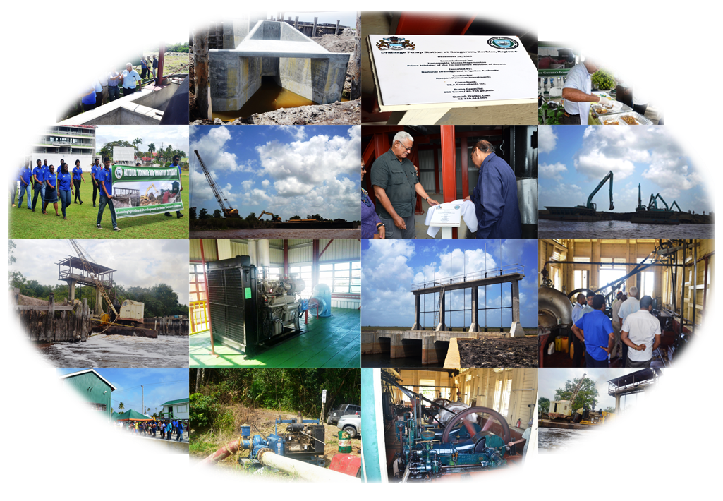
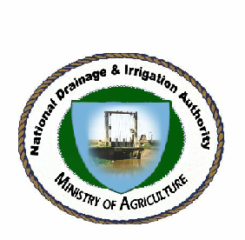

Table of Contents
1.0 MISSION STATEMENT 5
2.0 STRATEGIC OBJECTIVES 5-6
3.0 The Functions of the National Drainage & Irrigation Authority 6
4.0 Chief Executive Officer's Statement …………………………………………………………………………….7
5.0 EXECUTIVE SUMMARY 8-11
6.0 ORGANISATION STRUCTURE 12-13
6.1 Operational Divisions 13
6.2 General administration Divisions 13
7.0 SECTIONS WITHIN NDIA 13
7.1 Office of the Chief Executive Officer 13-14
7.2 Engineering Section 14
7.3 Finance and Administrative Section 14-15
7.4 Procurement Department 15
7.5 Audit Department 15
7.5.1 Duties of the Audit Department: 15-16
7.6 Mechanical and Electrical Engineering Department 16-17
7.7 Preventative Maintenance - Benefits of the exercise 17
7.8 Recommendations implemented by Mechanical Department 17-18
7.9 Machinery 18
8.0 ADMINISTATIVE DEPARTMENTAL MATTERS .18
8.1 Staff Complement 18
8.2 Staff Appointments 18-19
8.3 MOA Scholars . 19
8.4 Acting Appointments . 19

8.5 Dismissals 19
8.6 Resignations 20
8.7 In Memoriam 20
9.0 SUMMARY OF WORKS UNDERTAKEN IN 2015…………………………………………………….21-22
9.1 NDIA Projects 23
9.2 Construction of EDWC Northern Relief 23-25
9.3 Status Report 2015 26-35
10.0 Financial Summary 36
10.1 Financial Statement 36-37
10.2 Unpresented Cheques 37
10.3 NDIA Accounting and Bank Balances 37-38

1.0 MISSION STATEMENT
“The National Drainage and Irrigation Authority functions as the Nation’s apex organization dealing with all public matters pertaining to management, improvement, extension and provision of drainage, irrigation and flood control infrastructure and services in declared areas of the country. While providing support and assistance to other public institutions dealing with connected activities, it shall also evolve mechanisms for improved water use with financial sustainability, equity and efficiency as the guiding principles.”

2.0 STRATEGIC OBJECTIVES
The strategic objectives to ensure that the National Drainage and Irrigation Authority execute its legislative mandate shall be to:
- Develop an institutional structure in terms of water resources management strategy and water use planning or the primary purpose of locating, evaluating, conserving and distributing water resources of the country for agricultural purposes.
2. Establish the Authority as the regulatory and coordinating agency responsible for the operation, maintenance, control and management of the drainage and irrigation and flood control system and works to effectively harmonize activities to enhance agricultural production.
3. Ensure that the existing drainage and irrigation system and flood control and any new expansions that are made are operated and maintained in a sustainable manner.
4. Provide for cost recover for sustainable management of the primary and secondary elements of the drainage and irrigation system and flood control.
5. Promote and provide support for the participation of Water Users’ Association, farmers association and local government organs in the management operation and maintenance of the drainage and irrigation systems and flood control.
6. Promote participation of Water Users’ Association, farmers organizations and local government organs in the planning , design, management, operation and maintenance of the drainage and irrigation and flood control systems.

7. Promote and encourage the involvement of private sector in the construction, management, operation and maintenance of the drainage and irrigation of flood control systems.

3.0 The Functions of the National Drainage & Irrigation Authority

The functions of the Authority are the functions conferred upon it by the National Drainage and Irrigation Act 2004 and the regulations made there under, these include:

(a) Recommend a national drainage and irrigation policy.
(b) Co-ordinate the operation and maintenance of drainage and irrigation activities through such measures as may be appropriate and to make suitable recommendation therefore.
(C) Manage, operate and maintain the drainage and irrigation systems and related access roads and facilities, constructed or acquired by the Authority under the Act.
(d) Develop programmes and plans to locate, evaluate, conserve and distribute water resources for agricultural development and for the efficient management, operation, evaluation and monitoring of the drainage and irrigation systems.
(e) Implement a system of financing that separates public and private services of the drainage and irrigation systems and divide drainage and irrigation infrastructure into related public and private categories with the result that the operation and maintenance of the private goods elements of the system are paid for by the direct users of the services and that upkeep of the public elements of the system is supported by public revenue.
(f) Develop procedures, norms, standards including irrigation and environmental standards and operation schedule for the efficient operation and maintenance for the drainage and irrigation systems within the regions.
(g) Execute feasibility studies and appraisals for programmed works to determine priorities and quality standards for plans for the drainage and irrigation systems.
(h) Carry out capital works or contract them to the private sector using competitive bidding procedures.
(i) Set, monitor and enforce the terms and conditions subject to which contracts are entered into by the Authority.
- Undertake anything incidental or conductive to the performance of any of the foregoing functions.

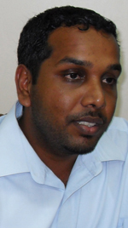
4.0 CHIEF EXECUTIVE OFFICER’S STATEMENT

The year 2015 was full of challenges but the National Drainage and Irrigation Authority (NDIA) was able to complete a significant amount of works in vulnerable farming communities and residential areas around the country.

As part of the NDIA’s master plan, an aggressive plan for maintenance of all pumps and machinery was initiated as well as ensuring all sluices and drainage infrastructure were fully operational to ensure optimum drainage performance.

Throughout the year, the NDIA staff and engineers worked beyond their call of duty in ensuring that farming and residential communities were secured from adverse weather conditions. The Authority also attended a number of individual and regional meetings aimed at finding solutions, getting suggestions and making interventions.

In various Regions, dredging of outfall channels were undertaken in order to enhance the drainage capacity in key areas. This process was undertaken using a pontoon with two excavators that was created for this purpose. In the past this work was given to private contractors but this was found to be costly to the organization.

In Regions 2, 3,4,5,6 and 10, emphasis was placed on agricultural communities. Excavation and rehabilitation of dams was carried out to assist farmers in various regions. Monthly maintenance of canals continued with the NDIA providing significant sums to the Water Users Association to upkeep drainage and irrigation channels.

To improve drainage and irrigation in vulnerable communities, various contracts were signed for the improvement of the drainage and irrigation infrastructure. Rehabilitation works were also carried out on others.

2015 was a successful year by far when compared to other years since the adverse effects of climate change were mitigated significantly by the National Drainage and Irrigation Authority (NDIA). However, the down time of equipment continues to be of concern to the organization.
In concluding, I wish to say thanks to the staff of the NDIA for putting in their efforts and energies as we strive to create a sustainable and enhanced drainage and irrigation system.

5.0 EXECUTIVE SUMMARY
The National Drainage and Irrigation Authority (NDIA) has successfully implemented its work plan for 2015. This was manifested with the construction of several drainage pump stations, clearing of numerous canals and the installation of pumps countrywide.
Improving the drainage network across the country was a major part of the NDIA’s mandate which has been successfully undertaken during 2015. As a result, construction of drainage pump stations were completed at Windsor Forest, Canal No. 1 Polder, Paradise/Enterprise, Pine Ground, Rose Hall, Vrede-en-Vriendschap and GuySuCo No. 66 Village Eversham BBP, No. 43 Village BBP, Bengal BBP, Gangaram, and Lima.
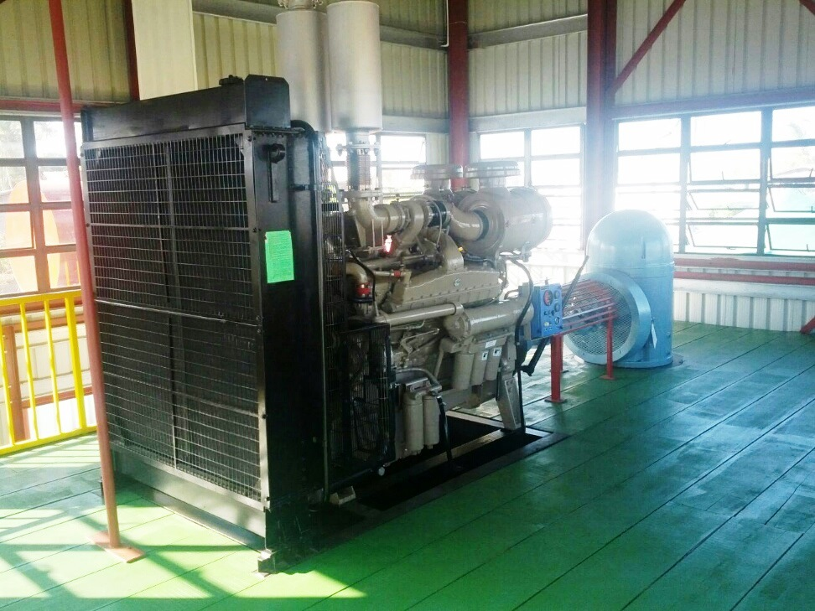
A section of the newly commissioned Mibicuri Pump Station at Eversham, Berbice

The primary focus of NDIA continues to be to improve and upgrade drainage and irrigation services countywide, thereby enhancing the competitiveness of the various sectors and improving productivity.
NDIA carried out a number of maintenance work during 2015. There was maintenance of approximately 24,350 rods of drainage & irrigation canals within Wakenaam, Leguan & Cane Grove NDC, maintenance of 106,177 rods of drainage and irrigation channels and canals within Community Development Councils areas such as Greenfield, Hope, Anns Grove, Two Friends, Bellfield, Nabaclis, Golden Grove, Haslington, Triumph, Friendship, Kuru Kuru, Mocha, Barnwell North, Bell West, Friendship, Lusignan to Vryheid's Lust Area, Canals Polder, etc. and maintenance of 129,376 rods of drainage and irrigation channels and canals within Water Users Associations’ areas such as Cane Grove, Golden Grove/Victoria, Blankenburg/ Den Amstel, Vergenoegen/ Naamryck, Lot 52 – 74, Black Bush Polder, Crabwood Creek, Vreed-en Hoop/La Jalousie.

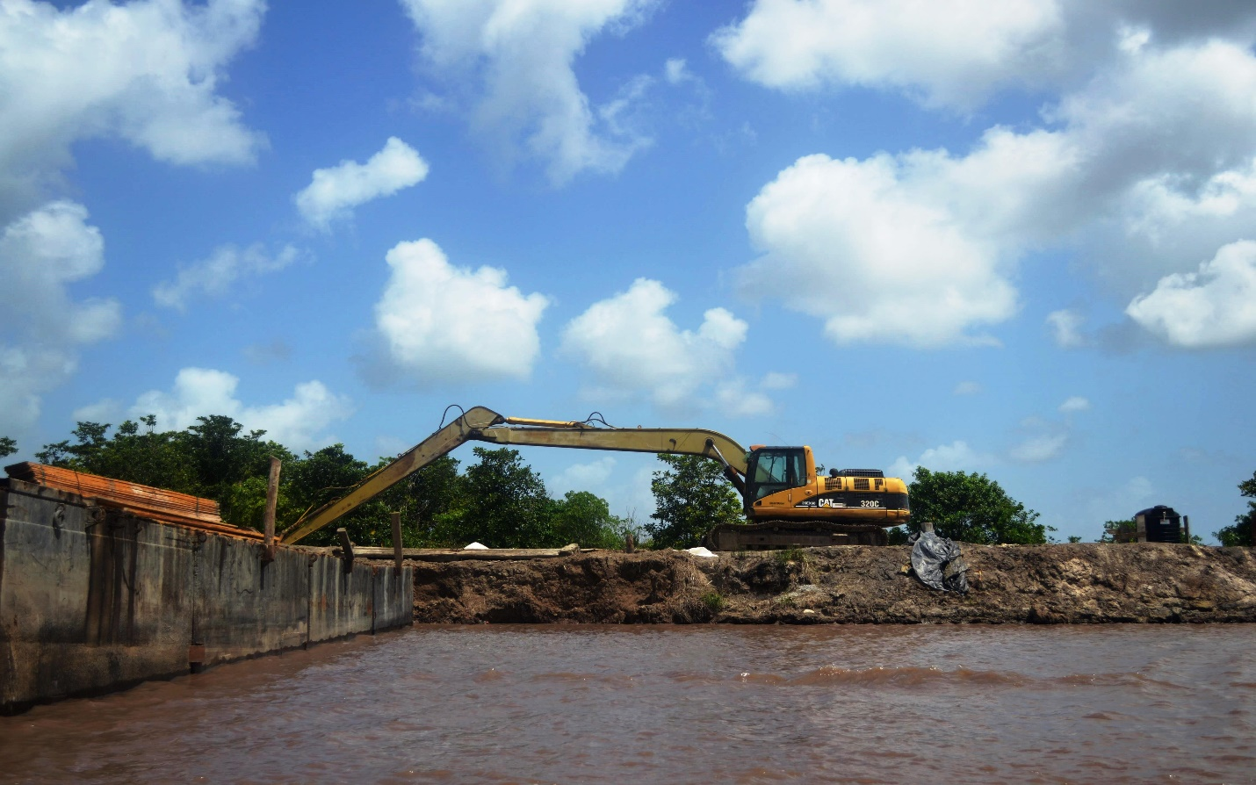
The 2015 capital budget of $4.295 billion entailed the provision of $1.701 billion for the maintenance of D&I infrastructure and the operation of pumps, excavators, etc., $2.051 billion for the construction and rehabilitation of D&I infrastructure; $0.311 billion for the construction of the East Demerara Water Conservancy (EDWC) channel at Hope/ Dochfour and $0.232 billion for the rehabilitation of the EDWC structures. NDIA was able to execute its 2015 recurrent work programme according to plan.
The NDIA also continued to work along with the MMA to bring relief to rice farmers along the coast.
The finance department was faced with a number of constraints during the 2015 as a result of a financial audit, resignation of the finance manager and two assistant accounts and issues with transportation.

2015 saw Guyana experiencing both flooding and drought like weather conditions which resulted in the NDIA having to undertake a number of emergency operations to aid farmers and residents in general. In May 2015, the NDIA was tasked with bring some level of relief to rice farmers who were suffering from flooded rice lands on the Essequibo Coast.
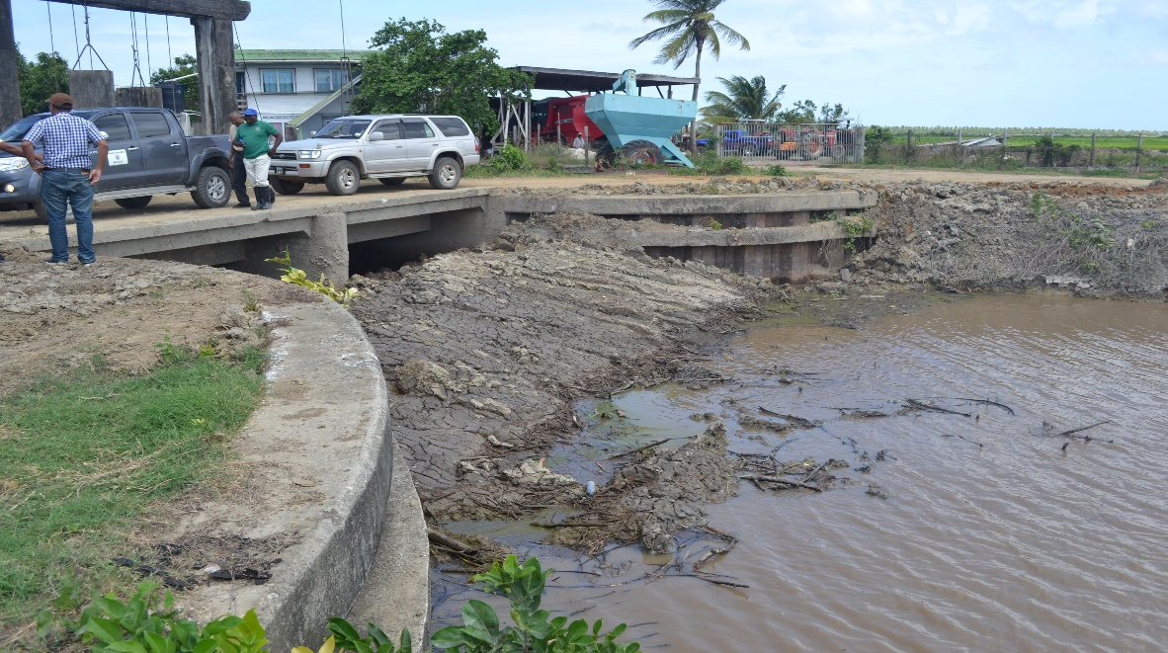
With the continuing El Nino period, the NDIA was further tasked with conducting continuous works across the country to provide irrigation to farmers given the limited water resources available. Officials from the NDIA also met with members of the CDC, GWI and other officials to discuss the way forward impeding the El Nino conditions.
During 2015, NDIA saw a total of 169 project activities being undertaken under the local capital funded component. 130 of these projects have been successfully completed with the remaining 38 projects rolling over into 2016. However, one project had to be abandoned due to a shortage in material. Pump station constructions were completed at Windsor Forest, Canal No. 1 Polder, Pine Ground, Paradise/ Enterprise, Joppa, Eversham, Gangaram and Lima. In addition to completing pump stations, NDIA carried out repairs to a number of sluices, culverts, revetment and bridges.

As it relates to administrative matters, in July the CEO of NDIA, Mr Lionel Wordsworth, proceeded on administrative leave and Mr. Fredrick Flatts was appointed as the acting CEO. The NDIA had a total of sixty six staff employed as at December 31, 2015. Twelve MOA scholars were assigned to the agency while four persons resigned.

NDIA staff participated in IICA’s four day workshop on Farming wit climate change. The participating persons were able to walk away with a synthesis of ideas to solve the problems associated with water management and shortage.
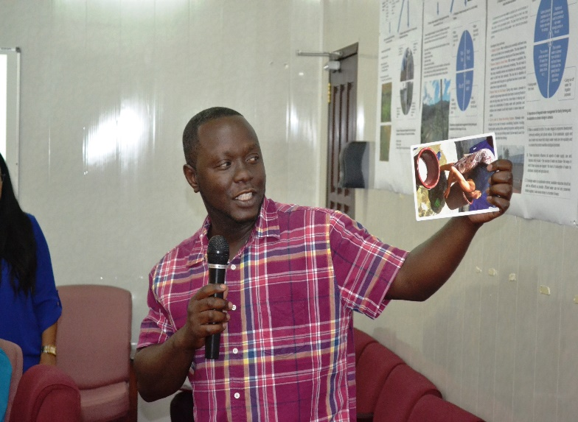

His Excellency David A Granger introduced a National tree planting exercise in October last which saw the staff of the NDIA partaking in the activity by planting trees in and around the compound and around pump stations across the country.
On a lighter note, two NDIA engineers rescued a stranded flamingo from the Essequibo River while conducting routine visits to drainage and irrigation structures. The animal was brought to the city and immediately donated to the Zoological Park. The NDIA staff also participated in the Ministry’s annual cook off and inter-ministry sports activities.

6.0 ORGANISATION STRUCTURE
The National Drainage and Irrigation Authority is governed by a Board of Directors appointed by the Minister. The Board of Directors of the NDIA subject to the provision of the National Drainage and Irrigation Act 2004 and shall be responsible for the policy and general administration of the affairs of the authority. The Chief Executive Officer of the Authority is responsible for the overall direction and management of the Authority and for ensuring it fulfils all of its statutory functions and other responsibilities.
The members of the NDIA board for the year 2015 are:
NAMES DESIGNATION
Mr. John Piggott Chairman, NDIA
Mr. Fredrick Flatts Director, C.E.O. (ag.), NDIA
Mr. George Jervis Director, Permanent Secretary, MOA
Mr. Bernard Lord Director, Ministry of Finance
Mr. Devanand Ramdatt Director, Regional Chairman, Region No. 2
Mr. Julius Faerber Director, Regional Chairman, Region No.3
Ms. Genevieve Allen Director, Regional Chairman, Region No.4
Mr. Walter Persaud Director, Cane Farming Manager, GuySuCo
Mr. Vickchand Ramphal Director, Regional Chairman, Region No.5
Mr. David Armogan Director, Regional Chairman, Region No. 6
Mr. Renis Morian Director, Regional Chairman, Region No.10
Colonel (ret’d)Chabilal Ramsarup Director, Civil Defence Commission
Pastor Sewnauth Punalall Director, National Taskforce Commission
Mr. Victor Wilson Director
Mr. Rene Duesbury Director, Guyana Lands and Surveys
Commission
Mr. Sirepaul Hemraj Director, WUA Representative
Mr. Hemraj Ragnauth Director, WUA Representative
Mr. Omadat Persaud Director, GuySuCo Representative
Mr. Omadatt Chandan Corporate Secretary, NDIA

The Authority is divided into three Operational Divisions as follows:-

6.1 Operational Divisions
- Operations and Maintenance
- Construction and Development

The general administration, which includes support and control, is carried out by two divisions as follows:-

6.2 General administration Divisions
- Finance and Budgeting
- Human Resources and Administration

7.0 SECTIONS WITHIN NDIA

7.1 Office of the Chief Executive Officer
The Chief Executive Officer is the Chief Engineer and Head of Department of the National Drainage and Irrigation Authority. All technical, administrative and financial powers to manage the Authority are vested in him. He also deals with and ensures the existing drainage and irrigation infrastructure is in a functioning state, and improved where necessary to function more efficiently while staying within the guidelines set out in the Laws of Guyana. He is primarily responsible for all technical and scientific matters and matters related to special projects of the Authority. He co-ordinates with the Ministry of Agriculture, Regional Administrations, local agencies and beneficiaries in promoting improved drainage and irrigation within the agricultural sector and performs other related activities.
7.2 Engineering Section
This section is responsible for co-coordinating all drainage and irrigation engineering activities and reports to the Chief Executive Officer.
The responsibility of the engineering division involves:
- Tender and contract management, procurement of material and equipment and conducts cost analysis to firm up the rate of different work and updates it every year.
- Water management and monitoring and evaluation. It is also responsible for keeping an inventory of drainage and irrigation system data on computer files. Monitors and evaluates the annual work programme and prepares monthly, mid year and annual performance reports of the National Drainage and Irrigation Authority for submission to the Minister, CEO and the Board of Directors.
- Operation and maintenance of all equipment including those executing rehabilitation works under force account. It ensures that the existing equipment remain in operating condition with acceptable fuel and operational efficiency.
7.3 Finance and Administrative Section
This section has the responsibility of budget, expenditure and revenue collection, and reports to the Chief Executive Officer. It prepares the budget of expenditure for each year in advance and monitors the progress so as to achieve the targets. At the end of the year, the section prepares the report on financial performance to be included in the annual performance report of the Authority. It also ensures that the expenditure in each head of accounts that has been identified stays within the allocated budget. Additionally, the section is in charge of support services, office management, stores and procurement, recruitment and service matter including disciplinary action, human resource development and training.

7.4 Procurement Department
This department is responsible for the preparation of contracts, collecting of bid documents and attending tender board opening and awarding of contracts. This department also has the responsibility of ensuring that all procurement laws and procedures are adhered to. Two staff members have the responsibility of manning the operations of this department and another staff would soon be appointed to join this department.

7.5 Audit Department
The National Drainage and Irrigation Authority (NDIA) is also subject to auditing procedures since it has a significant number of personnel and machinery in the operating field.
7.5.1 Duties of the Audit Department:
These include:
- Ensuring that adequate safeguards exist for the safekeeping of public funds and stores.
- Ensuring that adequate checks are made of all stores and assets and all log books for vehicles and equipment within the NDIA are properly written up.
- Ensuring that monthly reports on fuel consumption are submitted and analyzed.
- Drawing up programme and reviewing all stock verification reports.
- Making recommendations as necessary and taking appropriate follow-up actions.
- Carrying out investigations relating to contracts for works and to allegations of fraud and malpractices.

7.6 Mechanical and Electrical Engineering Department
Aspects of Mechanical and Electrical engineering were carried out by the following staff:
- Mr. Avinash Singh (Mechanical)
- Mr. Irzad Khan (Engineer Technician) Sadly Mr. Khan passed away last year. Condolences were given to the family by NDIA.
- Prabhodial Sattan (Preventative Maintenance Clerk)
- Pooran Persaud (Fuel Clerk)
- Garfield Roberts (Fuel Controller)
- Andre Giddings (Driver/Mechanic)
- Seosankar Omram (Mechanical Foreman)
Under the mechanical department, there is a programme of planned maintenance of all machinery owned and controlled by the National Drainage and Irrigation Authority (NDIA).
Duties of this department include:
- Ensuring the continued serviceability of all drainage and irrigation equipment.
- Installing and calibrating new systems and services.
- Maintaining and repairing computer equipment and other equipment.
- Preventative maintenance for all drainage and irrigation equipment. This includes the setting up and monitoring of a preventative maintenance programme for each piece of equipment.
- Ensuring that all unserviceable equipment is repaired to acceptable standards and service reports attended to.
- Requisitioning spares to ensure that an adequate stock is available.
- Ensuring that necessary test equipment is available, in proper working order and arranges for calibration.
- Assisting staff in specific tasks.
- Assembling testing procedures as necessary to ensure that equipment is maintained to optimum performance levels.
- Assisting the CEO in the planning of new installations.
- Ensuring that staff is trained in the maintenance of new installations.
- Keeping up to date with new regulations, procedures and technological advances.

7.7 Preventative Maintenance - Benefits of the exercise
Maximum availability and reliability of all the NDIA Mobile and Fixed Drainage Pumps is important, when the demand for drainage is needed. With the increase in rainfall accumulated in Guyana due to climate change and the rise of the ocean there is need for additional drainage method during the year end rainy season since Hence, ensuring that all the NDIA Mobile and Fixed Drainage Pumps are serviced and all faults are corrected prior to the yearend rainy season, will ensure optimum land drainage as needed.
7.8 Recommendations implemented by Mechanical Department
Preventative Maintenance by changing Generator Engine Oil, Oil Filter, Fuel Filter, Hydraulic Filter and Clean Air Filter is needed every two hundred and fifty (250) hours. This service is important since at 250 hours the engine oil loses viscosity resulting in reduced engine lubrication. Continued operation in this state causes damages to the major components of the engine.
Also the filters at 250 hours become clogged with sediments. Continued operation results in engine “black smoking” which is caused by fuel starvation. Black smoking is the release of heavy Carbon Deposits into the environment and carbon is major contributor to Global Warming.
In addition, fuel starvation will result in the damage of major parts of the fuel pump.
Carrying out a Plan Preventative Maintenance on all the NDIA Mobile & Fixed Drainage Pumps in preparation of the year end rainy season will enhance optimum drainage of water from land hence reduce flooding and discomfort of the citizens and in addition minimum loss in farming of crops and livestock.

7.9 Machinery
There is also a planned maintenance programme for the NDIA excavators. However, with over half of NDIA’s equipment being down, more needs to be done by the Department to improve the percentage of machinery carrying out NDIA’s work programme.

8.0 Administrative Departmental Matters

8.1 Staff Complement
Sixty six (66) employees comprised the staff strength of the National Drainage & Irrigation Authority; they are supervised by their respective Department Heads.
8.2 Staff Appointments
There were eleven (11) staff appointments during this period:
- Deonarine Budhan Driver/Mechanic
- Rudolph Persaud Civil Engineer
- Jogram Pump Operator
- Rajendra Surujpaul Pump Operator
- Omdat Singh Driver/Mechanic
- Doodmattie Mansram Assistant Accountant
- Leon Kissoon Stores Assistant
- Janel Blackman Human Resource Officer
- Ramesh Badal Stores and Inventory Control Officer
- Terrianne Bascom Finance Officer II
- Loretta Bernard Office Assistant

8.3 MOA Scholars

A total of twelve (12) scholars attached to the Ministry of Agriculture were placed in the NDIA depatrment
- Ramesh Baichoo Engineer
- Mathew Bellamy Electrical Engineer
- Lonsdale Edghill Agricultural Engineer
- Andrea Edwards Engineer
- Roderick Rainford-Grant Engineer
- Kevon King Engineer
- Lester Persaud Civil Engineer
- Suraj Persaud Agricultural Engineer
- Molly Manbodh Agricultural Engineer
- Litecha Harriram Agricultural Engineer
- Kenny Seurattan Mechanical Engineer
- Ancil Ramdat Engineer

8.4 Acting Appointments

There was one acting appointment during this period:
- Fredrick Flatts Chief Executive Officer(ag)

8.5 Dismissals
There was one dismissal during this period:
- Dashwantie Persaud Assistant Accountant
8.6 Resignations
There were four (4) resignations during this period:
- Mark Hamilton Office Assistant
- Suresh Narayan Finance Manager
- Raphael Gravesande Regional Engineer
- James Mc Rae Stores and Inventory Control Officer

8.7 In Memoriam
Mr. Irzad Khan, Engineer/technician from the Mechanical Department passed away during the reporting period. Condolences were given to the family by NDIA. Mr. Khan had provided useful service to the NDIA.

9.0 SUMMARY OF WORKS UNDERTAKEN IN 2015

The year 2015 has seen the continuation of significant strides in diverse directions with the ultimate objective of strengthening the D & I infrastructure of the country. The National Drainage and Irrigation Authority has not only undertaken several high quality construction projects but has worked tirelessly to strengthen itself and the sector.

The significant financial investment and focus on the D & I sector has seen the successful completion of a significant part of the rehabilitation activities embarked upon to resuscitate the existing D & I infrastructure in keeping with the drainage and irrigation master plan. These investments have improved the efficiency of the D & I systems and have resulted in a drastic decline in the prevalence of floods associated with exceptionally high intensity rainfall and rise in water levels in oceans due to Global warming.

The 2015 capital budget of $4.295 billion entails a provision of 1.701 billion for the maintenance of D&I infrastructure and operation of pumps, excavators, etc; 2.051 billion for construction & rehabilitation of D & I infrastructure; 0.311 billion for the for the construction of the EDWC relief channel at Hope/Dochfour financed under Petrocaribe and Counterpart; 0.232 billion for the rehabilitation of EDWC structures.

CHART OF ACCOUNT | BUDGET | ACTUAL EXP | UNSPENT BALANCES | REMARKS
 | (G$M) | (G$M) | (G$M)
6321 | 1,701,223,317 | 1,688,855,831 | 12,367,486 | Appendix 1
1301600 | 2,051,335,000 | 1,930,741,126 | 120,593,874 | Appendix 2
1301700 | 310,732,000 | 171,061,629 | 139,670,371 | Appendix 3
2100500 | 231,566,000 | 131,487,351 | 100,078,649 | Appendix 4
TOTAL | 4,294,856,317 | 3,922,145,937 | 372,710,380

6321: Subsidies & Contribution to Local Organization
The National Drainage & Irrigation Authority has manage to execute its 2015 recurrent work programme according to plan. This includes:
- Maintenance of approximately 329,376 rods of channels with WUAs areas in Reg. # 3, 4 & 6; 49,701 rods of channels within NDCs area in regions # 3 & 4 & 6; Maintenance & cleaning of 324,903 rods of channels within CDC Groups in Regions 3, 4, 6 & 10 and repair works to sluices, culverts, bridges, revetments, etc.
- Provision of fuel and lubricant for 110 excavators, 46 D&I pumps, dragline ,8 dozer, 9 outboards engines etc.
- Maintenance of 110 excavators, 46 D&I pumps, dragline ,8 dozer,9 outboards engines, etc.
- Operation and monitoring of 110 excavators, 46 D&I pumps, dragline, 8 dozers.

1301600: National Drainage & Irrigation Authority (Capital –Local Funded)

The Authority has executed its work programme under this project component quite successfully. A total of 169 project activities have been executed under this project component. A total of 130 activities have been completed while 38 roll over into fiscal year 2016, while one has been abandoned due to shortage of materials (Steel Sheet Piles).

Approximately $120million were not spent and subsequently paid back to the consolidated fund via the Accountant General. The delay in NPTA award of variation for projects contributed significantly to this situation.

A number of activities have been executed and completed under this project component such as construction of sluices at Buxton; expansion of sluice at Grove/Diamond; excavation of outfall channels in Region 6; Construction of pump station at Canal No 1 Polder, Pine Ground Mahaicony, Vrede-en-Vriendschap, Joppa No 43 Village, Eversham, Gangaram & Lima; Rehabilitation of excavators, pontoons & pumps.

1301700: Drainage & Irrigation (Capital –Foreign/Counterpart Funded)
Significant strides have been made under this project component for the completion of the Hope Canal Project. However there has been shortcoming with the Completion of the High level Sluice Outfall Structure and lengthy delay by NDIA in the submission of tender documents to NPTA which led to delay in NPTA award of contract resulted in significant sums being paid back to the consolidated fun. This project has been roll-over to fiscal year 2016 with the aim of being completed.

2100500: East Demerara Water Conservancy (Capital -Foreign Funded JICA)
This project entails the rehabilitation of structures along the EDWC with the aim of strengthening same. Works are in progress. There are several shortcomings, with the payment arrangements for the Consultant and Management Agent being effected without the Authority knowledge. This poses great difficulty in reporting of same to the Government of Guyana and in the clearance of the said funds.

9.1 NDIA PROJECTS
9.2 Construction of EDWC Northern Relief Channel at Hope/Dochfour
MINISTRY OF AGRICULTURE - NDIA
STATUS REPORT ON CONSTRUCTION OF EDWC NORTHERN TRELIEF CHANNEL
21:1301700 DRAINAGE AND IRRIGATION
No | Project/  Activities | Contract Sum | Overall Status |  | Budget 2015 |  |  | 2015 Financial Status
 |  |  | Exp at July 2015 | % | Specific | Local | Total | Petro Caribe (Specific) | Counterpart (Local) | Total Exp 2015 | Remarks
1 | Supply of 14 super long reach hydraulic excavators | 441,628,000 | 441,628,000 | 100 |  |  |  | 0 | 0 | 0 | Completed
2 | Supply of 2-4x4 vehicles | 8,400,000 | 8,400,000 | 100 |  |  |  | 0 | 0 | 0 | Completed
3 | Compensation package for residents and farmers | 110,368,982 | 110,368,982 | 100 |  |  |  | 0 | 0 | 0 | Completed
4 | Supply of timber mats | 49,807,580 | 49,807,580 | 100 |  |  |  | 0 | 0 | 0 | Completed
5 | Operation and monitoring of machinery | 24,700/day per machinery | 384,682,800 | 99 | 40,831,000 | 30,000,000 | 70,831,000 | 40,831,000 | 0 | 40,831,000 | Delay in procurement resulted in payment not being effected
6 | Fuel and lubricants | 238,737,869 | 224,250,744 | 100 |  |  |  | 0 | 0 | 0 | Completed
7 | Engineering design and geotechnical investigation | 56,772,000 | 30,011,124 | 100 |  |  |  | 0 | 0 | 0 | Completed
8 | Technical oversight for the engineering design | 10,200,000 | 9,600,000 | 100 |  |  |  | 0 | 0 | 0 | Completed
9 | Construction of head regulator | 420,796,867 | 368,821,601 | 100 | - | 19,000,000 | 19,000,000 | 0 | 9,456,964 | 9,456,964 | 5% retention. Approval granted for $19,077,500 to be utilized from projected savings to complete scour protection works listed at items 24-27
10 | Construction of high level sluice outfall structure | 605,430,630 | 590,993,178 | 95 | 8,850,039 | 78,662,770 | 87,512,809 | 8,850,039 | 64,225,318 | 73,075,357 | For completion of scour protection works
11 | Construction of public road bridge | 349,654,353 | 349,654,018 | 100 | 8,741,359 | - | 8,741,359 | 8,741,359 | 0 | 8,741,359 | Completed
12 | Consultancy supervision for construction of channel | 133,442,500 | 113,890,100 | 98 | - | 38,407,337 | 38,407,337 | 0 | 0 | 0 | Awaiting NPTA approval of variation
13 | Consultancy supervision for construction of structures | 136,107,833 | 130,480,408 | 98 | - | 40,464,805 | 40,464,805 | 0 | 0 | 0 | Awaiting NPTA approval of variation
14 | Supply of geotextile materials | 286,459,665 | 286,459,665 | 100 | 3,045,060 | 2,486,845 | 5,531,905 | 0 | 0 | 0 | Completed
15 | Supply of sheet piles | 211,332,690 | 211,332,690 | 100 |  |  |  | 0 | 0 | 0 | Completed
16 | Supply of steel for gate of high level sluice | 54,319,530 | 54,319,530 | 100 |  |  |  | 0 | 0 | 0 | Completed
17 | Procurement of 2 aluminum boats and engines | 4,460,000 | 1,700,000 | 100 |  |  |  | 0 | 0 | 0 | Completed
18 | Fabrication of settlement plates | 1,282,800 | 1,282,800 | 100 |  |  |  | 0 | 0 | 0 | Completed
19 | Re-location of Hope Secondary school shed/car park | 9,284,150 | 2,141,748 | 80 |  |  |  | 0 | 0 | 0
20 | Provision of technical oversight | 6,700,000 | 6,700,000 | 100 |  |  |  | 0 | 0 | 0 | Completed
21 | Hauling of materials for earthern embankment | 10,404,400 | 2,179,908 | 100 |  |  |  | 0 | 0 | 0 | Completed
22 | Fabrication and delivery of 8 stainless steel gates | 44,464,994 | 43,089,774 | 100 |  |  |  | 3,045,060 | 1,111,625 | 4,156,685 | Completed
23 | Supply of a gate lifting mechanism for head regulator | 24,900,000 | 24,900,000 | 100 | 18,225,000 | 2,940,000 | 21,165,000 | 18,225,000 | 2,940,000 | 21,165,000 | Completed
24 | Supply of 825 tons of gabion stones | 7,012,500 | 7,012,500 | 100 |  | 7,012,500 | 7,012,500 | 0 | 7,012,500 | 7,012,500 | Financed from savings under item 9
25 | Supply of gabion mattress | 5,175,000 | 2,430,000 | 50 |  | 5,175,000 | 5,175,000 | 0 | 2,430,000 | 2,430,000 | '
26 | Transportation of gabion stones to Flagstaff | 1,650,000 | 1,608,750 | 100 |  | 1,650,000 | 1,650,000 | 0 | 1,608,750 | 1,608,750 | '
27 | Construction of scour protection | 5,240,000 | 2,584,014 | 50 |  | 5,240,000 | 5,240,000 | 0 | 2,584,014 | 2,584,014 | '
 | TOTAL | 3,618,715,143 | 3,460,329,914 |  | 79,692,458 | 231,039,257 | 310,731,715 | 79,692,458 | 91,369,171 | 171,061,629

MINISTRY OF FINANCE
DETAILS OF CONTRACTS 2015/2016
21:2100500 EAST DEMERARA WATER CONSERVANCY
PROJECT TITLE/LOCATION | TENDER BOARD REF# | NAME OF CONTRACTOR | CONTRACT COST (G$) | DATE COMMENCED | DURATION | DEFECTS/ LIABILITY | EXPENDITURE 2015 (G$) | REMARKS
Rehabilitation of intake structures at Anns Grove, Hope, Annandale and Nancy and relief sluices at Maduni and Sarah Johanna (Cunha) | GYW11/11588/031-1 dd. March 3, 2015 | A & S General Contractors Inc. | 197,104,754 | 3/1/2015 | 365 days | 365 days | 69,930,042 | Contract sum of US$947,619.01 at exchange rate of GY$208
Procurement management agent | N/A | Crown Agents | 126,000,000 | 15/2/2012 | N/A | N/A | 17,492,407 | Contract sum of JPY50.4M at exchange rate of GY$2.5
Supervision of rehabilitation | N/A | Sanyu Consultants Inc | 158,702,500 | 6/2/2014 | 3 years | N/A | 44,064,902 | Contract sum of JPY63.481M at exchange rate of GY$2.5
Legal services
Technical assistance (Soft components)
Administarative costs to be borne by GOG:
Commission for banking arrangement
Equipment for technical assistance
TOTAL |  |  |  |  |  |  | 131,487,351

9.3 Status Report 2015
21: Ministry of Agriculture - 1301600 National Drainage and Irrigation Authority
Status report 2015
No | Project/Activities | Contractor | NPTA | Date Completed | Status | Total Contract Sum | Budget Estimate | Exp | Remarks
 | 2014 Roll over Projects: |  |  |  |  |  | 1,697,585,809 | 1,610,466,095
1 | Construction of sluice at Profit Abary, WCB | Courtney Benn Contracting Services | 830/10 dd. 10/12/10 | Mar-16 | 98% | 145,856,377 | - | - | Budget 2016 21,149,024
2 | Supervision services for the construction of sluice at Profit, Abary, WCB | SRKN'gineering | 833/10 dd. 7/7/10 | Jun-15 | 100 | 10,000,000 | - | - | Contract completed.
3 | Supervision services for the expansion of sluice at Grove Diamond | E&A Consultants | 1865/ dd 21/9/11 | Oct-15 | 100 | 16,908,000 | - | - | Savings. Approval for variation at NPTA.
4 | Construction of sluice at Buxton | Colin Talbot | 1013/11 dd. 8/9/11 | Oct-15 | 100 | 78,573,840 | 21,149,024 | 21,149,024 | Completed
5 | Supervision services for the construction of sluice at Buxton | E&A Consultants | 1866/11/dd/21/9/11 | Oct-15 | 100 | 14,900,000 | 4,300,000 | 4,300,000 | Completed
6 | Construction of drainage pump station at Windsor Forest | Samaroo's Investment | 3046/12 dd. 21/12/12 | Jun-15 | 100 | 157,360,047 | 36,496,757 | 28,998,343 | Retention in 2016 Budget . Awaiting Variation Approval of 7,553,393. At NPTA-24/8/2015.
7 | Construction of drainage pump station at Canal No.1 Polder | Samaroo's Investment | 3047/1 dd. 21/12/12 | Aug-15 | 100 | 124,854,023 | 10,155,303 | 10,155,303 | completed
8 | Construction of drainage pump station at Pine Ground, Mahaicony | Fyuse Hoosein | 3049/12 dd. 31/12/12 | Aug-15 | 100 | 199,414,250 | 36,596,963 | 36,596,963 | completed
9 | Construction of drainage pump station at Vrede-en-Vriendschap, East Canjie | H. Nauth & Sons | 3045/12 dd. 31/12/12 | Feb-16 | D L | 198,375,430 | 33,540,000 | 33,540,000 | 2016 Budget 4,135,729. Variation of 4,131,830 at NPTA.
10 | Construction of doors for drainage structures at Canal No. 2 main drain | Sattrohan Maraj | 1416/12 dd. 27/8/12 | Apr-15 | 100 | 11,225,000 | 1,071,224 | 1,071,224 | Completed
11 | Construction of Guysuco drainage pump station at No. 66 Village Canjie | Yunas Civil & Building Contracting Services | 3607/12 dd 7/3/2013 | Jul-15 | 100 | 153,457,000 | 7,668,601 | 7,668,601 | Completed
12 | Construction of drainage pump station at Paradise/Enterprise | General Engineering Supplies and Services | 1781/13 dd 30/8/13 | Apr-15 | 100 | 181,813,250 | 18,911,538 | 18,911,538 | Completed
13 | Provision of supervision services for the construction of drainage pump stations in Region 3,4,5 & 6 | E&A Consultants Inc. | 3133/12 dd 8/2/2013; 4521/14 dd 24/12/14 | Dec-15 | 100 | 16,229,500 | 6,837,500 | 6,817,500 | 2016 Budget 1,302,000. Roll-Over
14 | Provision of supervision services for the construction of drainage pump stations in Regions 4-5 (Paradise/Enterprise and Pine Ground, Mahaicony) | SRKN'gineering | 3133/12 dd.2013/02/08:2014/08/22 | On-Going | 100 | 13,848,000 | 7,015,000 | 4,000,000 | 2016 Budget 2,000,000. Roll-Over
15 | Provision of supervision services for the construction of drainage pump stations in Region 6 (Rose Hall, Skeldon and Vrede-en-Vriendschap) | CEMCO | 3133/12 dd 8/2/2013 | On-Going | 100 | 27,756,000 | - | - | 2016 Budget 14,436,000 Awaiting NPTA Variation Approval
16 | Rehabilitation of NDIA drainage pumps at Huntley | General Engineering Supplies and Services | 978/13 dd 24/6/13 | Apr-15 | 100 | 4,400,000 | 440,000 | 440,000 | Completed
17 | Construction of GH revetment at Lama, EDWC | Khans Construction & Transp Serv Inc | 1895/13 dd 30/8/13 | Jan-15 | 100 | 20,045,240 | - | - | Completed
18 | Construction of revetment/structure at Buxton/Friendship | Colin Talbot Contracting Services | 1901/13 dd 13/8/13 | Jan-15 | 100 | 14,195,800 | - | - | Completed
19 | Rehabilitation of timber revetment at Pheonix Koker, Leguan | S. Maraj Contracting Services | 1896/13 dd 17/9/13 |  |  | 6,785,750 | 637,840 | 637,840 | Completed
20 | Empoldering farmlands at Kabakaburi, Upper Pomeroon | M. Sukhai Contracting Service | 3334/12 dd 23/1/13 | Mar-15 | 100 | 9,825,000 | 982,150 | 982,150 | Completed
21 | Construction of seepage canal and install tubes at A & B Line Boerasirie conservancy | Rajnauth | 1437/13 dd. 11/11/13 | Jun-15 | D L | 18,987,630 | 15,201,255 | 15,201,255 | Completed
22 | Construction of pump station at Joppa, No. 43 Village, Corentyne | Roopan Ramotar Investment | 1814/14 dd 8/14 | Dec-15 | D L | 181,896,000 | 152,801,200 | 151,495,500 | 2016 Budget 30,400,500. Retention
23 | Construction of pump station at Eversham | General Engineering Supplies & Services | 1819/14 dd 10/10/14 | Oct-15 | D L | 183,388,700 | 123,776,555 | 122,121,542 | 2016 Budget 33,758,853. Retention
24 | Construction of pump station at Gangaram | Roopan Ramotar Investment | 1850/14 dd 13/8/14 | Dec-15 | D L | 213,000,375 | 174,218,960 | 173,017,529 | 2016 Budget 24,944,746. Retention
25 | Construction of pump station at Lima | Samaroo's Investment | 1886/14 dd 26/8/14 | Dec-15 | D L | 191,510,260 | 126,147,151 | 126,147,151 | 2016 Budget 36,636,570. Retention
26 | Provision of supervision services for the construction of drainage pump station at Joppa # 43 | CEMCO | 1846/14 dd 26/8/14: 2015/11/24 | Dec-15 | 100 | 13,125,000 | 11,968,750 | 11,718,750 | Completed.
27 | Provision of supervision services for the construction of drainage pump station at Eversham | CEMCO | 1847/14 dd 10/10/2014: 2015/11/24 | Nov-15 | 100 | 12,043,750 | 10,887,500 | 10,887,500 | Completed
28 | Provision of supervision services for the construction of drainage pump station at Gangaram | E&A Consultants Inc. | 1844/14 dd 18/8/14: /2015/11/23 | Dec-15 | 100 | 14,971,700 | 13,687,037 | 13,462,737 | Completed
29 | Provision of supervision services for the construction of drainage pump station at Lima | E&A Consultants Inc. | 1845/14 dd 18/8/14: 2015/11/24 | Dec-15 | 100 | 14,884,000 | 13,560,900 | 13,560,900 | Completed
30 | Procurement of steel sheet piles for construction of pump stations at No. 43, Eversham, Gangaram and Lima | Suresh Jagmohan Hardware Supplies & Construction Services | 572/14 dd 8/8/2014 | Dec-15 | 100 | 177,820,000 | 100,190,175 | 100,190,175 | Completed
31 | Construction of sluice at La Grange, WBD | NABI Construction Inc | 1656/14 dd 22/8/14 | Feb-16 | 80 | 137,642,500 | 118,339,724 | 99,562,770 | 2016 Budget 38,079,730. Roll Over
32 | Construction of sluice at Bagotville, WBD | Jainul Hossain Civil Engineering Contracting | 1434/14 dd 22/8/14:2015/12/03 | Feb-16 | 92 | 65,462,575 | 52,055,154 | 37,501,182 | 2016 Budget 20,656,682. Roll Over
33 | Provision of supervision services for the construction of sluice at La Grange | SRKN'gineering | 1656/14 dd 22/8/14 | Dec-15 | 100 | 17,675,000 | 16,405,000 | 16,405,000 | Completed.
34 | Provision of supervision services for the construction of sluice at Bagotville | SRKN'gineering | 1758/14 dd 8/8/2014 | Dec-15 | 100 | 17,675,000 | 16,405,000 | 16,405,000 | Completed.
35 | Construction of revetment at Salem, WCD | Roopan Ramotar Investments | 596/14 dd 21/3/14 |  |  | 10,077,875 | 0 | - | Project stalled due to difficulty in acquiring steel sheet piles
36 | Construction of revetment at Kofi, EDWC | A&S General Contractors | 2917/13 dd 9/5/2014 | Nov-15 | D L | 17,716,400 | 14,326,870 | 14,326,870 | 2016 Budget 1,617,890. Retention
37 | Construction of drainage structure & excavation of seepage canal at Marafriends | Mohamed Kayum Hoosein Contracting | 1433/14 dd 11/9/2014 | Jun-15 | 100 | 14,145,200 | 8,420,350 | 8,420,350 | Completed.
38 | Procurement of mini excavators for NDIA | Guyana Tractor & Equipment | 3320/13 dd 20/12/13 | Jun-15 | 100 | 247,600,000 | 0 | - | Completed.
39 | Rehabilitation of NDIA equipment Lots 1,2,4 - Caterpillar, Doosan, Hyundai | Guyana Tractor & Equipment | 475/13 dd 4/7/13 | Jun-15 | 100 | 49,205,606 | 0 | - | Completed.
40 | Rehabilitation of NDIA equipment Lot 3 - Kobelco | Dax Contracting Services | 475/13 dd 4/7/13 | Jun-15 | 100 | 25,977,000 | 13,813,000 | 13,813,000 | Completed.
41 | Rehabilitation of NDIA Nos 20, 9 excavator. | Dax Contracting Services | 324/14 | Jun-15 | 100 | 27,136,000 | 7,055,000 | 7,055,000 | Engineer recc payments of $7,055,000 & termination of contract.
42 | Rehabilitation of NDIA No. 49 Doosan DX 225LCA excavator | Mohamed Kayum Hoosein Contracting | 4523/14 dd 24/12/14 | Feb-15 | 100 | 2,083,000 | 2,048,000 | 2,048,000 | Completed.
43 | Rehabilitation of excavators | D. Sawh Mechanical Workshop | 323/14 dd7/5/2014 | Apr-15 | 100 | 82,482,260 | 21,860,762 | 21,860,762 | Completed
44 | Rehabilitation of NDIA No. 3 320 CL Caterpillar excavator at Hope/ Douchfour NRC | D. Sawh Mechanical Workshop | 3079/14 dd 14/11/14 | Jul-15 | 100 | 12,325,600 | 12,325,600 | 12,325,600 | Completed.
45 | Rehabilitation of No. 11 320 CL Caterpillar excavator components | RCMB Contracting & Mining | 4326/14 dd 24/12/14 | Apr-15 | 100 | 1,510,000 | 1,510,000 | 1,510,000 | Completed
46 | Rehabilitation of NDIA No. 55 track type dozer component | RCMB Contracting & Mining | 1085/14 dd 19/12/14 | Apr-15 | 100 | 10,815,000 | 4,215,000 | 4,215,000 | Completed
47 | Rehabilitation of NDIA No. 38 Doosan DX 225 LCA excavator component | RCMB Contracting & Mining | 4519/14 dd 19/12/14 | Feb-15 | 100 | 1,642,800 | 1,642,800 | 1,642,800 | Completed
48 | Rehabilitation of NDIA No. 47 Doosan DX225LCA excavator component, Belwest | RCMB Contracting & Mining | 4517/14/DD 24/12/14 | Feb-15 | 100 | 2,555,000 | 2,555,000 | 2,555,000 | Completed
49 | Rehabilitation of No. 22 excavator components | RCMB Contracting & Mining | 4577/14 dd 24/12/14 | Apr-15 | 100 | 1,990,000 | 1,990,000 | 1,990,000 | Completed
50 | Rehabilitation of No. 14 SK 210 Mark 8 excavator components, Boerasirie Conservancy | International Import and Supplies | 4520/14 dd 24/12/14 | Apr-15 | 100 | 6,451,000 | 6,451,000 | 6,451,000 | Completed
51 | Rehabilitation of No. 52,57,58 bulldozer components | International Import and Supplies | 4574/14 dd 14/12/14 | Apr-15 | 100 | 7,169,015 | 7,169,015 | 7,169,015 | Completed
52 | Rehabilitation of No. 6,8,11,30,33,44,46,48,81 excavator components | International Import and Supplies | 4575/14 dd 24/12/14 | Jun-15 | 100 | 10,759,300 | 10,759,300 | 10,759,300 | Completed
53 | Rehabilitation of No. 18 Kobelco excavator components | International Import and Supplies | 4576/14 dd 24/12/14 | Feb-15 | 100 | 1,910,000 | 1,910,000 | 1,910,000 | Completed
54 | Rehabilitation of No. 11, 35 excavator | International Import and Supplies | 4635/14 dd 24/12/14 | Jun-15 | 100 | 7,177,048 | 7,177,048 | 7,177,048 | Completed
55 | Rehabilitation of No. 30 Kobelco SK210 excavator components | International Import and Supplies | 4645/14 dd 24/12/14 | Jun-15 | 100 | 1,553,000 | 1,535,000 | 1,535,000 | Completed
56 | Rehabilitation of No. 25 320 CL caterpillar excavator | S. Maraj Contracting Services | 3584/14 dd 23/12/14 | Jan-16 | 90 | 5,665,500 | 9,165,500 | 5,098,950 | 2016 Budget 566,550. Roll Over
57 | Rehabilitation of No. 30, 40 Doosan DX 225LCA excavator | S. Maraj Contracting Services | 3587/14 dd 10/12/14 | Dec-15 | 100 | 4,524,000 | 4,524,000 | 4,524,000 | Completed
58 | Rehabilitation of No. 19 Doosan excavator | Ghamandi & Sons Engineering & Computerize Manufacturing | 3080/14 dd 12/11/14 | Jan-16 | 90 | 4,887,500 | 4,887,500 | 2,932,500 | 2016 Budget 1,955,000. Roll Over
59 | Rehabilitation of No. 13 320 caterpillar excavator components | Krishna Ralph | 4325/14 dd24/12/14 | Apr-15 | 100 | 1,350,000 | 1,350,000 | 1,350,000 | Complete.
60 | Rehabilitation of NDIA's excavators bucket components | Krishna Ralph | 4630/14 dd24/12/14 | Feb-15 | 100 | 11,230,000 | 11,230,000 | 11,230,000 | Complete.
61 | Rehabilitation of NDIA fixed and mobile pump components at Bagotville | Harrychand Tulsi | 4350/14 dd 24/12/14 | Feb-15 | 100 | 1,100,000 | 1,100,000 | 1,100,000 | Complete.
62 | Rehabilitation of fixed and mobile pump components at Stanleytown, Region 3 | Ghamandi & Sons Engineering | 4351/14 DD 24/12/14 | Apr-15 | 100 | 5,065,000 | 5,065,000 | 5,065,000 | Complete.
63 | Rehabilitation of fixed and mobile pump components in Regions 2-6 - Lot 2 | Fyuse Hoosain Construction Inc | 3536/14 dd 24/12/14 | Apr-15 | 100 | 12,445,000 | 4,417,500 | 4,417,500 | Complete.
64 | Rehabilitation of fixed and mobile pump components in Regions 2-6 - Lot 4 | D. Sawh Mechanical Workshop | 3526/14 dd 11/4/14 | Feb-16 | 100 | 4,386,000 | 675,300 | 675,300 | Complete.
65 | Rehabilitation of NDIA mobile hydra flow pump component | Samaroo's Invstment | 3083/14 dd 11/11/14 | Feb-16 | 100 | 4,770,000 | 4,770,000 | 4,770,000 | Complete.
66 | Rehabilitation of NDIA mobile hydra flow pump engine and building at No. 19 Village | D. Sawh Mechanical Workshop | 3082/14 dd 11/11/14 | Apr-15 | 100 | 2,481,500 | 2,481,500 | 2,481,500 | Complete.
67 | Rehabilitation of Mibicuri pumps | D. Sawh Mechanical Workshop | 1776/14 dd 2/7/2014 | Apr-15 | 100 | 10,120,000 | 1,012,000 | 1,012,000 | Complete.
68 | Rehabilitation of pumps in Regions 2 - 6 | General Engineering Supplies & Services | 1127/14 dd 17/7/14 | Feb-15 | 100 | 13,916,000 | 13,916,000 | 13,916,000 | Complete.
69 | Rehabilitation of No.1 pontoon dredge | Khans Construction & Transp Serv Inc | 3081/14 dd11/11/14 | Feb-15 | 100 | 6,354,500 | 5,419,325 | 5,419,325 | Complete.
70 | Desilting of outfall channel at Lesbeholden | Associated Construction Service | 3069/14 dd 30/9/14 | Apr-15 | 100 | 7,433,320 | 0 | - | Complete.
71 | Excavation of Eversham outfall channel | Memorex Enterprises | 924/14 dd 12/6/2014 | Apr-15 | 100 | 12,749,815 | 1,131,126 | 1,131,126 | Complete.
72 | Excavationof Adventure outfall channel | Memorex Enterprises | 923/14 dd 12/6/2014 | Apr-15 | 100 | 5,903,280 | 512,880 | 512,880 | Complete.
73 | Excavation of Bengal outfall channel | K.P. Jagdeo | 925/14 dd 13/6/14 | Feb-16 | 0 | 4,428,790 | 4,207,351 | - | 2016 Budget 4,428,790. Roll Over. Awaiting rainy season to commence works
74 | Excavation of Joppa outfall channel | K.P. Jagdeo | 922/14 dd 23/6/14 | Feb-15 | 100 | 14,106,595 | 705,330 | 705,330 | Completed
75 | Conduct environmental studies for Aurora Land Development Project | Enviromental Management Consultants | 1985/14 dd18/8/14 | Feb-16 | 100 |  | 6,140,642 | 6,140,642 | 2016 Budget 1,001,837. Roll Over. Awaiting EPA approval on final report
76 | Construction of pump basin and installation of pump at Bengal, Corentyne | General Engineering Supplies & Services | 1851/14 dd10/14 | Mar-16 | 75 | 147,800,000 | 125,000,000 | 103,110,000 | 2016 Budget 26,960,000. Roll Over
77 | Procurement of irrigation pump for Mibicuri pump station | MWI Corporation | 3275/14 dd 29/4/14 | Feb-15 | 100 | 49,920,000 | 4,992,000 | 4,992,000 | Completed
78 | Rehabilitation of pump station at Hope, ECD | Khan's Construction Services | 3110/14 dd 20/1/14 | Mar-16 | 70 | 19,312,370 | 9,299,532 | 3,140,073 | 2016 Budget 9,465,949. Roll Over
79 | Rehabilitation of sluice at Waterloo, Leguan | Roopan Ramotar Investment | 652/14 dd.2014/07/15:2015/12/09 | Apr-15 | 100 | 38,890,000 | 8,348,340 | 8,348,340 | Completed.
80 | Rehabilitation of structure and revetment at Eastern Hogg Island | Khan's Construction Services | 653/14 dd 13/6/14 | Mar-16 | 60 | 18,051,160 | 1,998,825 | 1,998,825 | 2016 Budget 11,629,060. Roll Over
81 | Empoldering farm lands in the left bank of Jacklow Pomeroon | Satesh Narine | 1429/14 dd 9/7/2014 | Jun-15 | 100 | 4,490,000 | 2,108,000 | 2,108,000 | Completed.
82 | Empoldering farm lands in Charity to Cozier Pomeroon | Satesh Narine | 1429/14 dd 9/7/2014 | Jun-15 | 100 | 4,640,000 | 2,521,000 | 2,521,000 | Completed.
83 | Empoldering farm lands in the Right Bank of Akawini creek, Pomeroon | Builders Hardware | 1431/14 dd 16/12/14 | Jun-15 | 100 | 3,770,000 | 376,700 | 376,700 | Completed.
84 | Excavation of Hymara Creek, Linden | Mohamed Kayum Hoosein | 1428/14 dd 11/7/2014 | Jul-15 | 100 | 5,075,000 | 482,000 | 482,000 | Completed.
85 | Excavation of Cacakatara Creek, Linden | Mohamed Kayum Hoosein | 1426/14 dd 25/7/14 | Jul-15 | 100 | 3,912,000 | 1,151,700 | 1,151,700 | Completed
86 | Expansion of sluice at Grove Diamond, EBD | Guatam Singh Khan | 89/14 dd 9/5/2014 | Jul-15 | 100 | 19,733,000 | 951,625 | 951,625 | Completed.
87 | Rehabilitation of bottom flat of NDIA office building | M. Sukhai Contracting Service | 52/14 dd 26/3/14 | May-15 | 100 | 7,726,800 | 663,712 | 663,712 | Completed.
88 | Rehabilitation of 5 door relief structure at Warima, Boerasirie conservancy | Jainul Hoosain Contracting Services | 1435/14 dd 28/5/14 | Jun-15 | 100 | 4,756,750 | 237,838 | 237,838 | Completed
89 | Rehabilitation of main facade canal from Dartmouth to Walton Hall Essequibo Coast | M. Sukhai Contracting Service | 2780/14 dd 20/10/14 | Mar-15 | 100 | 9,376,870 | 937,679 | 937,679 | Completed.
90 | Rehabilitation of main facade canal from Devonshire Castle to Lima Essequibo Coast | M. Sukhai Contracting Service | 2781/14 dd 20/10/14 | Mar-15 | 100 | 12,310,860 | 1,231,079 | 1,231,079 | Completed.
91 | Rehabilitation of main facade canal from Lima to Mainstay Essequibo Coast | S. Maraj Contracting Services | 2782/14 dd 20/10/14 | Mar-15 | 100 | 9,213,585 | 2,437,949 | 2,437,949 | Completed.
92 | Rehabilitation of main facade canal from Three Friends to La Union Essequibo Coast | S. Maraj Contracting Services | 2783/14 dd 20/10/14 | Mar-15 | 100 | 8,574,000 | 856,233 | 856,233 | Completed.
93 | Rehabilitation of main facade canal from Annandale to Johanna Cecilia E/bo Coast | Roopan Ramotar Investment | 2785/14 dd 20/10/14 | Mar-15 | 100 | 10,078,000 | 2,660,699 | 2,660,699 | Completed.
94 | Rehabilitation of main facade canal at CD-3 Essequibo Coast | M. Sukhai Contracting Service | 3084/14 dd 13/11/14 | Mar-15 | 100 | 8,503,828 | 3,174,652 | 3,174,652 | Completed.
95 | Rehabilitation of main facade canal in Cozier Essequibo Coast | M. Sukhai Contracting Service | 3037/14 dd 13/11/14 | Mar-15 | 100 | 9,236,000 | 4,161,540 | 4,161,540 | Completed.
96 | Rehabilitation of Anna Regina and Capoey collector drain, Essequibo Coast | S. Maraj Contracting Services | 2784/14 dd 4/12/2014 | Mar-15 | 100 | 5,097,710 | 2,067,230 | 2,067,230 | Completed.
97 | Construction of access road to NDIA's fuel bond at Lusignan | Alvin Chowritmotto | 764/14 dd 1/11/14 | Oct-15 | D L | 9,278,100 | 8,335,854 | 8,335,854 | 2016 Budget 942,246. Retention.
98 | Construction of fuel tank bond at Lusignan | Alvin Chowritmotto | 768/14 dd 1/11/14 | Oct-15 | D L | 8,868,500 | 8,159,450 | 7,818,880 | 2016 Budget 1,049,620. Retention.
99 | Construction of revetment at Greenfield, ECD | Roopan Ramotar Investment | 1984/14 dd 1/12/14 | Sep-15 | 100 | 7,934,800 | 7,184,800 | 7,184,800 | Completed.
100 | Compensation for removal of private property at Paradise, ECD |  | CP(2014)10:3:V dd 20/10/14 | Oct-15 | 100 | 20,407,000 | 7,704,975 | 7,704,975 | Completed.
101 | Rehabilitation of dams in Black Bush Polder Service area | Black Bush Polder Water Users Association | 4250/14 dd 11/12/14 | Apr-15 | 100 | 11,550,000 | 11,550,000 | 11,550,000 | Completed
102 | Procurement of Low Bed Trailer | STP Investments | 1427/14 dd 21/8/14 |  |  | 9,500,000 | 0 | - | 2016 Budget 9,500,000. Contractor requested extension.
103 | Construction of revetment at YR channel, West Bank Demerara | A & S General Contractors Inc | 3849/14 dd. 11/14 | Sep-15 | 100 | 9,775,000 | 6,032,000 | 6,032,000 | Completed.
104 | Construction of seepage canal at Southern Hogg Island | GSK Excavation Services | 3998/14 dd 22/12/14 | Jun-15 | 100 | 14,356,500 | 12,836,500 | 12,836,500 | Completed.
105 | Rehabilitation of Friendship koker doors, ECD | Colin Talbot Contracting Services | 4327/14 dd 19/12/14 | Nov-15 | 100 | 3,114,600 | 3,109,600 | 3,109,600 | Completed.
106 | Construction of timber mats for NDIA | Memorex Enterprises | 815/14 dd 31/10/14 | Feb-15 | 100 | 10,034,100 | 10,034,100 | 10,034,100 | Completed
107 | Rehabilitation of sluice door at Farm/Herstelling | Fyuse Hoosain Construction Inc | 3852/14 dd 19/11/14 | May-15 | 100 | 3,077,850 | 3,067,150 | 3,067,150 | Completed.
108 | Rehabilitation of sluice door at Bagotstown | Roopan Ramotar Investment | 4066/14 dd 1/12/14 | Nov-15 | 100 | 2,360,450 | 2,360,450 | 2,360,450 | Completed
109 | Rehabilitation of NDIA mobile hydra flow pump components, Diamond EBD | D. Sawh Mechanical Workshop | 3579/14 dd.2014/11/25 | Sep-15 | 100 | 5,940,000 | 5,940,000 | 5,940,000 | Completed.
110 | Rehabilitation of NDIA 80 Cusec drainage pump , Sea Well, Palmyra | D. Sawh Mechanical Workshop | 3580/14 dd.2014/11/25 | Sep-15 | 100 | 4,860,000 | 4,840,000 | 4,840,000 | Completed.
111 | Rehabilitation of NDIA 120 Cusec drainage pump , Lusignan workshop | D. Sawh Mechanical Workshop | 3591/14 dd.2014/11/25 | Sep-15 | 100 | 9,830,000 | 9,830,000 | 9,830,000 | Completed.
112 | Excavation of Joppa/No. 43 outfall, Corentyne | Associated Construction Services Ltd | 3259/14 dd.2014/11/13 | Jun-15 | 100 | 14,226,620 | 14,226,620 | 14,226,620 | Completed
113 | Excavation of Eversham/Mibicuri outfall, Corentyne | Associated Construction Services Ltd | 3261/14 dd.2014/11/11 | Jun-15 | 100 | 13,604,390 | 13,367,790 | 13,367,790 | Completed.
114 | Excavation of No. 51/52 outfall, Corentyne | K. P. Jagdeo | 3260/14 dd.20147/11/11 | Jun-15 | 100 | 6,564,925 | 6,351,325 | 6,351,325 | Completed.
115 | Excavationof Adventure/Lesbeholden outfall, Corentyne | K. P. Jagdeo | 3262/14 dd.2014/11/11 | Jun-15 | 100 | 8,086,640 | 7,639,600 | 7,639,600 | Completed.
116 | Rehabilitation of unifloats for pontoon (#2) at Hope/Dochfour, ECD | Krishna Ralph | 4638/14 dd.2014/12/14 | Aug-15 | 100 | 2,164,100 | 2,164,100 | 2,164,100 | Completed
117 | Rehabilitation of unifloats for pontoon (#1) at Hope/Dochfour, ECD | Krishna Ralph | 4633/14 dd.2014/12/14 | Aug-15 | 100 | 6,591,150 | 6,591,150 | 6,591,150 | Completed
118 | Rehabilitation of No. 14 SK 210 Kobelco Hydraulic excavator | International Import & Supplies | 4734/14 dd.2014/12/30 | Sep-15 | 100 | 1,365,500 | 1,365,500 | 1,365,500 | Completed
119 | Rehabilitation of No. 45 320DL Caterpillar excavator, Hope canal | International Import & Supplies | 4733/14 dd.30/12/2014 | Sep-15 | 100 | 2,850,348 | 2,850,348 | 2,850,348 | Completed
120 | Rehabilitation of No. 6 Caterpillar 320 CL Hydraulic excavator | International Import & Supplies | 4730/14 dd.2014/12/30 | Sep-15 | 100 | 14,790,204 | 14,790,204 | 14,790,204 | Completed
121 | Supervision services for the construction of drainge sluice at Cottage, Mahaicony | CEMCO | 3112/15 dd. 1247/2009 | Sep-15 | 100 | 24,675,000 | 10,675,000 | 10,675,000 | Completed
 | Outstanding Liability: |  |  |  |  |  | 30,400,000 | 30,400,000
122 | Purchase of rubber type excavator and 26" pump | General Equipment Guyana Ltd | 480/13 dd.2013/09/10 | Jan-15 | 100 | 198,000,000 | 30,400,000 | 30,400,000 | Completed
 | New Projects 2015: |  |  |  |  |  | 316,799,191 | 289,875,031
123 | Procurement and installation of drainage pump at Three Friends, E/bo Coast, Region 2 |  |  |  |  |  | 10,000,000 | 0 | Awaiting Cabinet Approval. Roll Over 2016
124 | Construction of koker door for sluice at Golden Fleece, Essequibo, Region 2 | M. Sukhai Contracting Service | 1756/15 dd. 2015/07/13 | Oct-15 | 100 | 1,253,160 | 1,253,160 | 1,253,160 | Completed
125 | Construction of timber bridge at Hyde Park, Mahaicony, Region 5 | Fyuse Hoosain Construction Inc | 2394/15 dd.2015/09/09 | Nov-15 | 100 | 1,985,800 | 1,985,800 | 1,985,800 | Completed
126 | Construction of drainage canal at Bengal, Corentyne, Region 6 | KB&B Contractors | 3438/15 dd.2015/12/31 | Apr-16 | 100 | 27,980,620 | 1,500,000 | 0 | 2016 Budget 27,980,620. Roll Over
127 | Construction of structure at Affiance No.1 dam, Region 2 | M. Sukhai Contracting Service | 3439/15 dd.2015/12/15 | Feb-16 | 50 | 9,987,860 | 4,000,000 | 1,498,179 | 2016 Budget 8,489,681. Roll Over
128 | Construction of tail regulator at Buxton/Friendship, ECD, Region 4 | H. Nauth & Sons | 3009/2015 dd. 2015/12/21 | Oct-16 |  | 15,918,360 | 2,000,000 | 0 | 2016 Budget 15,918,360. Roll Over
129 | Supply of HDPE tubes | Hardware Depot |  | Jul-15 | 100 | 696,000 | 1,696,000 | 696,000 | Completed
130 | Excavation of outfall channels, Regions 2-6: |  |  |  |  |  | 35,361,011 | 31,361,011
a | Excavation of Joppa Outfall, Corentyne, Berbice, Region No. 6. | Associated Construction Services Ltd | 1117/15 dd.2015/06/08 | Feb-16 | D L | 10,949,930 | 5,732,585 | 5,732,585 | 2016 Budget 301,715. Retention.
b | Excavation of Eversham Outfall, Corentyne, Berbice, Region No. 6. | Associated Construction Services Ltd | 1119/15 dd.2015/06/08 | Feb-16 | D L | 11,646,620 | 6,730,712 | 6,730,712 | 2016 Budget 354,248. Retention.
c | Mechanical excavation of Adventure Outfall, Corentyne, Berbice | K. P. Jagdeo | 2805/15 dd.02/10/2015 | Feb-15 | 100 | 10,956,600 | 10,956,600 | 10,956,600 | Completed
d | Excavation of letter Kenny Outfall (Down stream & Upstream), Corentyne, Berbice | Associated Construction Services Ltd | 2902/15 dd.2015/10/12 | Feb-15 | 100 | 4,153,350 | 4,153,350 | 4,153,350 | Completed
e | Excavation of No 51 Outfall, Corentyne, Berbice | Memorex Enterprises | 1118/15 dd.2015/06/08 | Feb-16 | D L | 6,613,300 | 3,787,764 | 3,787,764 | 2016 Budget 199,356. Retention.
f | Excavation works at No 51/52 Outfall, Corentyne, Berbice, Region 6 | D. Sawh Mechanical Workshop | 2560/15 dd.2015/11/25 | Feb-16 | 0 | 5,620,280 | 1,000,000 | 0 | 2016 Budget 5,620,280. Roll Over
g | Excavation works at Eversham Outfall, Corentyne, Berbice, Region 6 | Memorex Enterprises | 2561/15 dd.2015/11/12 | Feb-16 | 0 | 12,100,000 | 1,000,000 | 0 | 2016 Budget 12,100,000. Roll Over.
h | Excavation works at Joppa Outfall, Corentyne, Berbice, Region 6 | Memorex Enterprises | 2559/15 dd.2015/11/12 | Feb-16 | 0 | 11,884,400 | 1,000,000 | 0 | 2016 Budget 11,884,400. Roll Over
i | Mechanical excavation of Adventure Outfall, Corentyne, Berbice | Associated Construction Services Ltd | 1120/15 dd.2015/06/08 | Feb-16 | 0 | 7,844,980 | 1,000,000 | 0 | 2016 Budget 7,844,980. Roll Over
131 | Rehabilitation of excavators, dozers, pontoons, pumps : |  |  |  |  |  | 105,033,552 | 103,023,047
a | Rehabilitation of NDIA No. 59 Bulldozer, Whim, Berbice, Region 6 | D. Sawh Mechanical Workshop | 2592/15 dd.2015/10/15 | Apr-16 | D L | 14,210,550 | 12,800,000 | 12,789,495 | 2016 Budget 1,421,055. Retention.
b | Rehabilitation of NDIA No. 60, 61, 63, 64, 65 & 66Hydraulic Excavators Components | Ghamandi & Sons | 3008/15 dd.2015/11/17 | Apr-16 | On - going | 6,454,000 | 1,000,000 | 0 | 2016 Budget 6,454,000. Roll Over
c | Rehabilitation of NDIA No. 39 hydraulic excavators | RCMB Contracting & Mining | 3104/15 dd.2015/10/26 | Nov-15 | 100 | 956,000 | 956,000 | 956,000 | Completed.
d | Rehabilitation of NDIA No. 41 hydraulic excavators | RCMB Contracting & Mining | 3106/15 dd.2015/10/26 | Nov-15 | 100 | 1,757,000 | 1,757,000 | 1,757,000 | Completed.
e | Rehabilitation of NDIA No. 67 hydraulic excavators | RCMB Contracting & Mining | 3105/15 dd.2015/10/26 | Nov-15 | 100 | 2,071,000 | 2,071,000 | 2,071,000 | Completed.
f | Rehabilitation of NDIA No. 40 Cusec drainage pumps at Blankenburg, Region No 3 | General Engineering Supplies & Services | 3567/15 dd.2015/11/24 | Dec-15 | 100 | 3,370,000 | 3,370,000 | 3,370,000 | Completed.
g | Rehabilitation of NDIA No. 40 Cusec drainage pumps at Plaisance, Region No 4 | General Engineering Supplies & Services | 3777/15 dd.2015/12/04 | Dec-15 | 100 | 4,955,000 | 4,955,000 | 4,955,000 | Completed.
h | Rehabilitation of NDIA mobile hydroflow pump at Mibicuri | General Engineering Supplies & Services | 3776/15 dd.2015/12/04 | Dec-15 | 100 | 2,200,000 | 2,200,000 | 2,200,000 | Completed.
i | Procure of 320CL caterpillar hydraulic excavator engine | MACORP | 3566/15 dd.2015/11/24 | Nov-15 | 100 | 5,383,642 | 5,383,642 | 5,383,642 | Completed.
j | Procure of R55 hyundai mini hydraulic excavator engine | Guyana Tractor & Equipment | 3103/15 dd.2015/10/26 | Dec-15 | 100 | 5,220,000 | 5,220,000 | 5,220,000 | Completed.
k | Rehabilitation of NDIA drainage pump in Region 6 (lot 1-Liverpool, Lot 2 Manarabisi & Lot 3-Whim) | D. Sawh Mechanical Workshop | 1403/15 dd.2015/07/02 | Jun-16 | D L | 10,108,800 | 9,097,920 | 9,097,920 | 2016 Budget 1,010,880. Retention.
l | Supply of excavators two (2)buckets to NDIA | RCMB Contracting & Mining | 3105/15 dd.2015/10/26 | Dec-15 | 100 | 2,320,000 | 2,320,000 | 2,320,000 | Completed.
m | Supply of engines for Irrigation Pump at East Berbice | General Engineering Supplies & Services | 3334/15 dd.2015/12/07 | Jun-16 | 80 | 26,000,000 | 16,200,000 | 16,200,000 | 2016 Budget 9,800,000. Roll Over
n | Rehab of NDIA No 33, 34 & 40 Doosan hydraulic excavators components | Farm Supplies Ltd | 2591/15 dd.2015/12/31 | Dec-15 | 100 | 6,510,802 | 6,510,802 | 6,510,802 | Completed.
o | Rehab of NDIA drainage pump within Reg 2,3,4 & 6 | General Engineering Supplies & Services | 2303/15 dd.2015/12/31 | Dec-15 | 100 | 11,354,000 | 11,354,000 | 11,354,000 | Completed.
p | Rehab of NDIA fixed and mobile drainage pumps within Reg 2,3 & 4 | General Engineering Supplies & Services | 4725/14 dd.2015/11/24 | Dec-15 | 100 | 13,815,000 | 13,815,000 | 13,815,000 | Completed.
q | Rehab of NDIA No 102 R-55 Mini hydraulic excavator components | GUYTRAC | 2395/15 dd.2015/09/09 | Dec-15 | 100 | 3,673,188 | 3,673,188 | 3,673,188 | Completed.
r | Rehabilitation of NDIA No 6 320 CL Caterpillar hydraulic excavator compoenents at Hogg Island | International Import & Supplies | 2713/15 dd.29/09/2015 | Nov-15 | 100 | 1,350,000 | 1,350,000 | 1,350,000 | Completed.
t | Rehabilitation of NDIA No 3 320 CL Caterpillar Hydraulic excavator | MACORP | 3564/15 dd.2015/11/24 | Mar-16 |  | 1,898,698 | 1,000,000 | 0 | 2016 Budget 1,898,698. Roll Over
132 | Purchase of Office Furniture and Equipment: |  |  |  |  |  | 7,189,011 | 7,189,011
a | Purchase and installation of Air Condition Unit for NDIA main office | Auto Supplies Co. |  | Sep-15 | 100 | 174,000 | 174,000 | 174,000 | Completed.
b | Purchase of six executive leather chairs | Starcomm Office Furniture |  | Oct-15 | 100 | 241,164 | 241,164 | 241,164 | Completed.
c | Purchase of Filing Cabinet,Microwave & Hot & Cold Water dispenser | Regal Stationery |  | Oct-15 | 100 | 378,160 | 378,160 | 378,160 | Completed.
d | Purchase of 1 executive high back chair & 2 guest chair | Starcomm Office Furniture |  | Oct-15 | 100 | 120,582 | 120,582 | 120,582 | Completed.
e | Purchase of two (2) sony 20.1 mega pixels camera | Electronic City |  | Nov-15 | 100 | 60,002 | 60,002 | 60,002 | Completed.
f | Supply of five(5) HP office jet 7612 wide format E-AIO Printer & Ink | Massy Technologies |  | Nov-15 | 100 | 577,000 | 577,000 | 577,000 | Completed.
g | Supply & install 3 AC units to NDIA | Auto Supplies Co. |  | Nov-15 | 100 | 697,870 | 697,870 | 697,870 | Completed.
h | Purchase of eight(8) chairs to NDIA | Starcomm Office Furniture |  | Dec-15 | 100 | 321,552 | 321,552 | 321,552 | Completed.
i | Purchase of server and power back up system | Digital Technology | 4017/15 dd.2015/12/17 | Dec-15 | 100 | 1,728,278 | 1,728,278 | 1,728,278 | Completed.
j | Supply & install Doors and office partation | Starcomm Office Furniture |  | Dec-15 | 100 | 406,812 | 406,812 | 406,812 | Completed.
k | Supply & install cubicles | Starcomm Office Furniture |  | Dec-15 | 100 | 727,633 | 727,633 | 727,633 | Completed.
l | Supply of computer hardware components | Starr Computer |  | Dec-15 | 100 | 792,358 | 792,358 | 792,358 | Completed.
m | Purchasing of DVD/CD duplicator | Alpes Variety Store |  | Dec-15 | 100 | 300,000 | 300,000 | 300,000 | Completed.
n | Supply office furniture to NDIA | Builders Hardware & General Suppliers |  | Dec-15 | 100 | 565,000 | 565,000 | 565,000 | Completed.
o | Supply of one digital flated scanner to NDIA | Massy Technologies |  | Dec-15 | 100 | 98,600 | 98,600 | 98,600 | Completed.
133 | Design of the boulder slope and sea defence components for the construction of sluice at Buxton, Region 4 | E & A Consultant | 2696/15 dd.2015/09/29 | Sep-15 | 100 | 3,574,650 | 3,574,955 | 3,574,650 | Completed.
134 | Rehabilitation of canals in Good-in-Tent Village, WBD, Region 3 | G.S.K Excavation Services | 2393/15 dd.2015/09/09 | Nov-15 | 100 | 8,950,000 | 8,950,000 | 8,950,000 | Completed.
135 | Excavation of Hymara creek, Mackenzie, Linden, Region 10 | Winston Ceasar | 145/15 dd.2015/02/15 | Nov-15 | 100 | 3,800,000 | 2,862,500 | 2,862,500 | Completed.
136 | Rehabilitation of NDIA punt house at Boarasirie Water Conservancy, Region 3 | Deodharry Shibsahai | 2903/15 dd.2015/10/15 | Nov-15 | 100 |  | 1,687,045 | 1,687,045 | Completed.
137 | Supply of three (3) super long reach excavator | Farm Supplies Ltd | 3936/15 dd.2015/12/31 | Dec-15 | 100 | 90,000,000 | 90,000,000 | 90,000,000 | Completed.
138 | Supply of 1 no. cleaning bucket for excavators to the NDIA | GUYTRAC | 4019/15 dd.2015/2/17 | Dec-15 | 100 | 1,321,820 | 1,321,820 | 1,321,820 | Comepletd
139 | Supply of 1 no. cleaning bucket for excavators to the NDIA | Farm Supplies Ltd | 4020/15 dd.2015/12/17 | Feb-16 |  | 1,914,000 | 1,914,000 | 0 | 2016 Budget 1,914,000. Roll Over
140 | Supply of 1 no. cleaning bucket for excavators to the NDIA | MACORP | 4018/15 dd.2015/12/17 | Feb-16 |  | 1,997,529 | 1,997,529 | 0 | 2016 Budget 1,914,000. Roll Over
141 | Procurement of 3 boats and engines | General Marine Company | 3935/15 dd.2015/12/21 | Dec-15 | 100 | 7,372,808 | 7,372,808 | 7,372,808 | Completed.
142 | Procurement of 2 No. 4x4 double cab pick up vehicles for NDIA Finance & Mechanical Department | Massy Industries Ltd | 3937/15 dd. 2015/12/31 | Dec-15 | 100 | 15,100,000 | 15,100,000 | 15,100,000 | Completed.
143 | Purchase of 1 mini excavator Excavator | Farm Supplies Ltd | 3936/15 dd.2015/12/31 | Dec-15 | 100 | 120,000,000 | 12,000,000 | 12,000,000 | Completed.
Total: |  |  |  |  |  |  | 2,044,785,000 | 1,930,741,126

FINANCIAL SUMMARY

FINANCE

- The Finance Department was faced with many constraints during the fiscal year 2015:

- Resignation of two Assistant Accountants– this place extra burden on the entire Finance Department. Staff were required to perform additional duties.

- Forensic Audit – this place considerable constraint on the Finance Department. Staff were required to work beyond the normal working hours and on Saturdays & Sundays to gather information for the Auditors.

- Resignation of Finance Manager – This place even greater burden on the Finance Department with the Accountant now required to perform both the duties of Managing the Authority’s Finance & provide Accountability of same.

- Transportation – there are numerous instances where by the lack of availability of drivers/vehicles affected the Finance Department ability to function effectively and efficiently.

FINANCIAL STATEMENT

- Preparation of Financial Statement 2014– this was done by an external Accounting firm. This being the first statement of the Authority pose a great challenge especially in soliciting records of the Authority’s Assets before 2011 & the valuation of same. The statement was done via the Cash basis of Accounting rather than the Accrual Basis.

- The preparation of Financial Statement for Fiscal year 2015 is in progress. A request is made to the Valuation Office of Guyana for an official valuation of the Authority’s Assets before the completion of the statements for 2015. However a decision should be taken whether or not an external financial firm be procured to provide consultancy/specialist service in this regard. This would better help in having independence and more transparency in the declaration of the Authority’s financial position.

FIXED ASSET REGISTER
The National Drainage & Irrigation Authority has assets in the value of $ 7,188,113,911 at the end of fiscal year 2014. (SEE APPENDIX 5 FOR BREAKDOWN)

MAINTENANCE & DISPOSAL OF ASSETS
- There are assets with the Authority’s that needs to be disposed of. The costs of maintenance of same are extremely high and in instances more than half of the price of the asset for maintenance.

UNPRESENTED CHEQUES

- There were unpresented cheques totaling six hundred and eighty nine million, three hundred and forty five thousand, nine hundred and forty eight dollars (689,345,948) at the end of December 2015.
- Eight (8) cheques totaling one hundred and ninety two thousand dollars ($192,000) represent payments made in fiscal year 2013 but have not been collected by the respective payee. A decision has to be taken whether or not to refund the monies to the consolidated fund.
- Four (4) cheques totaling one hundred and ninety thousand, two hundred dollars ($190,200) represent payments made in fiscal year 2014. Three (3) cheques have been uplifted but have not been cashed, while one has not been uplifted. A decision has to be taken whether or not to refund the monies to the consolidated fund.

NDIA ACCOUNTS & BANK BALANCES

The National Drainage & Irrigation Authority presently has four accounts at Bank of Guyana, with only one being in use. The details of these accounts are as follows:

- Official NDIA MOA, AC No 016290004280: This Account is Active and has a end of year balance of $ 868,077,878.

- OFFICIAL COMMUNITY D&I, AC No. 0162600428012: This Account is inactive and has a balance of $10,518,825 at the end of fiscal year 2015. There are unclear transactions totaling 6,918,716 in the said account. There were numerous efforts to have these transaction cleared but to no avail. It is recommended that this account be closed and all monies paid back to the consolidated fund.

- OFF. CARIPETRO FUND NDIA, MOA, AC No. 0162700428004: This account is inactive and has a balance of $ 8,880,726 at the end of fiscal year 2015. A decision needs to be made regarding the closure of this account and the balance be paid back to the consolidated fund or utilize for projects.

- OFF. JAPAN NON PROJECT GRANT, NDIA, AC No. 0162700428013: This account is inactive and has a zero balance at the end of fiscal year 2015. It is recommended that this account be closed.

- The Authority’s has to improve and be able to address issues in a timely manner, especially with regards to have full staffing. However the lack of office space significantly affects the hiring of staff, this significantly constraint the Authority’s relative to enhance its institutional development and capacity building programme.

- Untimely submission of payments by engineers. For example, payments are submitted in November-December for works done in period January to April.

- Engineers should maintain project finance files/records on projects executed. Especially with regards to the maintenance/repairs/rehabilitation of machinery, equipment & vehicles. These information are necessary to enhance managerial decision making, since there are instances whereby the cost of repairs of excavators and vehicle in fiscal year 2015 were more than half the cost of a new asset.

- More consultation with Finance Department should be done before submission of and awarding of projects.

- Contracts for transportation & operation, servicing & monitoring of machinery & equipment, and maintenance of equipment needs to be more regularized so as to provide more accurate projection in Budget reporting, planning & monitoring.

