

**Annual Report**

**2018**

**Vision Statement**

“An integrated, sustainable and profitable industry and marketing rice for the benefit of all Guyanese.”

**Mission Statement**

“To efficiently utilize the resources of Guyana to produce and market high quality rice and rice by-products, including value-added products, for local and international markers, while providing employment and foreign exchange earnings.”

**Functions of the Guyana Rice Development Board**

Guyana Rice Development Board (GRDB) was established by Act Number 15 of 1994. The main functions of the Board are as follows:

1. To develop the rice industry in Guyana and to promote the expansion of the export trade in the industry;
2. To establish facilities for the conduct of research, and to conduct research relating to rice and extend to rice farmers through an established system, the benefits derived from such research;
3. To engage in such promotional and developmental activities which the Board deems necessary for the purpose of developing the rice industry.

The Board provides its functions through the following structure:

* Marketing
* Shipping & Logistics
* Research
* Plant Breeding
* Agronomy
* Pathology
* Entomology
* Seed Production
* Extension
* Quality control
* Post-Harvest/Value-Added
* Human Resource Management
* Finance
* Internal Audit
* Administration
* Information Technology
* Procurement

**Marketing**

Comprising of a marketing assistant, a research assistant, a customs clerk, a marketing clerk and a confidential secretary, this department is solely responsible for the preparation of all relevant documentation for the exportation of rice and rice products from Guyana.

**Shipping and Logistics**

The Shipping and Logistics Unit’s main objective is to aid in the facilitation of commodity trade with government to government contracts.

**Research**

Based at the Rice Research Station (RRS), Burma, Mahaicony, this department conducts research in Plant Breeding, Agronomy, Plant Pathology and Entomology is where new varieties are developed to enable farmers’ access to seeds that are more conducive to providing a better quality and higher volume of grain, as well as greater resistance to pests, diseases and weather fluctuations.

**Extension**

The Extension Department functions in four (4) main areas: transfer of technology from research to the farmer, data collection, marketing seed paddy and organizing special activities for farmers. Extension Officers are based in all regions provide guidance to farmers on best agronomic practices for cultivating rice.

**Quality Control**

Quality Control is responsible for ensuring that the quality of rice produced and/or sold by rice millers and exporters meet the requisite specifications. Quality Control Officers are tasked with ensuring that rice leaving Guyana is of the prescribed quality as per contract requirements and international standards. The department also ensures that the rice sold locally and is safe for human consumption.

**Post Harvest/Value Added**

This Department conducts research in two areas: post-harvest processes associated with rice production, and manufacturing value-added products that can be made from rice and its by-products.

**Human Resource**

The Department includes a human resource officer and a human resource assistant, who are responsible for ensuring that the board has the requisite human resources to execute its functions.

**Finance**

This Department manages the financial aspect of the Board and ensure that prescribed standards are upheld.

**Internal Audit**

Maintains the requisite operational procedures and ensure that prescribes standards are upheld.

**Administration**

The Administrative Department is responsible for providing relevant support to all staff to ensure the smooth operations of the Board.

**Information Technology**

The Information Technology Department is responsible for managing and maintaining all IT equipment inclusive of software at all of the Board’s locations; maintaining the network and internet equipment, servers, printers; installing and keeping abreast with new software and custom applications.

**Procurement Unit**

The Procurement Unit is responsible for the Board’s procurement.

All departments of the Board work together towards ensuring that the Board executes its mandate.

**Marketing**

Shifting delivery schedules, extended credit period requests and delay in receiving payments from buyers are some reasons that resulted in total exports for 2018 reducing by 13% when compared to 2017. 470,312 tonnes were exported during 2017 compared to 539,387 tonnes for 2017.

The major markets regions for Guyana’s rice were European Union, CARICOM and Latin America. European Union imported 146,092 tonnes or 31% of the total exports, CARICOM imported 82,656 tonnes 18% of total exports while Latin America imported 241,441 tonnes or 51% of total exports. (see pie chart below).

Exports were valued at US$186,057,007.

Rice was also exported to Benin and Ivory Coast in West Africa.

Guyana also participated in the ANTAD Trade Fair in Mexico and was successful in obtaining contacts for the exportation of paddy to that country.

Three contracts were signed with Instituto De Mercadeo Agropecuario for the exportation of white rice to Panama. The three contracts totaled six hundred thousand (600,000) quintals or 27,273 tonnes. In addition, one contract was inked by a private exporter for sixty thousand tonnes (60,000) of white rice to Cuba.

|  |  |  |
| --- | --- | --- |
| **Product** | **2017** | **2018** |
| White Rice | 148,631 | 144,249 |
| Paddy | 187,292 | 134,892 |
| Cargo Rice | 122,540 | 111,449 |
| Parboiled Rice | 38,605 | 36,965 |
| Cargo Broken | 11,860 | 13,555 |
| Bran | 11,628 | 11,674 |
| White Broken | 13,941 | 11,026 |
| Others | 3,947 | 4,135 |
| Cargo Parboiled | 259 | 1,360 |
| Parboiled Broken | 684 | 1,007 |

Table above showing export as per product for 2018 compared with 2017.

White rice was the largest of the rice types exported for 2018 and was 31% of total exports, followed by paddy 29%, cargo rice 24%, parboiled rice 8% and other products total 8%.

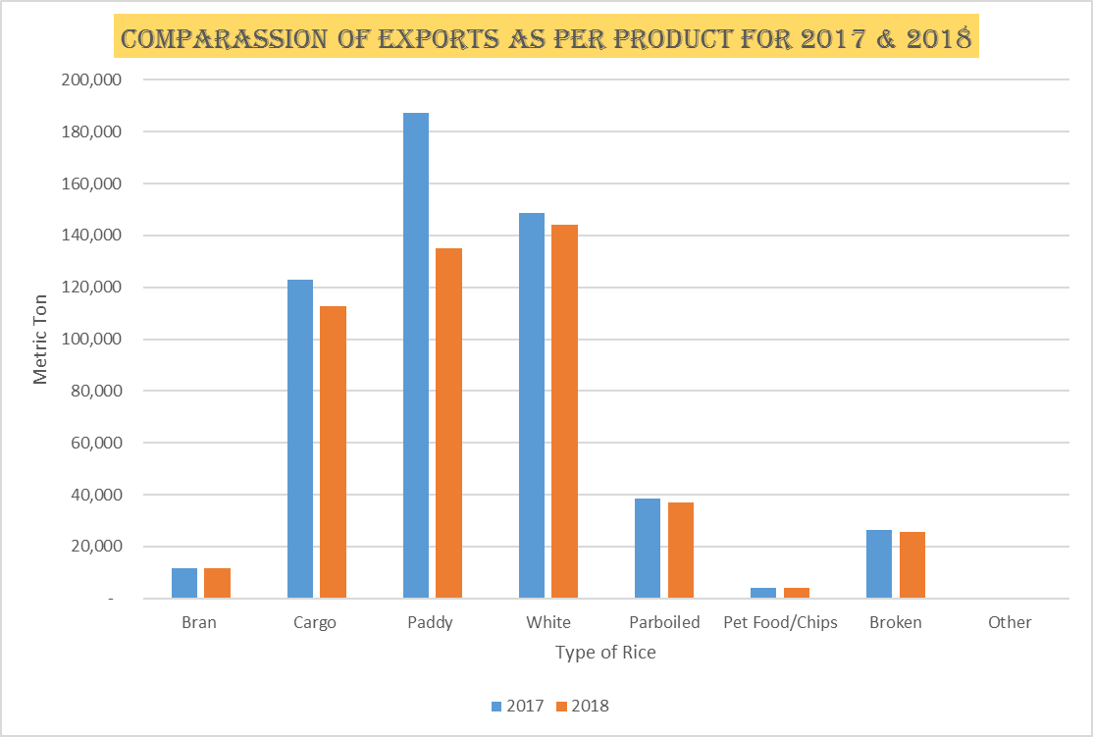

**Shipping & Logistics**

For the year 2018, the Shipping and Logistics Unit (SLU) of the Board took part in facilitating the delivery of government to government rice contracts and worked in collaboration with all rice stakeholders in achieving the Board’s mandate.

**Activities of the SLU**

1. Coordinated GREMA’s (Guyana Rice Exporters and Millers Association) allocation of weekly rice quotas to millers as per shipping schedule;
2. Coordinate GREMA’s re-allocation of weekly rice quotas to millers to avoid short shipments;
3. Booking shipments with shipping lines as per shipping schedule;
4. Compiled packing list from our suppliers with all container details for shipping lines;
5. Submitting shipping instructions to generate draft bill of lading for shipments done during the month;
6. Liaised with the marketing department in the preparation of final documentation for consignee;
7. Coordinated locally and internationally with shipping lines and GRDB agent to ensure safe cargo arrival,
8. Visited packaging facilities and loading ports.

These activities are all important and are key for the smooth flow of operations the SLU is responsible for.

### 

### **White Rice Shipments to Panama**

While rice millers continued exporting to their traditional rice markets, efforts by GRDB to secure government to government rice contracts for 2018 were initiated and were successful.

The year 2018 commenced with the GRDB securing Panama’s commitment to purchase 27,273 tonnes (600,000.00 quintals) of rice through three contracts.

As seen in figure 1.1 below, upon Panama’s request, rice shipments commenced in March of 2018 with contract, FF-022-2018, for 200,000 quintals which concluded in May 2018. No GRDB Panama rice shipments were done for the months June and July, 2018 because of delayed payments from IMA on contracts already delivered. Shipments recommenced in August 2018, on contract FF-025-2018, when payments were received from IMA.

**Fig 1. :** *Showing the total rice shipped to the Panamanian market for the month of January to December, 2018.*

Shipments on contract FF-025-2018 recommenced in late November 2018 and said contract was completed in the same month. In December 2018, two shipments on contract FF-026-2018 were done which concluded all GRDB Panama shipments for 2018 with a total of 434,227 quintals/19,700 mts (72.37%) of the 2018 purchase commitment from Panama)

For the reporting year, white rice shipments to Panama were done by the **Compagnie Maritime d'Affrètement (CMA) C**ompagnieGénérale Maritime (CGM and Sealand/Maersk shipping lines.

**ANTAD 2018**

GRDB participated in Expo ANTAD 2018, Guadalajara, Mexico to promote Guyana's rice and its industry, and to strengthen and develop new rice contacts and networks with various rice companies and food distributors.

Expo Antad & Alimentaria Mexico 2018 was organized by The National Retailers Association of Mexico, A.C. (ANTAD) and Alimentaria. This expo was held March 06 to 08, 2018 at the Expo-Guadalajara in Guadalajara City, Mexico.

**EXPO ANTAD Guadalajara-México 2018**

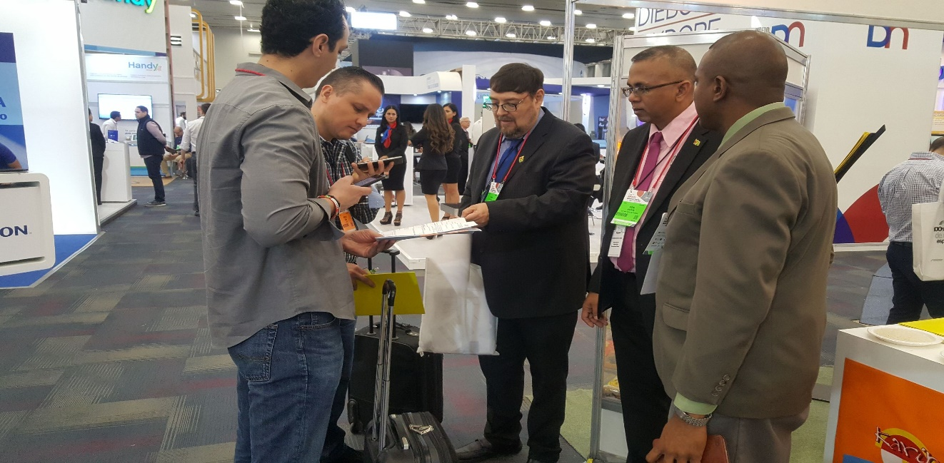

**Visitors being shown the process for the import of Guyana’s rice into Mexico**

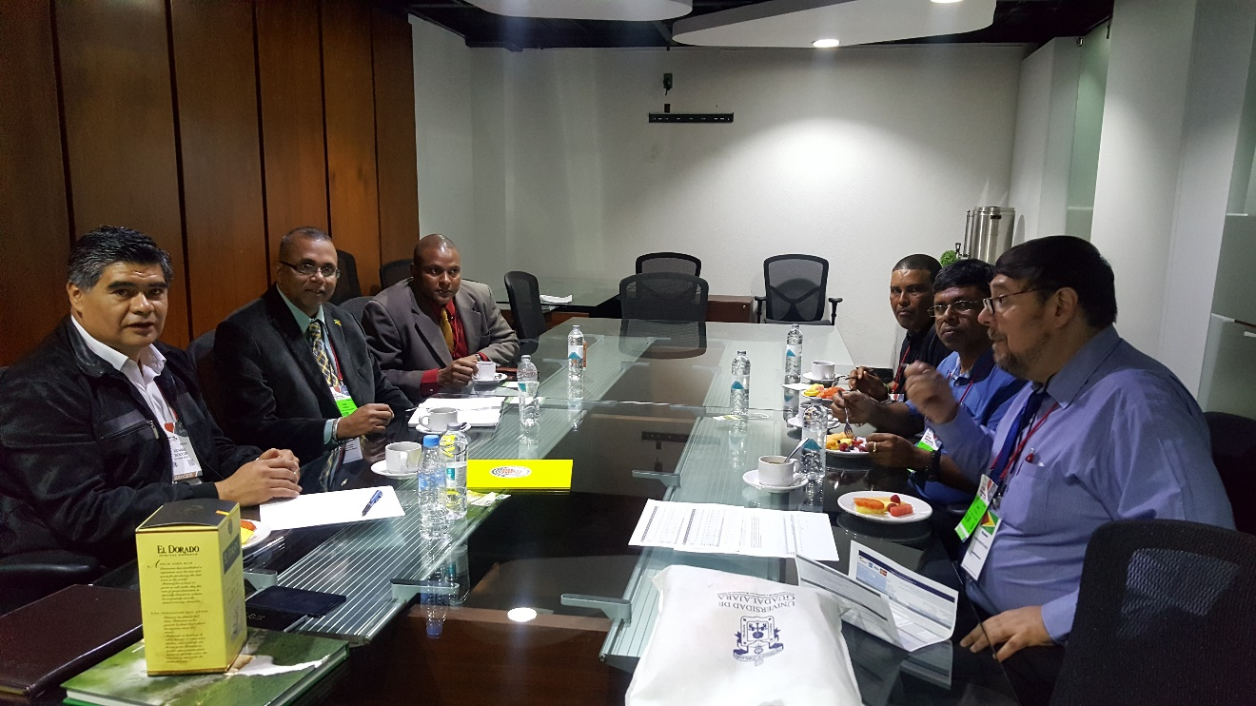



**Meeting with Mr. Ricardo Mendoza of the Mexican Rice Council and the GRDB and GREMA Team.**

**RESEARCH**

**PLANT BREEDING**

1. **Performance of New Rice Varieties**

A new paddy variety, GRDB 15, was released along with its’ production and agronomical package at the end of the first crop of 2018. This variety is a high yielding variety and was released in time for cultivation in the second crop of 2018.

During 2018, GRDB 10 remained the number one variety cultivated (52%), followed by GRDB 12 (6%) and GRDB 14 (5.6%). In relation to the varieties sown first Crop 2109; the leading variety was GRDB 10 (51% and a total area of 10,379 ha), while GRDB 15 accounted for 19%) as of December 31, 2028.

Paddy productivity in Guyana moved from 5.5 t/ha in 2017 to 5.8 in 2018.

1. **New Genotype Released for Commercial Cultivation (FG12-49)**

The release of a strain for use as a variety is based on conclusive demonstration of its superiority over the best existing variety (included as check in the evaluation trials) in yielding ability or some other feature of economic importance, such as disease resistance, tolerance to lodging, quality traits, etc. New strain (FG12-49) has consistently demonstrated a yield advantage of more than 10% over the seasons as compared to the popular check GRDB 10..

**On Farm Trial Spring 2018:** The new strain FG12-47 (named GRDB 15) indicated superior performance over the most popular variety (GRDB 10) in On Farm Trials at thirty three locations across all the main rice growing regions in the country in plot size ranging from one to six acres in the first crop of 2018. GRDB 15 demonstrated higher grain yields averaging 7.1 t/ha (46 bags/ac) (Fig 1) in comparison to GRDB 10 with 6.0 t/ha (39 bags/ac) which represented a yield advantage of 17.9%. Also the candidate variety (GRDB 15) recorded no lodging while 20% was noted for GRDB 10. At the end of the first crop, it was recommended that GRDB 15 being released as a new rice variety for commercial cultivation in Guyana. Over 5000 acres across the country was sown with GRDB 15 for the second crop 2018.

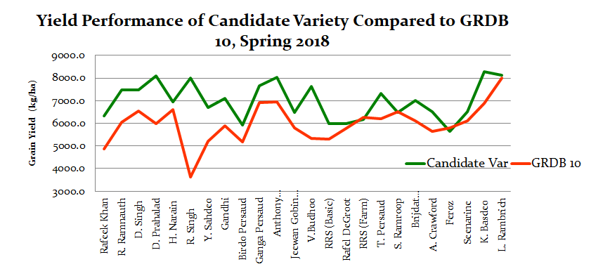

**Figure 1: Yield (Kg/ha) Performance of GRDB 15 as compare to GRDB 10**

**On-Farm Verification Trial Autumn 2108:** The On Farm Verification trials continued during the second crop 2018. During the second crop of 2018, similar trend observed where GRDB 15 demonstrated higher grain yield average of 6.6t/ha (Fig 2 and 3a) in comparison to GRDB 10 with 5.7 t/ha , with GRDB 15 showing less than 5% lodging while GRDB 10 showed 15 % lodging (Fig 3b). This variety quickly gaining acceptance among farmers. It has become the second most popular variety as at December 31, 2018.

**Figure 2: Yield (Kg/ha) Performance of GRDB 15 as compare to GRDB 10**

**Figure 3: Yield (Bags/ac) Performance of GRDB 15 as compare to GRDB 10**

**(a) and Lodging percentage (b) of both varieties during Autumn 2018**

1. **Advanced Yield Trials (AYT)**

Three multi-location trials were conducted at Rice Research Station, Black Bush Polder, and Anna Regina during the first two seasons. Fifteen elite strains were evaluated during the first and second crop of 2018 and three cheeks (GRDB-10, 12 and 14) in a Randomize Block Design with three replications.

Significant differences in grain yield among genotypes were observed at the different locations during the first crop of 2018. Eight strains viz. FG12-23, FG12-49, FG12-259, G14-10, G15-11, FG 14-43, G13-126 and GRDB 12) showed an overall average of over 8 t/ha (over 51 bags/ac @ 140 lbs each). Most of the lines showed good tolerance to lodging over the three locations.

During the second crop similar performance were noted among the strains tested. FG 12-49 out yielded all strains over the two seasons. Fifteen strains were selected for further testing in 2019 while four strains viz. G13-103, G16-107, G13- 114 and G13-123 were not selected for further studies.

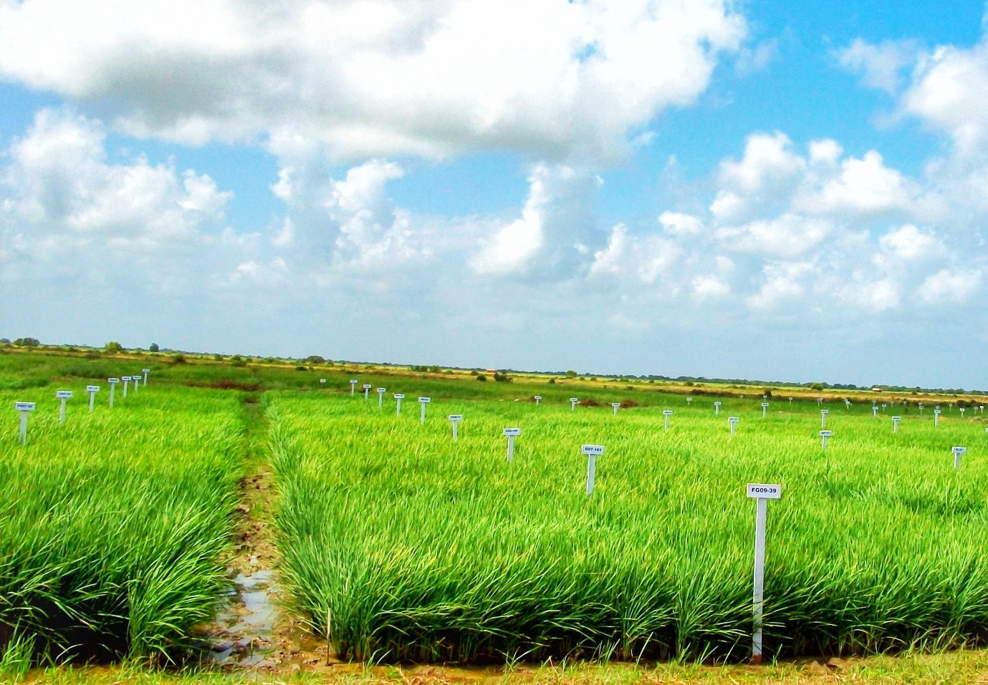

1. **Advance Yield Trails (Scented)**

In 2018, the Department continued its focus on developing aromatic strains. Nineteen (19) Scented strains were studied over the two seasons of 2018 in a Randomize Block Design with three replications at the Research Station in order primarily to determine the yielding ability and agronomic traits of strains which were found to possess aroma.

High yielding check GRDB 15 yielded 9.3 t/ha which was significantly (P= 0.05) higher than all other strains during the first crop. Nine strains (G13-126, G13-118, G13-114, G13-117, G13-125, G13-110, G13-113, G13-115, G13-116) showed similar grain yield to check variety GRDB 10 (7.3 t/ha). In the second crop High yielding check G13-123 and G17-138 yielded 5.5 t/ha and 5.4 r/ha respectively, which was significantly (P= 0.05), higher than all other strains including the high yielding check GEDB 15. Fourteen strains were selected for further testing during the first crop of 2019 to confirm the performance of these strains.

1. **Observational Yield Trial (OYT)**

Ninety nine strains strain were studied along with two checks in both the first and second crop in an augmented design for initial assessment of yield potential and other important characters at the Research Station. The yield potential of the strains tested ranged between 4.87 t/ha (G17-130) and 11.85 t/ha (G17-109). The check variety GRDB 10 and GRDB 15 (FG12-49) yielded 10.55 and 10.81 t/ha respectively After testing in the first season, 82 strains were retained for further studies in this trial while seventeen advanced breeding lines were included in the second crop trial. During the crop seven promising strains (FG12-19, G16-110, G17-109, G17-116, G18-02, G18-04, G18-05) were promoted to be tested in the Advanced Yield Trial in 2019. Fifty three entries were retained for further studies while 46 entries were not selected for further development work.

1. **Variability and Germplasm**

A total of seventy three crosses were successfully made to create variability in the crop of 2018. Hybridization was aimed at creating variability for increasing yield potential, salt tolerance, aroma, submergence tolerance, and plant type. The twenty six crosses made in the second crop of 2018 was successfully raised in F1 population in the first crop of 2019. During this crop a total of 3,644 progenies (F3 – F13 generation) was grown and approx. 3,000 single plant selections were taken, which will be further evaluated in the spring crop of 2019. Seventeen and forty six advanced breeding lines were selected bulked respectively in the first and second crop 2018, which were promoted to the initial yield testing and strain purification in 2019 is the subsequent season. A germplasm of 4000 accession was maintained, while 200 breeding lines were received from FLAR.

1. **Strain Purification**

Four hundred and six strains (406 were purified during second crop of 2018. These are entries originated from AYT, OYT and Pedigree. The strains were grown in progeny rows (5 - 25 per strain) for the purpose of purification. Over three hundred and thirty nine (339) strains were recommended for further purification in first crop of 2019.

1. **Seedlings Emergence**

Studies were conduct to evaluate the ability of new rice strain , FG 12-49, to emerge from different depths of standing water *viz.*7.5 cm, 15 cm, 22.5 cm (3, 6 and 9 inch). FG 12-49 showed excellent extra early vigor by emerging from all three depths of water.

1. **Maintenance Breeding and Seed Production**

More than 15,000 progenies of all the varieties were grown, and studied during the two seasons. The genetic purity of each variety was maintained and more than 15,000 selections were made.

More than 6,000 kg of pre-basic seed (for all the varieties) were produced over the two seasons of 2018. Approximately 1200 tonnes of basic seed were produced from ten varieties (Rustic, GRDB 10, GRDB 12, Aromatic, GRDB 14, G98-22-4, G98-196, 98-30-3, G98-135, GRDB 15), over the two season at the Research Station. Seed generated here were supplied to the seed production unit of the Research Station and the remainder were sold to farmers to improve their stock.

**PLANT PATHOLOGY**

1. **Screening of rice germplasms for resistant against blast disease (*Pyricularia oryzae* (Cav.)**

During the spring and autumn season of 2018 at total of thirty seven hundred and forty seven (3,747) rice germplasm were evaluated against blast (*P. oryzae*) disease. Those evaluated included advanced breeding materials as well as pedigree material. The multi-location testing was conducted at Canje, Black Bush Polder, Onverwagt Back and Wales. The method adopted was the Upland Blast Nursery (UBN). More than 90 % of the advanced germplasms expressed highly resistant to moderate resistant, while as much as 99% of the pedigree germplasm expressed highly to moderately resistance. The susceptible check *cv.* Rustic recorded susceptible to highly susceptible blast disease reaction through the experiment.

1. **Fungicides Screening and Disease Management Trials**
   1. **Foliar application of fungicides for management of rice diseases**
2. **Blast (*P. oryzae*) disease screening trial:** Eight fungicides *viz.* Antracol 70WP, Rodazim 50 SC, AmistarXtra 28 SC, Tantor 25 SC, Glory 75 WG, Tridium 70 WG, Carbendazim 50SC and Fugione; three plant extracts *viz.* Black sage, Bale tree and Madar plant along with an untreated control were evaluated against blast disease under field conditions during spring and autumn season 2018. Treatments with these fungicides and plant extracts has given promising results, with high level of control of the blast disease and also showed a positive influence for grain yield. Treatment with Black sage extracts and the fungicide *viz.* Tradium and Rodazim demonstrated better control when compared to other treatments over both seasons.
3. **Sheath blight (*R. solani*) disease screening trial:**Ten fungicides *viz.*Rodazim 50 SC, Amistar Xtra 28 SC, Tantor 25 SC, Glory 75 WG, Tridium 70 WG, Antracol 70WP, Serenade 1.34 SC, Manzate Pro Stick TM, Carbendazim 50SC and Fugione were evaluated against sheath blight disease during both cropping seasons of 2018. During the first season the fungicides Fugi-One and Serenade1.34 SC was demonstrated greater control of sheath blight disease as compared to the other fungicides treatment. Also Manzate, Carbendazim and Rodazim showed promising results, as they were able to effectively control the sheath blight disease. Similar results were obtained from these fungicide treatment in the second season.
   1. **Evaluation of fungicides as seed treatment**

Eight fungicides (Amistar Xtra 28 SC, Tantor 25 SC, Glory 75 WG, Tridium 70 WG, Antracol 70WP, Rodazim 50 SC, Carbendazim 50SC, and Manzate Pro Stick TM) were evaluated in laboratory and pot culture to determine their effect on seed germination and vigour. The results from this seed treatment trial showed that seed treated with these fungicides has given promising results. Slightly higher percentage germination and seedling vigour was observed in seedlings treated with some chemicals (Carbendazim and Amistar) as compared to the untreated control. The results therefore indicate that apart from acting as a fungicide some of these fungicides can also add to the vigour of seedlings.

1. **Studies on grain discoloration**

***Field trial results:*** During spring season 2018, nine fungicides (AmistarXtra 28 SC, Tantor 25 SC, Glory 75 WG, Tridium 70 WG, Antracol 70WP, Carbendazim 50SC, Manzate Pro Stick TM, Fugioneand Rodazim 50SC) along with an untreated control were evaluated under field condition at Burma back. All fungicidal treatment recorded significantly lower percent grain discoloration incidence as compared to the untreated control. Out of which these treatment *viz.* Amistar Xtra 28 SC at 300 ml/ac; Glory 75 WG at 600 and 1000 g/ac; Antracol 70WP at 1000 g/ac and Carbendazim 50SC at 300 ml/ac, showed a more than 50 percent reduction in the incidence of grain discoloration as compared to the untreated control as well as a positive influence in terms of grain yields. The best preforming treatments was selected for further larger plot demonstration exercise within farmer’s fields across the rice growing region to demonstrate the findings and confirm the results.

***Demonstration plots results*:** The treatment with AmistarXtra 28 SC; Glory 75 WG; Antracol 70WP and Carbendazim 50SC consistently showed higher level (greater than 45 percent) reduction in the incidence of grain discoloration as compared to the untreated control within the demonstration plots. Also, these fungicide treatments expressed positive influence on yield parameters and higher grain yields. This seems to suggest that these fungicides may not only give a significant reduction in the incidence of grain discoloration (black tip) but may also have influence on the overall grain quality and yield.

1. **Disease Monitoring and Surveillance**
2. **Monitored the incidence of rice diseases on-station and farmers’ fields across the country**

The incidence of the four major rice disease (*Pyricularia oryzae; Bipolaris oryzae; Rhizoctonia solani* and*Sarocladium oryzae*) was assessed thought out the spring and autumn season of 2018 for the seed production fields on station. Low incidence of brown spot (*B. oryzae*) with scores ranged from 2 to 4 and sheath blight with scores ranged from one to three was observed in few of the fields. Suspected blast lesions (*P. oryzae*) and sheath rot (*S. oryzae*) disease symptoms were observed during the second season with a maximum score of two for both diseases. Isolated and sporadic cases of very low to no incidences of the for major rice diseases was observed and reported from farmers across the country. Wherever disease was recorded the appropriate recommendation was provided to the farmers for the management of the particular disease.

1. **Disease Severity Study**

In this trial 34 advance rice genotypes from the advance yield trials and 14 commercial varieties including a check *cv.* Rustic were assessed, under low land irrigated condition during spring season 2018. In general, very low level of blast (*P. oryzae*) with scores of 1 and brown spot (*B. oryzae*) disease with scores of 2 to 3 were observed on some of the genotypes. No incidence of sheath blight or sheath rot was observed on 47 genotypes with the exception of the check *cv.* Rustic which recorded an average disease score of 4 to 5 for the 4 major diseases.

1. **Laboratory culture and diagnosis of rice diseases**

Rice plant and grain samples with signs and symptoms of abnormalities were received, processed and analyzed within the Plant Pathology laboratory. The assessment found the 4 major rice pathogens (*Pyricularia oryzae; Bipolaris oryzae; Rhizoctonia solani* and*Sarocladium oryzae*) to predominant among the samples diagnosed. Also, the other minor pathogens such as *Ustilaginoideavirens, Aspergillus* sp., *Curvularia*sp. and *Alternaria* sp. Were observed. In addition, there were few cases where no sign of microorganism were observed in samples processed. This likely to suggest that the abnormal symptom was not due to a pathological effect, but could have been due to some other reason.

**ENTOMOLOGY**

1. **Insecticide Evaluation**

Eight insecticides *viz.* Renova (Thiamethoxam), Matador 10EC (Carbosulfan), Triazophos (Triazophos), Super Capre (Acetamiprid), Ecotrol (Rosemary oil, Geraniol and Peppermint oil),Sydbar (Imidacloprid + Abamectin), Ethephon (Ethephon) and Jackpot (Lambda cyhalotrin) were evaluated under laboratory and field conditions and compared with two checks *viz.* control (water only) and Pronto (Imidacloprid). Results from the laboratory bioassays showed knockdown of the bugs within the first 15 minutes of introducing them to panicles treated with Renova, Matador, Triazophos, Super Capre, Sydbar, Jackpot and Pronto. This indicate that there is a fast knockdown by these insecticides. Paddy bugs that were introduced to panicles treated with water alone and control lived for more than four days afterwards.

Under field conditions, the number of paddy bugs present per plot was recorded 36 hours after the treatments were applied. Renova, Sydbar and Jackpot showed the lowest number of bugs present in the treatments, which was not significantly different from Pronto but significantly different from the control. These have been identified for advanced screening and evaluation.

1. **Investigation of the ‘unknown’ variety**

During a survey, it was noted that the foreign varieties grown are about three (3) which originated from Brazilian and one (1) which originated from Surinam. The most popular one is the Brazilian 90/100-day. These varieties are grown on over 7800 hectares by more than 700 farmers.

1. **Incidence of emerging insect pests**

An investigation was done to assess the incidence of emerging insect pests in Guyana, namely plant hopper, leaffolder and grasshopper. Plant hopper and grasshopper were recorded from all the regions, including Santa Fe, Region 9. Although the symptoms of plant hopper was absent in the fields sampled, the number of hoppers caught indicate that this insect must be closely monitored.

1. **Behavior of paddy bugs**

Assessment of the relationship between rainfall pattern and migration pattern of paddy bugs revealed that paddy bugs are directly influenced by rainfall that occurs during specific lunar phases. The migration timings were also linked to the availability of food, whether it is the rice crop during the reproductive and ripening phases or the abundant presence of blooming alternate hosts.

1. **Economic threshold evaluation**

A study was done to assess paddy bug damage by introducing varying number of bugs (0, 1, 2, 3, 4 and 5 pairs) each at the different stages of panicle development (flowering, milk/dough and ripening stages) and allowing the bugs to feed for different periods (12 hours at night; 12 hours during the day, 24, 48 and 72 hours. This experiment will conclude in 2019.

**AGRONOMY**

1. **Seed Density and Nitrogen Levels of GRDB 15**
2. **Effect of varying nitrogen levels on grain yield of GRDB 15.**

At Rice Research Station (RRS), application of highest nitrogen rate (125 kg ha-1) produced the highest grain yield (8403 kg ha-1) and was at par with application of 50, 75 and 100 kg N ha-1. Lowest grain yield (6776 kg ha-1) was recorded when no nitrogen was applied and was at par when 50 kg N ha-1 was applied. At Black Bush Polder, 100 kg N ha-1 recorded highest (7015 kg ha-1) grain yield and was at par with 75 and 125 kg N ha-1. However, 100 kg N ha-1 was significant over 0 (4739 kg ha-1) and 50 kg N ha-1. At both locations, it can be concluded that an application of 75 kg N ha-1 will produce optimum yield.

1. **Interaction effect of seeding rates and nitrogen levels of GRDB 15**

Three seeding rates (80, 120 and 160 lbs per acre) and nitrogen rates (75, 100 and 125 kg ha-1) were evaluated using GRDB 15 showed that neither seed rates nor nitrogen rates affected the grain yield in both locations (BRRS and BBP). Grain yield at BRRS were higher as compared to BBP. There was interaction effect at BRRS between 160 lbs per acre seed and 100 kg N ha-1 which recorded highest grain yield (5649 kg ha-1) and was statistically on par with combination of 120 lbs seed rate with 75 kg N ha-1 and 80 lbs seed rate with 100 kg N ha-1. No interaction was observed at BBP.

1. **Effect of varying seed rates on grain yield of GRDB 15.**

At RRS, application of 100 lbs seeds ac-1 produced significantly highest grain yield (9457 kg ha-1) and was at par with 80, 120 and 140 lbs seeds ac-1. Lowest grain yield (7345 kg ha-1) recorded when lowest seed rate of 60 lbs ac-1 was used. At Black Bush Polder, although grain yield slightly increased with increasing seed rate, it was not significant. It can be concluded that application of 80 to 100 lbs of quality seeds is adequate to produce economically best grain yield.

During the second crop, four seeding rates (80, 100, 120 and 140 lbs per acre) were evaluated on variety GRDB 15 and showed no significant differences in grain yield. Highest yield (5395 kg ha-1) was actually recorded with 80 lbs per acre. These results confirmed earlier experiments done where a seed rate of 80 to 100 lbs per acre is sufficient for newer varieties. The mean grain yield recorded was 5055 kg per ha.

1. **Optimization of nitrogen levels and scheduling for higher yield for GRDB 13.**

Increase in the nitrogen application rate from 75 to 125 kg ha-1 did not significantly increase the grain yield. Highest grain yield (7374 kg ha-1) was recorded when nitrogen was applied in three splits (1/4:1/2:1/4) and was significant as compare to when nitrogen was applied in 2 splits (3/4:1/4), 3 equal splits and 4 equal splits. Nitrogen applied in 2 equal splits recorded similar grain yield to ¼:1/2:1/4. The combination of 100 kg N ha-1 applied ¼:1/2:1/4 recorded highest grain yield.

1. **Effect of different sources and rates of nitrogen**

Highest grain yield was recorded with application of 100 kg N ha-1 with conventional urea in 3 splits application and was at par with 75 kg. This was significant when compared to similar rate of nitrogen applied through slow release nitrogen fertilizer (SRNF). A general trend was noticed whereby at similar nitrogen rate, there was a consistent decrease in grain yield using SRNF.

1. **Optimization of potassium levels and splits for higher grain yield**

All rates of granular (40 and 60 kg K2O ha-1 in single and two splits) and foliar (Best K at 1.0 and 1.5L ha-1) application of potassium recorded significantly higher grain yield as compare to no potassium application. The application of single application of 40 kg K2O ha-1 was at par with no potassium application.

1. **Optimization of NPK for higher grain yield.**

Of the 3 levels each of N (75, 100 & 125 kg ha-1), P (30, 40 & 50 kg ha-1) and K (40, 50 & 60 kg ha-1), the combination of 100:30:60, 75:50:40 and 125:30:60 NPK recorded significantly highest grain yield (8882, 8409 and 8159 kg ha-1, respectively).

In the second cropping season, the combination of 125:30:50 recorded the highest grain yield (6658 kg ha-1). Lowest grain yield (4849 kg per ha) was recorded with combination of 75:30:50. Mean grain yield for all treatments was 5764 kg per ha.

1. **Evaluation of various nutrition products for increase in grain yield.**

Of the two trials established, the different products did not significantly influence the grain yield as compared to when 100 % recommended NPK was applied. During the second crop, several foliar fertilizers (Jumpstart + Keyplex, Foliar complex, Boron + Zinquex, Quicksol, Eveergreen and Nutrimax AC) containing varying types and levels of nutrients were evaluated to determine the level of increase in grain yield in addition to the recommended dose of NPK. Nutrimax AC recorded the highest mean number of filled grains per panicle (153.7) while both treatments of Jumpstart + Keyplex and Evergreen recorded the least value (105.4). The mean number of filled grains per panicle for all treatments was 125.8. There was no statistically significant difference among treatments with respect to grain yield. Boron + Zinquex recorded the highest mean grain yield (5620 kg per ha) while Jumpstart + Keyplex recorded the least value (4582 kg per ha). The mean grain yield for all treatments was 5227 kg per ha.

1. **Substituting recommended granular fertilizer for foliar nutrition.**

Application of different combination of foliar nutrition alone recorded lowest grain yield. When 100% recommended dose of granular fertilizer is applied in combination of the different foliar nutrition, the grain yield were statistically similar to when only 100% recommended granular fertilizer alone applied. However, 75% recommended dose granular fertilizer with foliar nutrition recorded similar yields to 100% RDF. The milling yields and economic analysis on inputs needs to be determine.

1. **Date of sowing.**

Of the 3 sowing dates done, sowing on Dec 21 recorded highest grain yield (8960 kg ha-1) then followed by Nov 30 (7307 kg ha-1), and Dec 7 recording lowest yield (6133 kg ha-1). On Nov 30 sowing, GRDB 15 recorded highest grain yield (8677 kg ha-1) and was at par with GRDB 12, 13, 14 and 30-3. GRDB 10 and 196 recorded lowest grain yield. On Dec 7 sowing, all varieties produced similar yields. Dec 21` sowing shown that GRDB 12 recorded highest grain yield (9044 kg ha-1) and was similar to GRDB 10 (8962 kg ha-1), both being on par with GRDB 14, 15 and 30-3 while lowest yield was with 196 (6289 kg ha-1).

Similar trial conducted in the second season using different sowing dates, the yields recorded in the June 15 sowing were lower as compared to July 05 sowing by 1778 kg per ha. In the June 15 sowing, grain yields recorded in descending order was GRDB 13>GRDB 10>GRDB 15>GRDB 14>GRDB 12>G98-196 where as in July 05 sowing it was GRDB 14>G98-196>GRDB 10>GRDB 13>GRDB 12>GRDB 15.

1. **Effect of different rates and type of seed treatment on grain yield.**

Cruiser at 1.25 ml kg-1 seeds recorded highest grain yield (7613 kg ha-1) and was at par with Cruiser 1.0, 1.5 ml and seed soak at 3.75 ml kg-1 seeds. Also, it was significant over seed soak at 1.25 and 1.5 ml kg-1 seeds and no seed treatment. The present recommendation of 1.25 ml kg-1 seeds still hold.

1. **Slow Release Nitrogen Fertilizer**
2. **Application Rates and Timing of Slow Release Nitrogen Fertilizer**

Increasing the nitrogen application rates of SRNF from 75 to 125 kg ha-1 did not significantly influenced the grain yield. The application of regular urea in 3 splits produced significantly highest grain yield (9038 kg ha-1) when compared to application of SRNF before sowing and 7 DAS. However, it was at par when SRNF was applied 14 and 21 DAS yielding 8945 and 9045 kg ha-1 respectively. The results observed at BBP were different from that at BRRS where SRNF performs better at BBP but on par with regular urea.

In the second season, slow release nitrogen fertilizer was applied at three rates (50, 75 and 100 kg N ha-1) at four different application timing (just before sowing, 7, 14 and 21 DAS) and was compared to regular three split application of urea. Results recorded showed that slow release nitrogen fertilizer at 75 kg N ha-1 applied 14 days after sowing recorded highest grain yield (6446 kg ha-1) as compared to similar nitrogen level applied just before sowing (5175 kg ha-1). All other combination of nitrogen levels and timing of application were on par.

1. **Slow release nitrogen fertilizer compared to urea**

Slow release nitrogen fertilizer at four rates (50, 75, 100 and 125 kg N ha-1) were compared to regular urea at similar nitrogen rates. Results obtained showed no significant difference among nitrogen sources and rates. The mean yield for all treatments was 4316 kg per ha.

1. **Weed Management**
2. **Early post emergent weed control**

The dominant weeds species in the trial were Jhussia (44.6%), Schoonard grass (44.4%), Soap bush (5.6%), Wild clove (4.4%) and Duckweed (1.0%). Weed count taken 14 days after herbicide application shown that treatments where herbicides were applied recorded significantly lower weed count that ranges between 14.7 to 43.7 weeds m-2 as compared to no herbicide application (185 weeds m-2). Similarly trend in grain yield was also observed. Weed index (WI) recorded was in the range of 1.5 t o5.5.

1. **Pre-emergent weed control**

Schoonard grass was dominant in the trial with 59.2% followed by Jhussia (28.0%), Soap bush (6.5%) Wild clove (2.7%), water sedge and duckweed with 1.8% each. Weed count 14 days after herbicide application has shown that Nominee (check) recorded best weed control and was significant when compared to no herbicide application. All the pre-emergent herbicide treatments recorded on par weed control but were not significant as compared to the check or weedy plot.

1. **Survey**

A weed survey was conducted to identify the most common and prevalent weeds associated with rice in the different rice growing regions and the level of infestations. It showed that red rice is the dominant weed found in all the regions at varying levels of infestation.

1. **Efforts to manage iron toxicity at Whales**
2. **Effect of two levels of potassium on limed and non-limed soil.**

Mean grain yield of different levels of potassium (20 and 40 lbs MOP ac-1) on non-limed soil produced grain yield of 1569 kg ha-1 while on limed soil the grain yield was 3448 kg ha-1, a difference of 1878 kg ha-1. There was no significant difference in grain yield from the two levels of potassium. On a regular soil where the iron content is normal, the different rates (20 and 40 lbs MOP ac-1) of potassium did not influence the grain yield.

1. **Screening of foliar applied fertilizers containing mostly micronutrients**

The different products screened did not influence the grain yield.

1. **Varying levels of Potassium to alleviate Iron toxicity**

A different trial was conducted in the second season by application of varying levels of potassium on variety GRDB 10. Five (5) levels (55, 110, 165, 220 and 275 lbs. ac-1) of potassium in the form of Muriate of potash was applied to GRDB 10 at 21 and 42 DAS. The results does not indicate any significant difference among the levels of Potassium applied.

**SEED PRODUCTION**

1. **First Crop 2018**

|  |  |  |  |  |  |  |  |  |  |  |
| --- | --- | --- | --- | --- | --- | --- | --- | --- | --- | --- |
| **Variety** | **Acres** | **140 lbs bag** | | | **Productivity**  **(bags/ac)** | **Field Certification** | | | | |
| **Seed** | **Sold to mill** | **Total** | **Basic** | **C1** | **C2** | **Com** |
| GRDB 10 | 160.04 | 6,091 | - | 6,091 | 38.06 | 366 | 4,571 | 1,154 | - |
| GRDB 12 | 49.58 | 908 | 1,035 | 1,943 | 39.19 | - | - | - | 1,943 |
| GRDB 13 | 30.94 | 835 | 461 | 1,296 | 41.89 | - | 1,296 | - | - |
| GRDB 14 | 55.56 | 2,251 | - | 2,251 | 40.51 | - | 2,251 | - | - |
| GRDB 15 | 57.23 | 2,311 | - | 2,311 | 40.38 | - | 2,311 | - | - |
| G 98-196 | 26.33 | 869 | - | 869 | 33.00 | - | - | 869 | - |
| G 98-135 | 12.16 | 379 | - | 379 | 31.17 | - | - | 379 | - |
| G 98 30-3 | 13.83 | 474 | - | 474 | 34.27 | - | - | 474 | - |
| **TOTAL** | **405.67** | **14,118** | **1,496** | **15,614** | **38.49** | **366** | **10,428** | **2,876** | **1,943** |
| **%** |  | **90.42** | **9.58** |  |  | **2.34** | **66.79** | **18.42** | **12.44** |

During the 1st crop of 2018, eight varieties were cultivated for seed purposes on 405.67 acres where a total of 15,614 bags were harvested averaging 38.49 bags per acre. The dominant variety was GRDB 10 accounting for 6,091 bags. Based on field certification, 2.34% was basic, 66.79% Certified 1, 18.42% Certified 2 and 12.44% Commercial.

1. **Second Crop 2018**

|  |  |  |  |  |  |  |  |
| --- | --- | --- | --- | --- | --- | --- | --- |
| **Variety** | **Acres** | **Quantity (140 lbs/bag)** | | | **Productivity**  **(bags/ac)** | **Certification** | |
| **Seed** | **Grains** | **Total** | **C1** | **Com** |
| GRDB 10 | 130.81 | 4,157 | 564.4 | 4,721.4 | 36.09 | 4,157 | - |
| GRDB 12 | 41.91 | 1,429 | - | 1,429 | 34.01 | 1,429 | - |
| GRDB 13 | 23.00 | 764 | - | 764 | 33.22 | 764 | - |
| GRDB 14 | 40.21 | 1,443 | 7 | 1,450 | 36.06 | 1,292 | 151 |
| GRDB 15 | 57.23 | 1,526 | 440.5 | 1,966.5 | 34.36 | 1,526 | - |
| G 98-196 | 26.33 | 908 | - | 908 | 34.49 | 908 | - |
| G 98-135 | 12.16 | 407 | - | 407 | 33.47 | 407 | - |
| G 98 30-3 | 13.83 | 394 | - | 394 | 28.49 | 394 | - |
| G 98-22-4 | 7.83 | 207 | - | 207 | 26.44 | 207 | - |
| **TOTAL** | **353.31** | **11,235** | **1,011.9** | **12,246.9** | **34.64** | **11,084** | **151** |

Seed production cultivated 353.31 ac in the 2nd crop of 2018 producing a total 12,246.9 bags of paddy at an average of 34.64 bags per acre. Of the lot produced, 11,084 (90.5%) certified as C1, 151 (1.2%) as commercial and 1,011.9 (8.3%) sold to the mill as grains. Eight commercial varieties were cultivated whereby GRDB 10 was dominant (33.97%) followed by GRDB 15 (13.58%) and GRDB 12 (12.72%).

**Extension**

# 

# Introduction

The Extension Department continued to develop capacities and sharing technical knowledge to farmers in the areas of best practices, problem solving, management and decision- making during 2018. The department engaged in the process of facilitating, brokering information and advocacy, as it seek to expand its services to improve farmers’ livelihoods. It accomplished these tasks through interventions in the areas of technology transfer, seed production and marketing, data collection and special or supporting activities.

1. **Demonstration 1: Effectiveness of Improved Agronomic Practice**

## Methodology

1. Two plots were selected, one for farmer’s practice and the other for the six point practice
2. Sowing date for both plots was the same and was within the recommended time of planting.
3. Rice variety sown was of high yielding that was bred by the Rice Research Station mainly GRDB 10
4. On the Improved Practice Plot the following was done:

* 55 lbs of TSP + MOP or 110lbs NPK fertilizer was applied at final land preparation.
* High yielding variety was used at a seed rate of 100 lbs per acre
* Seed were treated with Frip (90ml/100 lbs of paddy) prior planting.
* Weed control was done 18 DAS using nominee @ 100g per acre.
* 1st dose urea was applied on moist soil 15-21 DAS @ 110 lbs/ac.
* Irrigation of plot was done 1-5 days after application of the 1st dose urea.
* 2nd and 3rd dose urea was applied 38 and 50 DAS @ 75 and 35 lbs/ac in a reduced water level.

1. The farmer carried out his normal practice on the Farmer Practice Plot.

## Results

**Table 1:** Table showing Average yield of improve practice vs Farmer practice

|  |  |  |  |
| --- | --- | --- | --- |
| **Regions** | **# of demonstration** | **Average yield of Improve Agronomic Practice** | **Average yield of Farmer practices** |
| **2** | 27 | 42 | 37 |
| **3** | 28 | 43 | 37 |
| **4 & 5** | 30 | 40 | 36 |
| **6** | 18 | 39 | 37 |
| **Avg.** |  | **41** | **36** |

**Fig. 1:** Graph showing improved practice vs Farmer practice

A total of 896 farmers were benefitted from the training on the effectiveness of the improved practice.

# Demonstration 2: Chemical Control of Schoonard Grass (Echinochloa glaberescens)

**Methodology**

1. Two 100m2 plots were selected, measured and pinned off in a field infested with Schoonard grass; plot (A) was used as the control measure and plot (B) was the treatment plot.
2. Both plots were drained one day prior to treatment.
3. A one meter square was used randomly in both plots to determine weed count/infestation.
4. Nomina at a rate of 100g per acre was applied 18 DAS in plot (A) avoiding any drift to plot (B).
5. A post weed count was done 5 to 14 days in both plots using the meter square.

## Results

**Table 2:** Average plants before and after Chemical Application

|  |  |  |  |
| --- | --- | --- | --- |
| **Regions** | **# of demonstrations** | **Avg. BCA** | **Avg. ACA** |
| **2** | 70 | 4 | 0 |
| **3** | 32 | 6 | 0 |
| **4 & 5** | 80 | 14 | 1 |
| **6** | 56 | 1 | 0 |
| **Total** | **238** |  |  |

**BCA:** Before Chemical Application

**ACA:** After Chemical Application

**Fig 2:** Graph showing chemical control of Schoonard Grass

# A total of 234 farmers benefitted from the methodology applied to control this weed through the Farmer Field School.

# Demonstration 3: Paddy Bug Demonstration

**Methodology**

1. A plot that was infested with paddy bug was selected.
2. Sweeping the field for paddy bug was done before 8 am and after 4 pm.
3. Fifty (50) consecutive sweeps was done in a zig zag pattern so as to obtain a random representation.
4. A count was done after the 50 consecutive sweeps. Where there were more beneficial insects than paddy bug no application of insecticide was recommended. If there were more active adults and nymphs paddy bug than beneficial insects and above the threshold (25 bugs in 50 sweeps) application of insecticide was recommended early.
5. Pronto at a rate of 15g per acre using two blower per one acre at 7.5g/blower was recommended with a walking distance of approximately 11 footsteps between each blower.
6. The blower was halved with water, and then premixing of chemical was done and poured into the blower then shake thoroughly, the blower was then fill to mark.
7. The nozzle of the blower was adjust and placed on a fixed setting based on the walking distance and above the plant.
8. Fifty (50) consecutive sweeps was done in the treatment field the following day to determine the level of control.

## 

## Results

**Table 3:** Number of paddy bugs before and after treatment

|  |  |  |  |
| --- | --- | --- | --- |
| **Regions** | **# of demonstrations** | **Avg. BCA** | **Avg. ACA** |
| **2** | 81 | 23 | 3 |
| **3** | 49 | 17 | 0 |
| **4 & 5** | 86 | 17 | 1 |
| **6** | 92 | 21 | 4 |
| **Avg.** | **308** | **19.5** | **2** |

**BCA:** Before Chemical Application

**ACA:** After Chemical Application

**Fig 3:** Graph showing Paddy Bugs before and after treatment as per Region

## Discussion:

A total of three hundred and eight (308) demonstrations were carried out throughout the country. Based on the graph region 2 had the highest infestation of paddy bug with a count of 23 in 50 sweeps before chemical application; this was followed by region 6 with a count of 21 bugs in 50 sweeps. It can be seen that control was obtained after chemical application with an average of 2 bugs in 50 sweeps was recorded after chemical application.

# A total of 763 farmers were benefitted from this demonstration through the Farmer Field School.

# Demonstration 4: Demonstration on Red Rice Management using the rope/stick method

**Rope/Stick method**

1. A section of the field which is highly infested with Red Rice was selected
2. Random selection was done by using a meter square to achieve a plant count.
3. Gramaxzone at 100% solution was used.
4. One piece of stick approximately 6 feet was used, wrapped with a highly absorbing cloth affixed tightly on the stick. In the case of rope, a 10ft length cotton rope was used
5. The stick or rope was drenched into the chemical and the excess Gramaxzone squeezed off.
6. The stick or rope was pulled over the infested area touching the leaves and panicle of the red rice plants.
7. A post count was done 3-14 days after and result being noted.

## Results

**Table 4:** Red rice before and after using the rope/stick method

|  |  |  |  |
| --- | --- | --- | --- |
| **Regions** | **# of demonstrations** | **Avg. BCA** | **Avg. ACA** |
| **2** | 78 | 4.4 | 0.4 |
| **3** | 50 | 7 | 0.3 |
| **4 & 5** | 76 | 13.6 | 1.4 |
| **6** | 81 | 6.2 | 0.7 |
| Avg. | **285** | **7.8** | **0.7** |

Fig 4: Graph showing Chemical control of Red Rice

A total of two hundred and eighty five (285) demonstrations were done on red rice control using the rope method; it was observed that Regions 4 & 5 had the highest infestation, followed by Region 3. There was an average of 14 red rice plants counted before chemical application for Regions 4 & 5; while 7 plants were counted in Region 3 before chemical application. Based on the graph it can be observed that there were positive control after the application of chemical on the red rice infested fields. Region 2 had the lowest infestation of red rice.

# Activity: Allocation and Sale of Seed paddy

A total of 23,921 bags of seed paddy were allocated to the various regions for 2018 and out of that a total of 23, 834 were sold to farmers. A total of 5,012 farmers were benefitted from the sale of seed paddy.

**Table 5:** Allocation and Marketing of Seed Paddy

|  |  |  |  |
| --- | --- | --- | --- |
| **Region** | **Allocated** | **Sold** | **Farmers Benefitted** |
| 2 | 4,200 | 4,187 | 1,160 |
| 3 | 2,600 | 2,587 | 554 |
| 4 & 5 | 13,021 | 12,968 | 2,416 |
| 6 | 4,100 | 4,092 | 882 |
| **Total** | **23,921** | **23,834** | **5,012** |

1. **Training of Extension Officers**

Training of Extension Officers is always an important area for the Department, training increases the skills and competency of extension officers which enable them to perform their jobs effectively.

|  |  |  |  |  |
| --- | --- | --- | --- | --- |
| **SN** | **Name of Training** | **Number of Extension Officers** | **Location** | **Delivered By** |
| 1 | Varietal Development | 17 | RRS | Dr. M. Persaud |
| 2 | Management of insects/pest in rice | 15 | RRS | Dr. V. Baharally |
| 3 | Integrated approach to manage red rice | 15 | RRS | Dr. G. Payman |
| 4 | Identification and managing disease in rice | 17 | RRS | Mr. R. Persaud |
| 5 | Communication in Extension and Farmer Field School | 15 | RRS | Mr. B. Persaud |
| 6 | Seed Certification | 14 | RRS | Dr. Veloza |
| 7 | Project Management | 5 | RRS | Mr. N. Hassan |

1. **The Farmers Field School**

The Farmers Field School is a grouped based system of learning which seek to empower farmers to make better decision in relation to the management of their crop. It encouraged participation and is seen as an effective tool in bridging the yield gap. It brings farmers from diverse backgrounds and performance level together, who are able to share their knowledge and experiences thereby motivating each other to improve their practices.

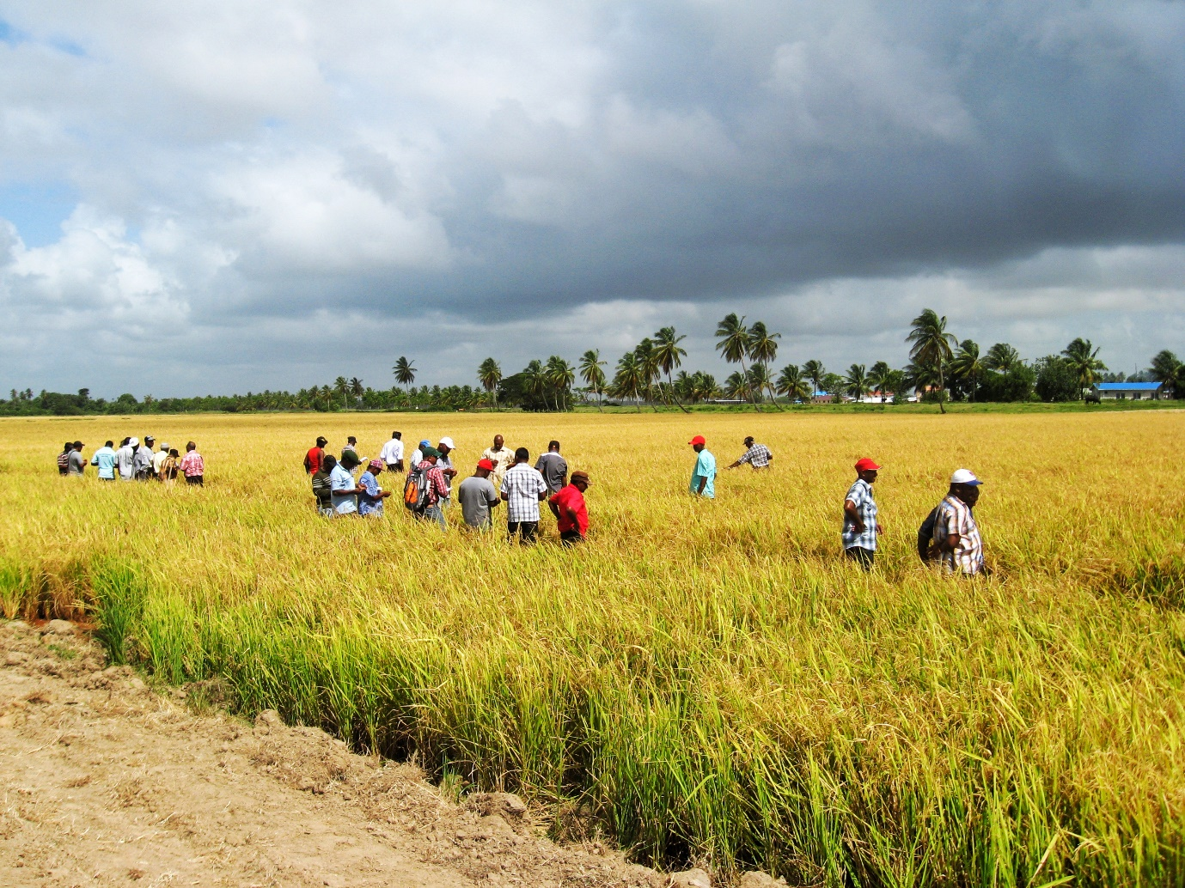

FFS are conducted for a cropping season and can have between 6 to 8 sessions per season.

FFS has evolved from group meetings to a more comprehensive program of on - farm demonstrations, involving farmer’s participation at all levels of the program. This method of participation and learning by doing has proven to be very beneficial to farmers The F.F.S is conducted using comparative demonstrations to illustrate or validate a technology. Farmers meet on a fortnight basis at the plot where data are collected and observations made.

Decisions with regard to the management of the crop are taken based on the data collected and the general observations of the farmers.

The decision is agreed upon by all and it is carried out by the collaborating farmer.

|  |  |  |
| --- | --- | --- |
| **Region** | **# of Schools** | **# of Registered Farmers** |
| 2 | 16 | 457 |
| 3 | 10 | 221 |
| 4 & 5 | 18 | 561 |
| 6 | 12 | 365 |
| **Total** | **56** | **1,604** |

**Quality Control**

# Introduction

# The department functions as mandated by the Guyana Rice Development Board (GRDB) Act of 1994, and the Rice Factories Act of 1998. It is responsible for the grading and certification of paddy, rice and it’s by- products intended for trade in or out of Guyana.

# Five Regional Quality Control Laboratories are operational at the regional offices of GRDB. The Central reference laboratory is located at the Head Office in Georgetown. The laboratories are located as stated below:

|  |  |
| --- | --- |
| **Region** | **Location** |
| 2 | Region 2 Sub-Office, Anna Regina, Essequibo Coast |
| 3 | Region 3 sub-Office, Crane, West Coast Demerara |
| 4 | Head Office (Central Laboratory), Georgetown |
| 4 & 5 | Rice Research Station, Burma, Mahaicony, East Coast Demerara |
| 6 | Region 6 Sub-Office, #56 Village, Corentyne, Berbice |

The workload of the department shifts to accommodate the exports and paddy harvested during any given year.

1. **Mill Licensing**

This year there was an increase in the number of mills being licensed from fifty one (51) in 2017 to fifty four (54) in 2018. These fifty four (54) mills accounted for a total of 303.5 tonnes per hour of milling capacity.

Table 1; Status and Production of Mills Regionally.

|  |  |  |
| --- | --- | --- |
| Region | No. of Mills Licensed | Milling Capacity (mt/h) |
| 2 | 15 | 70 |
| 3 | 9 | 22.5 |
| 4 & 5 | 17 | 157.5 |
| 6 | 13 | 53.5 |
| Total | 54 | 303.5 |

Table 1 shows the status and production of mills within the various regions. It can be seen from the data that the highest numbers of mills licensed were in Regions 4 & 5. This region also recorded the largest milling capacity (157.5 mt/h).

**Table 2: Analysis of the types of Mills**

|  |  |
| --- | --- |
| **Mill Type** | **Number in Operation** |
| Buying Centers | 5 |
| Toll Mills | 5 |
| Milling Capacity Below 5 mt | 18 |
| Milling Capacity 5mt and above | 26 |

Table 2 shows analysis of the types of mills operating country wide. Toll mills are mills which mill paddy on behalf of farmers. Buying Centers purchase paddy only.

1. **License Graders**

In accordance with the Rice Factories Act of 1994, GRDB issued sixty nine (69) licenses to grade paddy and rice. A Grader’s License is issued biannually.

1. **Training**

**4.1 Stakeholder Training**

The annual training course in Rice and Paddy Grading and Quality Management was held in the month of July for persons within the industry. Farmers were also trained in the various regions on the last Friday of every week during the training programme.

**Table 3**

|  |  |  |  |  |
| --- | --- | --- | --- | --- |
| **Date** | Region | **Venue** | **Participants Trained** | **Farmers Trained** |
| July 16th -20th , 2018 | 2 | GRDB’s Region 2 Sub-Office | 14 | 7 |
| July 03rd - 06th , 2018 | 3 | GRDB’s Region 3 Sub-Office | 8 | 10 |
| July 10th -13th , 2018 | 4 & 5 | Rice Research Station | 12 | 5 |
| July 23th - 27th , 2018 | 6 | GRDB’s Region 6 Sub-Office | 8 | 7 |
| **Total** | | | **42** | **29** |

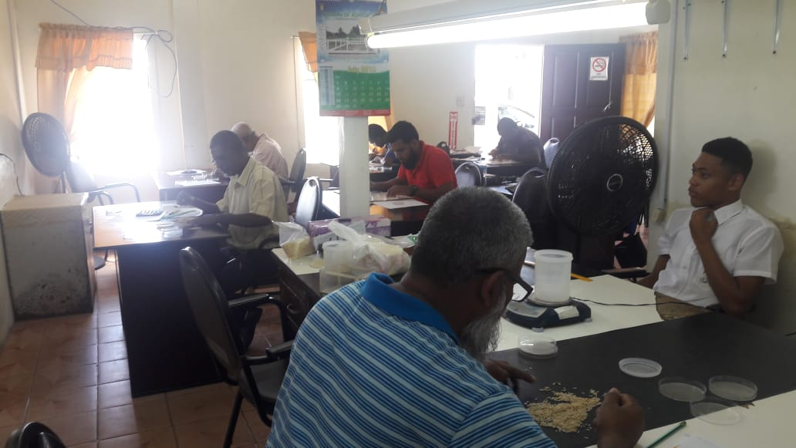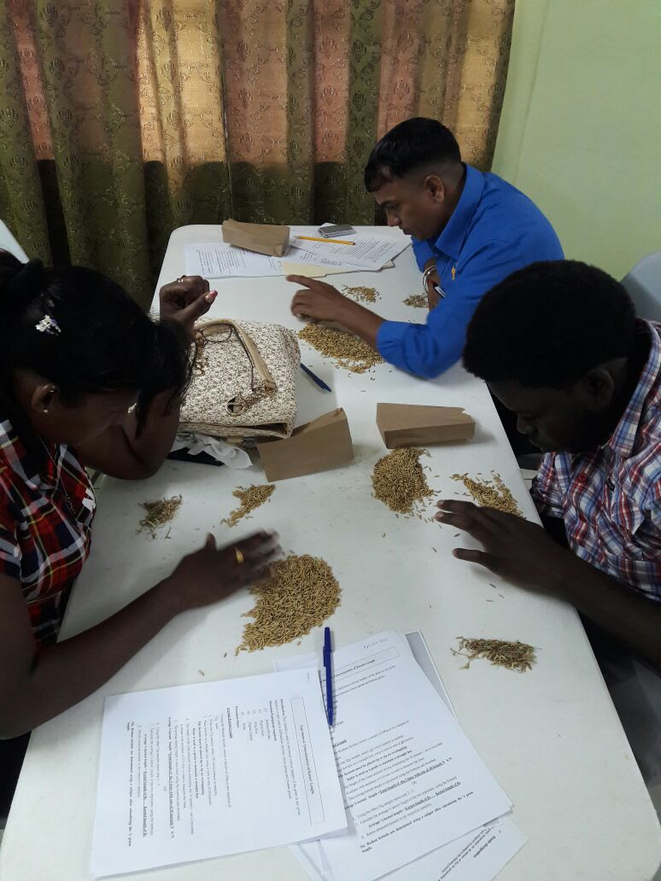

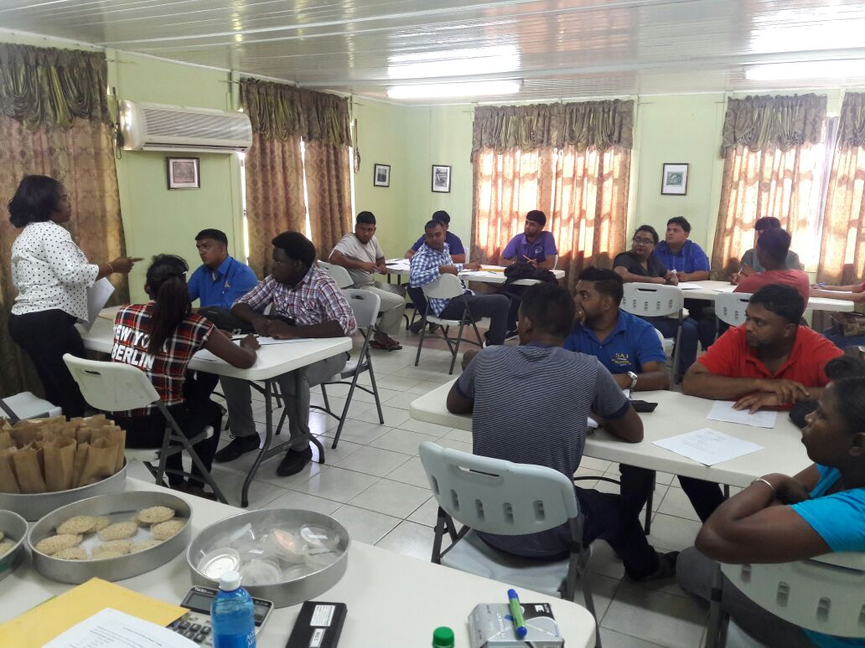 

Participants of the Grader’s License Course

**4.2 Staff Training**

4.2.1 Staff of the Department was trained “in house” as well as externally during the reporting period.

4.2.2 Training were done on:-

1. Grading of White and Parboiled Rice using the revised GYS211:2014
2. Quality System Procedures
3. Seed Certification Training.
4. Enhancing National Quality Infrastructure for Diversification and Trade Promoting.
5. Operation of various types of bodies performing Inspection ISO/17020:2012- Guyana National Bureau of Standards (GNBS).
6. Good laboratory practices on the requirements of the ISO/IEC 17025:2017 Standard.
7. Monitoring and Evaluation (Introductory level course)
   1. Licensed Graders Training

All licensed graders within the industry were trained on the revised standard GYS211:2014

1. **Data Collection**

The following data were compiled and released for informational purpose within the rice industry.

1. Twenty four 24 Bi- Monthly stock reports.
2. 12 Marketing surveillance reports.
3. Weekly payment update to farmers by millers.
4. Weekly Paddy intake (by grades) report.
5. Preparation of reports on Certification and fumigation of paddy, rice and by productsfor sale locally and export**.**
6. **Review of Central Laboratory Activities**

The Quality Management System coordinates activities to direct and control the laboratory with regards to quality. Laboratory quality focuses on accuracy, reliability and timeliness of reporting results.

* 1. Two Internal Audits were conducted by the Guyana National Bureau of Standards (GNBS) in March and September in keeping with the departments work plan. Audits are conducted to ensure conformance to the GYS170 and ISO17025 Standard. Results from these audits revealed that the system was effectively implemented in the area audited.
  2. The Central Laboratory facilitated its third surveillance assessment after accreditation to the

ISO/IEC 17025:2005 Standard. The laboratory was granted continuation of its accreditation.

* 1. Commencement of the transitioning process of the laboratory management system to the revised standard (ISO /IEC17025:2017). A review of the Quality Management system documentation regarding responsibilities was conducted to ensure suitability and effectiveness of policies and procedures and to introduce necessary changes that will improve the system.
  2. The laboratory participated in three (3) rounds of proficiency testing of cargo rice and paddy with Riz Lab.

**Post Harvest/Value-Added**

**Introduction**

In 2018, the Post-harvest/Value-added Department continued its research: to improve and enhance the rice post-harvest chain; and to explore options for the development of value-added rice products in Guyana. Projects focused on improving grain quality through field and laboratory investigations; and the utilization of rice flour in local products. This report highlights work done by the department for 2017.

**Post-Harvest**

1. **The Influence of harvesting time on Head Rice Yield of New Strains**

Correct timing of harvest is crucial to crop loss prevention. In order to obtain maximum rice yield and total milled rice, it is essential to harvest just on time. Early harvesting may reduce paddy yield and head rice due to the presence of immature kernels. In addition, harvesting at high moisture content increases the risk of degrading post-harvest quality and the rice needs careful in-store management. Late harvesting may also reduce rice yield because of grain shattering and lodging. Harvesting time is an important variable which determines the field yield, total and head yield of rice. Harvest time also affects the germination potential of rice seed. During the second crop of 2018, the Post-harvest and Plant Breeding Department collaborated in an effort to determine the correct harvesting time for three new high yielding strains (G14-10, FG12-49 and FG12-259) and one check variety (GRDB 13). Each line was harvested in replicates before and after the calculated harvesting date and the head rice yield was determined.

*Table 1: The head rice recovery of high yielding strains*

|  |  |  |  |  |
| --- | --- | --- | --- | --- |
| **Days Before /After Harvesting** | **G14-10** | **FG12-49** | **FG12-259** | **GRDB13** |
| **Head Rice Recovery (%)** | | | |
| 6 Days Before Harvesting | 62.34 ± 4.56 a | 60.41 ± 2.22 a | 58.63 ± 0.81 a | 58.80 ± 3.51 a |
| 3 Days Before Harvesting | 66.85 ± 2.29 a | 62.96 ± 7.68 a | 55.12 ± 4.10 a | 56.46 ± 3.42 a |
| Harvesting Date | 65.81 ± 1.69 a | 61.13 ± 6.66 a | 60.16 ± 1.13 ab | 59.28 ± 2.14 a |
| 3 Days After Harvesting | 66.39 ± 5.31 a | 61.61 ± 6.21 a | 60.68 ± 6.07 ab | 57.07 ± 1.09 a |
| 6 Days After Harvesting | 66.12 ± 4.96 a | 61.77 ± 3.75 a | 65.42 ± 1.53 b | 55.03 ± 1.47 a |
| Total | 65.50 ± 3.80 | 61.58 ± 4.87 | 60.00 ± 4.49 | 57.33 ± 2.67 |
| **P-Value** | **0.672** | **0.986** | **0.04** | **0.299** |

*Results are expressed as mean ± standard deviation

*Means with the same letter are not significantly different from each other

Table 1 show that there was no significant difference in the head rice recovery of strains G14-10 and FG12-49 harvested at the various timings (P>0.05). On the other hand, FG12-259 recorded significantly lower head rice recovery when harvested three and six days before the harvesting date (p=0.04).

1. **Sensory Evaluation of Local Food Products Made From Rice-wheat Composite Flour Mixture**

The production and exporting of rice is done on large-scale in Guyana; however, its utilization is narrow compared with that of other cereals such as wheat that is produced in other parts of the world. It is intended to promote rice consumption by tapping into the processed food industry.

When compared with wheat flour, rice flour possesses significantly lower protein content and it does not contain gluten. Gluten is a viscoelastic protein containing gliadin and glutenin proteins which assist in forming the dough structure for bakery products (Wanyo et al 2009, 49).

The Guyana Rice Development Board has undertaken physical and sensory analyses using various ratios of rice and wheat flour to determine the best blend for consumption. Rigorous testing of various fractions of rice flour blends was done at the Research Station during the years of 2017 and 2018. Both physical and sensory testing was carried out.

1. **Physical and Sensory Analyses of Bread Samples**

*Physical Analyses*

Figure 1: The average length, width, thickness, and weight of bread samples

Bread samples baked from 20% rice and 80% wheat recorded statically similar length, width and thickness as bread baked from 100% wheat (control). Samples made from 40% rice + 60% wheat, 60% rice + 40% wheat and 80% rice + 20% wheat recorded significantly lower width and thickness than the control and samples made from 20% rice + 80% wheat (figure 1).

*Figure 2: The average width of bread samples Figure 3: Average volume of bread samples*

Only samples made from 20% rice and 80% wheat recorded statistically similar weight and volume to the control (100% wheat) (figure 2 and 3).

*Sensory Analyses*

Aroma, colour, taste, texture and overall acceptance were evaluated for the various blends on a 9 point hedonic scale.

*Figure 4: The sensory analyses of bread samples*

Figure 4 shows that there was no significant differences in the aroma, colour, texture, taste and overall acceptance of samples made with 100% wheat (control) and 20% rice + 80% wheat. Samples made with 40% rice + 60% wheat recorded the lowest scores for all attributes tested.

1. **Investigating the milling efficiencies of various rice mills in Guyana with respect to drying**

Rice production includes several post-harvest operations i.e. harvesting, cleaning, drying, milling, storage and marketing. Post-harvest losses can occur during any of the different stages in the postharvest operations. These losses may be either quantitative, qualitative and in some cases both. Quantitative loss results in reduce weight or volume for example reduced head rice recovery; while qualitative loss reduces the value of the final product due to chemical changes, such as yellowing of the kernel and foul aroma.

The Food and Agriculture Organization (FAO) stated that drying attributed 1-5% of post-harvest losses, due to inadequate drying facilities and unsuitable drying conditions. The drying of paddy is a complex process; where the temperature of the air and grain, the moisture content of the grain, and the humidity of the air all changes simultaneously. The combination of effects that moisture and temperature has on the rice kernels is fundamental in understanding the decline in quality of the grains during the drying process. Unsuitable drying processes and post-drying conditions is a main contributor to fissuring.

The department developed a study to monitor the drying process of rice mills across Guyana to determine the various technologies/methods utilized and make comparisons based on their efficiencies and quality of rice produced.

*Figure 5: The percentage of mechanical and sun drying systems monitored*

According to figure 5, 33% of the drying systems surveyed and sampled utilize the sun drying system while 67% utilize mechanical drying. These drying systems were located in Regions: 2, 3, 4, 5, and 6.

*Figure 6: The types of dryers*

Figure 6 shows that there were various types of mechanical dryers surveyed with some using a combination of two dryers.

*Table 2: The average milling yield and percentage fissure kernels of samples collected from the mechanical drying system and sun drying system.*

|  |  |  |
| --- | --- | --- |
| **Drying Systems** | **Average** | |
| **Milling Yield (%)** | **Fissure Kernels (%)** |
| Mechanical Drying | 55.34 ± 4.12 | 7.22 ± 6.27 |
| Sun Drying | 53.49 ± 8.39 | 8.14 ± 9.32 |
| Total | 54.73 ± 5.91 | 7.53 ± 7.38 |
| P-Value | 0.185 | 0.598 |

*Results are expressed as mean ± standard deviation

*Means with the same letter are not significantly different from each other

Table 2 shows that there were no significant difference in both the milling yield and percentage fissure kernels of samples collected from the two different types of drying systems (P = 0.185 and P = 0.598 respectively).

1. **Evaluation of Glory**

Glory is a fungicide consisting of Azoxystrobin 5% + Mancozeb 70% WG used in the control of rice blast (*Pyricularia oryzae*) and brown sport (*Helminthosporium oryzae*). In addition to its fungicidal properties, Glory is also said to increase milling quality of the grain. An experiment was carried out during the first crop of 2018 in Field 10 of the Seed Production plots at the Rice Research Station, Burma. There were two treatments: T1 (Glory at 2kg/ha) and T2 (Control/Untreated). Glory 75 WG was applied twice: one week prior to flowering and one week after flowering at a rate of 2kg/ha. Samples were harvested manually then threshed, cleaned and sun-dried. Milling analyses were carried out in the Post-harvest laboratory at the Rice Research Station. Data was analyzed using the SPSS 16.0 Statistical Program.

*Table 3: The Milling Analyses of Samples Harvested from the Treated and Untreated Plots*

|  |  |  |  |  |
| --- | --- | --- | --- | --- |
| **Milling Factors** | **Treated** | **Untreated** | **Total** | **P-Value** |
| Hull (%) | 20.19 ± 0.43 a | 19.97 ± 0.93 a | 20.08 ± 0.69 | 0.64 |
| Cargo (%) | 79.81 ± 0.43 a | 80.03 ± 0.93 a | 79.92 ± 0.69 | 0.64 |
| Paddy Bug Damage (%) | 1.95 ± 0.88 a | 1.49 ± 0.51 a | 1.72 ± 0.72 | 0.34 |
| Green Grains (%) | 4.55 ± 2.27 a | 2.17 ± 1.95 a | 3.36 ± 2.36 | 0.11 |
| % Bran from Paddy | 8.47 ± 0.38 a | 9.53 ± 3.36 a | 9.00 ± 2.32 | 0.51 |
| Head Rice % of Milled Rice | 84.10 ± 4.90 a | 82.76 ± 5.30 a | 83.43 ± 4.86 | 0.69 |
| Broken % of Milled Rice | 9.95 ± 4.19 a | 8.51 ± 3.83 a | 9.23 ± 3.86 | 0.59 |
| Chalky (%) | 5.95 ± 1.59 a | 8.74 ± 2.16 b | 7.34 ± 2.31 | 0.04 |
| Fissured Kernels (%) | 0.00 | 0.00 | 0.00 |  |

*Results are expressed as mean ± standard deviation

*Means with the same letter are not significantly different from each other

Based on table 3, all milling factors of the treated plots were statically similar to the untreated plots (P≥0.05) except for the percentage of chalky grains. The percentage of chalky grains in plots treated with Glory 75 WG was significantly lower than that of the control / untreated plots (P =0.04). It can therefore be suggested that the use of Glory 75 WG produced less chalky grains; however, this trial was evaluated once by the Post-harvest Department and it is recommended to be repeated for another season.

**Human Resource Management**

1. **Staff appointed in 2018**

Workshop

Rice Research Station **-** Lennox Wilson

Workshop Supervisor

Quality Control Department

Rice Research Station - Errol Joseph (**6 months**)

Quality Control Consultant

Administrative Department

Region 2 Sub-Office - Kavita Jhagdatt (**4 months**)

Typist/Clerk

Region 3 Sub-Office - Oudi Paul

Security Guard

Rice Research Station - Dennis Sampson

Residential Driver

Head Office - Keith Saroop

Driver

- Conroy Grosvenor

Security Guard

Extension Department

Region 2 Sub-Office - Raul Persaud

District Rice Extension Officer

Region 3 Sub-Office - Ahmad Z. Khan

District Rice Extension Officer

* Preemraj Persaud

District Rice Extension Officer

Accounts Department

Head Office - Atesha Cato

Cashier

Audit Department

Head Office - Arun Dabie

Internal Auditor

Marketing Department

Head Office - Christe Fowler

Typist/Clerk

1. **Public service ministry scholars assigned to GRDB in 2018**
2. Dornel London
3. Toshon Benjamin
4. Milton Semple
5. Tawny Tappin
6. Sydicia Sutherland
7. Ottey Moore
8. Lajendra Rambaran
9. Tiffany Jordan
10. Clennell Petty
11. **Resignation, Terminations & Non-renewal of contracts**

There were four (4) resignations, three (3) voluntary terminations, one (1) termination of employment.

|  |
| --- |
| **Resignations** |
| Devika Singh |
| Tumeshwar Singh |
| Shonette Wills |
| Nekita Tang |

|  |
| --- |
| **Voluntary Termination** |
| Ronsard Boodhram |
| Chandrawattie Sukhdeo |
| Moonsar Persaud |

|  |
| --- |
| **Termination of Employment** |
| Marcia Walton |

|  |
| --- |
| **Seconded Staff whose contractual obligation ended** |
| Deoram Prahalad |
| Deroy Gilead |
| Linden Cambridge |
| Winfield Washington |

1. **Training of Employees**

|  |  |
| --- | --- |
| **NAME** | **COURSE** |
| Taneisha Bain | Sampling & Inspection Techniques – GNBS |
| Althea Melville | ISO/IEC 17020 Standard – Conformity Assessment – Requirements for the Operation of various types of bodies performing inspection |
| Heather Edwards | Understanding the requirements of the ISO/IEC 17025:2017 standard. |
| Vejailatchmi Harlequin | Monitoring & Evaluation Workshop |
| Miranda Henry | Monitoring & Evaluation Workshop |

1. **Employees sponsored by GRDB and who are currently on study leave**

|  |  |  |  |
| --- | --- | --- | --- |
| **Names** | **Programme** | **University** | **Remarks** |
| Rosmery Jaikaran | B.Sc. in Agriculture | University of Guyana | Third Year |
| Omadevi Lakheram | B.Sc. in Agriculture | University of Guyana | Third Year |

1. **Monthly Staff - 2018**

**Region 2 Sub-Office**

|  |  |  |
| --- | --- | --- |
| **Department** | **Name of Employee** | **Designation** |
| Quality Control | Sanjay Singh | Grading Officer |
| Ramkumar Seurattan | Grading Officer |
| Balkarran Beharry | Grading Officer |
| Kevin Joseph | Grading Officer |
| Nearajh Ramadar | Technical Assistant |
| Kara Ramnauth | Technical Assistant |
| Shabeena Rahman | Technical Assistant |
| Extension | Davendra Singh | District Rice Extension Officer |
| Gaydayal Ramnauth | District Rice Extension Officer |
| Tamesh Ramnauth | District Rice Extension Officer |
| Nimron Bahadur | District Rice Extension Officer |
| Sophia Boston | District Rice Extension Officer |
| Chris Cooblall | District Rice Extension Officer |
| Adrian Hopkison | District Rice Extension Officer |
| Administrative | Sant Ramlakhan | Security Guard |
| Cornell Beaton | Security Guard |
| Colin Bowling | Security Guard |
| Chidanand Das | Driver/Mechanic |
| Kelly Wong | Typist/Clerk |

**Region 3 Sub-Office**

|  |  |  |
| --- | --- | --- |
| **Department** | **Name of Employee** | **Designation** |
|  | Dahasrat Narain | Regional Superintendent |
| Quality Control | Donett Adams | Grading Officer |
| Uancy Chichester | Grading Officer |
| Christa Yaw | Grading Officer - MOA |
| Rosan Ali | Grading Officer – (MOA) |
| Surendra Jairam | Technical Assistant |
| Cordel Roberts | Technical Assistant |
| Extension | Deodram Garbarran | District Rice Extension Officer |
| Hemraj Sharma | District Rice Extension Officer |
| Administrative | Nivrita Seetaram | Typist/Clerk |
| Rudolph Adams | Security Guard |
| Bhagwandat Seemangal | Security Guard |
| Basil Hodge | Driver |

**Head Office**

|  |  |  |
| --- | --- | --- |
| **Department** | **Name** | **Designation** |
| Administrative | Nizam Hassan | General Manager |
| Somwattie Singh | Confidential Secretary |
| Janesa Marcus | Administrative Officer |
| Ananda Persaud | Monitoring & Evaluation Coordinator |
| Leroy Small | Manager Rice Milling & Prod. |
| Thakurdai Gopaul | Procurement Officer |
| Vejailatchmi Harlequin | Communications Clerk |
| Sylvester Jiaram | Office Assistant |
| Carletta Slowe | Office Attendant |
| Pulmattie Dyal | Office Attendant |
| Dwayne Daly | Driver |
| Anil Sawh | Driver |
| Yevette Richards | Security Guard |
| Marcia Oxford | Security Guard |
| Daveanand Ram | Security Guard |
| Shipping & Logistics Unit | Colin Watson | Shipping and Logistics Officer |
| Savita Liliah | Research Assistant |
| Human Resource | Raven Liverpool | Human Resource Officer |
|  | Soma Pooran | Humana Resource Assistant |
| Accounts | Errol Chester | Accountant |
|  | Abigail Constantine | Assistant Accountant |
|  | Carol Hintzen | Senior Accounts Clerk |
|  | Prabhawattie Victorino | Senior Accounts Clerk |
|  | Keshwanand Seetaram | Accounts Clerk |
|  | Padmanie Sahadeo | Secretary |
|  | Ariel Norton | Data Entry Clerk |
| Audit | Arun Dabie | Internal Auditor |
| Rayan Fung | Audit Clerk |
| Marketing | Gloria Chester | Marketing Assistant |
| Barabra Hochan | Research Assistant |
| Ramkaran Sitaram | Marketing Clerk |
| Jermaine Stewart | Clerk |
| Christe Fowler | Typist/Clerk |
| Quality Control | Allison Peters | Deputy General Manager |
| Analisha Jodhan | Secretary |
| Marsha Hohenkirk | Research Assistant |
| Shemeka Reece | Regional Supervisor |
| Roderick Somrah | Technical Assistant |
| Althea Melville | Research Assistant - MOA |
| Michelle Emanuel | Grading Officer |
| Paul Harry | Grading Officer |
| Trevonne Wright | Grading Officer |
| Colwyn Torrington | Grading Officer |
| Taneisha Bain | Grading Officer |
| Ayesha Bovell | Grading Officer |
| Malek Bourne | Grading Officer - MOA |
| Tarlyn Hopkinson | Grading Officer –MOA |
| Marcel Ageda | Grading Officer - MOA |
| Devon Critchlow | Grading Officer - MOA |
| Jamal Harris | Technical Assistant |
| Information Technology | Davin Panday | IT Officer |
| Arvindo Singh | IT Technician |
|  |  |  |
| Post-Harvest | Narita Singh | Food Safety and Quality Assurance Researcher |
|  | Gangadai Dindayal | Research Assistant |

**Rice Research Station**

|  |  |  |
| --- | --- | --- |
| **Department** | **Name** | **Designations** |
| Quality Control | Wanella La Rose | Regional Superintendent |
| Darren Vanderstoop | Grading Officer |
| Beverly Joseph | Grading Officer |
| Yonette Hawker | Grading Officer |
| Abdool DaSilva | Grading Officer |
| Dwayne London | Grading Officer |
| Vickeshram Seulall | Technical Assistant |
| Travis Rampal | Technical Assistant |
| Hakeem Jones | Technical Assistant |
| Extension | Bissessar Persaud | Extension Manager |
| Travis Pilgrim | Regional Supervisor (MOA) |
| Rishal Ramsarran | District Rice Extension Officer |
| Satish Sookram | District Rice Extension Officer |
| Quacie Wilson | District Rice Extension Officer |
| Delon McKenzie | District Rice Extension Officer |
| Tonya Durant | Extension Officer |
| Delon Wallerson | District Rice Extension Officer (MOA) |
| Akeembo David | District Rice Extension Officer |
| Sagar Bhajan | District Rice Extension Officer |
| Kelloyd Glasgow | District Rice Extension Officer (MOA) |
| Administrative | Satanand Narain | Administrative Manager |
| Kowsilla Singh | Receptionist |
| Vishnudatt Singh | Driver |
| Sunil Raman | Driver/Operator |
| Steven Veeren | Driver/Operator |
| Jainarine Mohan | Carpenter |
| Dewkoemar Jagan | Mechanic |
| Accounts | Marai Payman | Senior Accounts Clerk |
| Owen Thorman | Accounts Clerk |
| Angelie Enauth | Accounts Clerk |
| Khemraj Singh | Trainee Stores Clerk |
| Farm Operation | Jaddonauth Persaud | Farm Manager |
| Hemant Benimadhoo | Research Technician |
| Permal Ritney | Snr. Research Technician |
| Satrohan Persaud | Trainee Research Technician |
| Entomology | Viviane Baharally | Entomologist |
| Danata Mc Gowan | Scientist |
| Alana Peters | Research Assistant - MOA |
| Dindyal Jagdeo | Research Technician |
| Jenarine Hardat | Research Assistant (MOA) |
| Plant Breeding | Mahendra Persaud | Manager Rice Research Station/Chief Scientist/Plant Breeder |
| Violet Henry | Research Assistant |
| Nandram Gobind | Research Assistant |
| Elijah Adams | Research Technician |
| Jairam Persaud | Senior Research Technician |
| Naitram Persaud | Senior Research Technician |
| Jasmine Thompson | Research Technician |
| Shevon Abel Sharpe | Research Technician |
| Jamal Europe | Research Technician |
| Plant Pathology | Rajendra Persaud | Plant Pathologist/H.O.D |
| Shevon Gravesande | Research Assistant (MOA) |
| Orwin Hermanstein | Research Assistant (MOA) |
| Rawlston Rodney | Research Technician (MOA) |
| Agronomy | Ghansham Payman | Head of the Agronomy Department |
| Shanna Crawford | Agronomist |
| Miranda Henry | Scientist |
| Pooran Seeraj | Scientist |
| Tyrone English | Research Assistant |
| Munindra Seeraj | Research Assistant |
| Leelawatie Manhoar | Research Assistant |
| Suresh Hardat | Research Technician |

**Region 6 Sub-Office**

|  |  |  |
| --- | --- | --- |
| **Department** | **Name** | **Designation** |
|  | Phibian Joseph | Regional Superintendent (MOA) |
| Quality Control | Lubert Walcott | Grading Officer |
| Arleen Toney | Grading Officer |
| Iome Vanderstoop | Grading Officer |
| Steve Lyte | Grading Officer |
| Keyron Greaves | Technical Assistant |
| Extension | Phillip Jainarine | District Rice Extension Officer |
| Permeshwar Ramcharitar | Field Officer |
| Marcel Harvey | District Rice Extension Officer |
| Loann Inniss | District Rice Extension Officer |
| Narifa Mokhan | District Rice Extension Officer |
| Travis Philips | District Rice Extension Officer |
| Administrative | Sanjiv Sawh | Agricultural Engineer - MOA |
| Richard Ramdial | Driver |
| Lovene Luke | Typist/Clerk |

**Region 9 – MocoMoco**

Wilfred McInroy – Region 9 Co-ordinator

Weekly Employees

|  |  |
| --- | --- |
| **Department/Location** | **Permanent Weekly** |
| Agronomy | Ronald Jaigobin |
| Om Prakash Singh |
| Leon Simon |
| Garfield Stephen |
| Lendie Singh |
| Abiola Roberts |
| Entomology | Jamal Jones |
| Linda McPherson |
| Plant Pathology | Ackeim Casey |
| Wensley Grant |
| Plant Breeding | Balram Ramnauth |
| Sherwin Mingo |
| Simone James |
| Latchman Roopdeo |
| Tererence Hemerding |
| Yvette Wilson |
| Yonette Gordon |
| Ken Golsalves |
| Niketah Williams |
| Shunburn Lindo |
| Marlon Amsterdam |
| Nicola Roberts |
| Colvis Wilson |
| Keron Wilson |
| Tyrone Alexander |
| Administrative - RRS | Ganeshree Ramsukh |
| Kempton Archibald |
| Lakeram Persaud |
| Mahalia Carmichael |
| Marlyn Roberts |
| Premnauth Ramsood |
| Seeram Brijnauth |
| Sipaul Immanchal |
| Randy Ramdat |
| Malchand |
| Wendy Fordyce |
| Suruj Singh |
| Chandradat Hardat |
| Mohamed S. Baksh |
| Mohamed R. Baksh |
| Cheryl Inniss |
| Loretta Inniss |
| Jacob Achama |
| Jared Persaud |
| Bishram Raman |
| Sunil Persaud |
| Farm Operations | Anabelle da Silva |
| Carlette Fordyce |
| Climax Williams |
| Claudelle Gordon |
| Deochand Gildhari |
| Kelwin Hutson |
| Umadat Singh |
| Patryce Downer |
| Gopaul Jhangai |
| Doorsammy Malacondadu |
| Lakeram Basdeo |
| Lavi Longe |
| Adrian Halley |
| Colvin Hermanstein |
| Post-Harvest | Varshanie Mohan |
| Head Office | Bholanauth Baijnauth |
| Region 6 Sub-Office | Anand |
| Jagnarine Kennedy |
| Bivendra Budhu |
| Gitendra Rambarran |
| Claude Lowenfield |
| Ravichandra Ramotar |

|  |  |
| --- | --- |
| **Department/Location** | **Casual Weekly** |
| Plant Pathology | Cleon Johnson |
| Christopher James |
| Plant Breeding | Feona Robinson |
| Leelawatie Beepat |
| Administrative - RRS | Mohamed Nazeem Baksh |
| Chandraljuop Persaud |
| Phlexton Patterson |
| Rachel Bobb |
| Chante Daguiar |
| Farm Operation | Dennis Wilson |
| Region 2 Sub-Office | Martyle Marks |
| Region 3 Sub-Office | Yvette Cottam |
| Region 6 Sub-Office | Edna Adams |

**Administration Department**

For the period of January 01 – December 31, 2018, the following persons were appointed to the Board of Directors, namely:-

**List of Members of the Board of Directors January – December 2018**

|  |  |  |
| --- | --- | --- |
| **#** | **Name** | **Designation** |
| 1 | Mr. Claude E. Housty | Chairman |
| 2 | Mr. Nizam Hassan | Ex-Officio Member |
| 3 | Mr. George Seales | Member |
| 4 | Mr. Leekha Rambrich | Member |
| 5 | Mr. John Tracey | Member |
| 6 | Dr. Oudho Homenauth | Member |
| 7 | Mr. Rajindra Persaud | Member |
| 8 | Mr. Naith Ram | Member |
| 9 | Ms. Marcia Morrison | Member |
| 10 | Ms. Rajdai Jagarnauth | Member |
| 11 | Mr. Cecil Seepersaud | Member |
| 12 | Mr. Nazir Hakh | Member |
| 13 | Dr. Leslie Munroe | Member |
| 14 | Mrs. Candelle Walcott-Bostwick | Member |
| 15 | Ms. Bevon McDonald | Member |
| 16 | Mr. George Jervis | Ex-Officio Member |
| 17 | Ms. Allison Peters | Secretary |

There were eleven (11) statutory meetings and one (1) special meeting of the Board of Directors. The life of the Board of Directors concluded as at June 30, 2018 and recommenced on August 8, 2018 where Ms. Bevon McDonald was appointed to serve as a member. Mr. George Jervis was appointed as an Ex-officio member from December 2018.

Section 8 (1) of the Act provides for the appointment of the Sub-Committees to assist with the functions of the Board of Directors. Accordingly, four (4) Sub-Committees were appointed, namely:-

1. Finance and Administration
2. Marketing and Quality Control
3. Research and Extension
4. Procurement

Sub-Committee members of the various Sub-Committees are as follows:

**List of Finance and Administration Sub-Committee Members January – December, 2018**

|  |  |  |
| --- | --- | --- |
| **#** | **Name** | **Designation** |
| 1 | Mr. Cecil Seepersaud | Chairman |
| 2 | Mr. Claude E. Housty | Member |
| 3 | Mr. George Seales | Member |
| 4 | Mr. Errol Chester | Member |
| 5 | Mr. John Tracey | Member |
| 6 | Marcia Morrison | Member |
| 7 | Ms. Rajdai Jagernauth | Member |
| 8 | Ms. Raven Liverpool | Member |
| 9 | Ms. Janesa Marcus | Secretary |

There were ten (10) meetings of the Finance and Administration Sub-committee. Mr. John Tracey ceased to be a member of the committee from March 2018

**List of Marketing and Quality Control Sub-Committee Members January – December, 2018**

|  |  |  |
| --- | --- | --- |
| **#** | **Name** | **Designation** |
| 1 | Mr. Claude E. Housty | Chairman |
| 2 | Mr. Rajindra Persaud | Member |
| 3 | Ms. Candelle Walcott Bostwick | Member |
| 4 | Ms. Rajdai Jagarnauth | Member |
| 5 | Mr. Nizam Hassan | Member |
| 6 | Ms. Allison Peters | Member |
| 7 | Mr. Colin Watson | Member |
| 8. | Ms. Bevon Mc Donald | Member |
| 9. | Mrs. Gloria Chester | Secretary |

There were three (3) meetings of the Marketing and Quality Control Sub-committee members. Ms. Bevon Mc Donald was appointed to serve as a member from August 2018.

**List of Research and Extension Sub-committee Members January - December 2018**

|  |  |  |
| --- | --- | --- |
| **#** | **Name** | **Designation** |
| 1 | Dr. Oudho Homenauth | Chairman |
| 2 | Mr. Naith Ram | Member |
| 3 | Dr. Mahendra Persaud | Member |
| 4 | Dr. Viviane Baharally | Member |
| 5 | Mr. Bissessar Persaud | Member |
| 6 | Ms. Narita Singh | Member |
| 7 | Mr. Rajendra Persaud | Member |
| 8 | Mr. Leekha Rambrich | Member |
| 9 | Dr. Leslie Munroe | Member |
| 10 | Ms. Allison Peters | Member |
| 11 | Dr. Ghansham Payman | Member |
| 12 | Mr. Ragindra Persaud | Member |
| 13 | Ms. Shanna Crawford | Secretary |

There were eleven (11) meetings of the Research and Extension Sub-Committee members.

**List of Procurement Sub-Committee Members January – December, 2018**

|  |  |  |
| --- | --- | --- |
| **#** | **Name** | **Designation** |
| 1 | Mr. John Tracey | Chairperson |
| 2 | Mr. Naith Ram | Member |
| 3 | Mr. Candelle Walcott Bostwick | Member |
| 4 | Mr. Nizam Hassan | Member |
| 5 | Dr. Oudho Homenauth | Member |
| 6. | Mrs. Thakurdai Gopaul | Secretary |

There were three (3) meetings of the Procurement Sub-Committee members.

Appendix

Licence Mills for 2018

|  |  |
| --- | --- |
| **name of Miller** | **Address** |
| **Region 2** | |
| Imam Bacchus & Sons | Affiance, Essequibo Coast |
| Golden Fleece Rice Investment | Golden Fleece, Essequibo Coast |
| Caricom Rice Mill Ltd. | Anna Regina, Essequibo Coast |
| Old Mac (Guyana) Inc. | Fairfield, Essequibo Coast |
| Wazeer Hussein & Sons Rice Milling Complex | 29 Dryshore, Essequibo Coast |
| Wazeer Hussein and Sons Rice Milling Complex and Export | Hampton Court, Essequibo Coast |
| Arnold Sankar’s Rice Mill | 22 Airy Hall, Essequibo Coast |
| Sea Rice Caribbean Inc. | Paradise, Essequibo Coast |
| Sea Rice Caribbean Inc. | Vilvoorden Essequibo Coast |
| Golden Fleece Rice Investment -La Resource | La Resource, Essequibo Coast |
| Roopan Ramotar Investment | Land of Plenty, Essequibo Coast |
| Vilvoorden Investment Inc. | Paradise, Essequibo Coast |
| Vilvoorden Investment Inc. | Vilvoorden, Essequibo Coast |
| Ramlakhan & Son Rice Mill | Block “A” Ex-Mouth, Essequibo Coast |
| Deonarine Rice Milling & Contracting Services | 25 Evergreen, Essequibo Coast |
| **Region 3** | |
| E. Nandlall Rice Complex | Blankenburg, West Coast Demerara |
| Abdool Hakh & Sons | Harlem, West Coast Demerara |
| Two 2 Brothers Rice Milling Complex Inc. | Vergenoegen, East Bank Essequibo |
| Goed Fortuin Rice Mill (Jeetlall Ramraj) | Goed Fortuin, West Bank Demerara |
| Friendship Rice Mill | Friendship, Wakenaam |
| Fiuze Khan & Daughter Rice Milling Complex | Lot A Success, Leguan, Essequibo Island |
| Hansraj Persaud Rice Mill logging and Farm | Plot A Greenwich Park, EB.E |
| R. Badshaw & Sons Rice Mill | Lot C Waterloo Leguan Essequibo River |
| **Regions 4 & 5** | |
| Tecnomills Guyana Inc. | 76 Block DD Eccles, Industrial Estate, E.B.D. |
| A.C. Hakh & Sons | Golden Grove, E.C.D. |
| A.C Hakh & Sons Cane Grove Rice Mill | Cane Grove, Mahaica, E.C.D. |
| D. Sukhlal Rice Industry | De Hoop Mahaica, East Coast Demerara |
| Rayaadul Hakh Rice Industries | Strangroen, Mahaicony E.C.D |
| Kheman Racktoo Rice Milling Co. | De Kendren, Mahaicony, East Coast Demerara |
| Fairfield Rice Inc. | Fairfield, Mahaicony, E.C.D. |
| Saj Rice Group Inc. | Burma Mahaicony E.C.D |
| Fyuse Hoosain Rice Milling Complex | De Hoop, Mahaica, E.C.D |
| D. Sukhlal Rice Industry | Moor Park, Cottage West Coast Berbice |
| Chaitram Ramroop Rice Milling | Dundee Mahaicony East Coast Demerara |
| Guyana Stockfeed Inc. | Farm, E.B.D. |
| Satya Enterprise | Lot 4 Felicity, Mahaicony, E.C.D. |
| Buddy’s Rice Milling Complex | Letter N Supply, Mahaicony, East Coast Demerara |
| Guya Persaud Ramotar Rice Milling Complex | Lot 5 DeKendren, Mahaicony, E.C.D. |
| Pure Harvest Inc. | Esau & Jacob Branch Road, Mahaicony, E.C.D. |
| Kissoon Dyal & Son | 77 Chelsea Park, Mahaica, E.C.D. |
| **Region 6** | |
| Nand Persaud & Company Limited | No. 36 Village, Corentyne, Berbice |
| Ancient County Investment Inc. | Lot 34 Tarlogie Farm, Corentyne, Berbice |
| Amazonia Rice Investment Inc. | Johanna, Black Bush Polder |
| Rambrich Enterprise | 6 Bengal Farm, Corentyne |
| Krisco Business Enterprise | Lot 20B No. 57 Village, Corentyne, Berbice |
| Harnarine & Sons Rice Milling Complex | 183 Section B, No. 67 Village, Corentyne, Berbice |
| Tulshi Rice Mill | No. 49 Village, Corentyne, Berbice |
| Hemraj Rice Milling | 400 Bush Lot Village, Corentyne, Berbice |
| Tageraj Tulshi & Sons Rice Miller | Lot 1 No. 48 Village, Corentyne, Berbice |
| Corentyne Rice Inc. | 87 Johanna South, Black Bush Polder, Berbice |
| Rayaadul Hakh Rice Industries | 190 Lesbeholden South, Black Bush Polder, Corentyne, Berbice |
| Totaram Budhram Rice Mill | No. 64 Village, Corentyne, Berbice |
| Kissoon Dyal Rice Milling | Lot 1 Yakasari North, Black Bush Polder, Corentyne |

**Rice Statistics**

|  |  |  |  |  |  |  |
| --- | --- | --- | --- | --- | --- | --- |
| **Year** | **Hectare** | **Paddy** | **Yield** | **Rice Equi.** | **Quantity** | **Value** |
| **Harvested** | **Production** | **Tonnes/ha** | **Tonnes** | **Exported (Tonnes)** | **G$ & US$** |
| 1970 | 119,182 | 222,469 | 1.8 | 144,605 | 59,347 | 18,047 |
| 1971 | 94,551 | 187,535 | 1.9 | 121,989 | 67,515 | 21,334 |
| 1972 | 79,462 | 147,130 | 1.8 | 95,639 | 69,949 | 25,251 |
| 1973 | 92,821 | 152,360 | 1.6 | 99,034 | 47,814 | 25,005 |
| 1974 | 105,741 | 255,886 | 2.4 | 165,657 | 50,827 | 49,025 |
| 1975 | 108,486 | 297,099 | 2.7 | 172,259 | 82,035 | 84,937 |
| 1976 | 84,027 | 172,904 | 2.0 | 103,754 | 70,681 | 73,594 |
| 1977 | 130,528 | 358,290 | 2.7 | 214,972 | 65,855 | 66,812 |
| 1978 | 114,846 | 308,207 | 2.6 | 184,985 | 104,761 | 95,983 |
| 1979 | 90,227 | 240,556 | 2.6 | 144,328 | 84,080 | 80,814 |
| 1980 | 95,991 | 281,846 | 2.9 | 169,107 | 81,008 | 87,491 |
| 1981 | 89,053 | 276,006 | 3.0 | 165,604 | 78,010 | 110,009 |
| 1982 | 95,280 | 302,671 | 3.1 | 181,603 | 35,676 | 60,767 |
| 1983 | 75,807 | 246,064 | 3.2 | 147,639 | 41,715 | 64,933 |
| 1984 | 92,987 | 299,628 | 3.2 | 179,785 | 47,498 | 80,945 |
| 1985 | 77,777 | 260,207 | 3.3 | 156,124 | 29,339 | 56,594 |
| 1986 | 83,977 | 293,073 | 3.4 | 171,044 | 38,634 | 57,234 |
| 1987 | 75,146 | 243,398 | 3.2 | 145,879 | 68,987 | 157,128 |
| 1988 | 74,223 | 226,862 | 3.0 | 132,281 | 55,926 | 139,165 |
| 1989 | 68,544 | 237,183 | 3.4 | 142,310 | 40,575 | 367,427 |
| 1990 | 51,368 | 155,740 | 3.0 | 93,444 | 50,943 | 513,220 |
| 1991 | 76,209 | 251,321 | 3.3 | 150,783 | 54,047 | US$17,202,635 |
| 1992 | 77,327 | 286,000 | 3.7 | 171,000 | 115,102 | US$35,000,135 |
| 1993 | 98,061 | 336,207 | 3.4 | 201,702 | 124,089 | US$33,045,227 |
| 1994 | 97,660 | 378,432 | 3.8 | 233,111 | 182,585 | US$55,547,061 |
| 1995 | 132,344 | 525,500 | 3.4 | 315,301 | 200,336 | US$76,397,522 |
| 1996 | 135,436 | 543,437 | 4.0 | 332,542 | 262,265 | US$93,716,748 |
| 1997 | 142,782 | 568,186 | 3.9 | 340,911 | 285,051 | US$84,224,971 |
| 1998 | 129,469 | 522,907 | 4.0 | 339,890 | 249,755 | US$73,259,786 |
| 1999 | 147,071 | 562,260 | 3.8 | 365,469 | 251,519 | US$71,035,677 |
| 2000 | 115,872 | 448,740 | 3.8 | 291,967 | 207,638 | US$51,790,072 |
| 2001 | 124,565 | 495,862 | 3.9 | 322,310 | 209,042 | US$50,061,834 |
| 2002 | 107,902 | 443,654 | 4.1 | 288,375 | 193,416 | US$45,463,590 |
| 2003 | 127,662 | 546,183 | 4.3 | 355,019 | 200,432 | US$45,273,049 |
| 2004 | 115,742 | 500,911 | 4.3 | 325,592 | 243,093 | US$55,066,513 |
| 2005 | 106,645 | 420,365 | 3.9 | 273,237 | 182,175 | US$46,172,149 |
| 2006 | 102,934 | 472,363 | 4.6 | 307,036 | 204,577 | US$ 54,622,550 |
| 2007 | 105,865 | 458,653 | 4.3 | 298,125 | 269,436 | US $ 75,251,465 |
| 2008 | 119,792 | 507,036 | 4.2 | 329,574 | 196,233 | US $ 118,032,803 |
| 2009 | 124,820 | 553,522 | 4.4 | 359,789 | 260,815 | US $ 114,120,324 |
| 2010 | 131,412 | 556,193 | 4.2 | 361,525 | 336,313 | US $154,622,744 |
| 2011 | 140,674 | 619,198 | 4.4 | 402,479 | 305,382 | US$ 173,239,721 |
| 2012 | 143,386 | 649,320 | 4.5 | 422,058 | 334,140 | US $196,226,960 |
| 2013 | 164,808 | 823,930 | 5.0 | 535,555 | 394,988 | US $239,826,389 |
| 2014 | 185,021 | 977,289 | 5.3 | 635,238 | 501,208 | US $249,504,955 |
| 2015 | 190,789.56 | 1,058,129 | 5.5 | 687,784 | 537,334 | US$220,768,340 |
| 2016 | 150,244.05 | 822,229 | 5.5 | 534,449 | 499,192 | US$178,800,529 |
| 2017 | 172,255.10 | 969,390.60 | 5.6 | 630,103.97 | 539,387 | US$201,034,835 |
| 2018 | 167,160.69 | 964,471.8 | 5.8 | 626,906.7 | 470,312 | US$186,057,006.97 |

**Comparison of Yearly Exports**

|  |  |  |  |  |  |  |  |  |  |  |  |  |  |
| --- | --- | --- | --- | --- | --- | --- | --- | --- | --- | --- | --- | --- | --- |
|  | Jan. | Feb. | Mar. | Apr. | May | Jun. | Jul. | Aug. | Sept. | Oct. | Nov. | Dec. | Total |
| 2004 | 22,641 | 13,295 | 16,911 | 20,931 | 32,666 | 28,314 | 20,229 | 13,102 | 20,656 | 17,973 | 21,752 | 14,622 | 243,092 |
| 2005 | 10,426 | 15,582 | 11,487 | 16,189 | 17,911 | 18,261 | 13,086 | 10,149 | 13,052 | 22,566 | 20,629 | 12,837 | 182,175 |
| 2006 | 7,361 | 10,427 | 9,254 | 17,127 | 20,751 | 14,746 | 20,706 | 16,708 | 21,851 | 18,509 | 26,265 | 20,872 | 204,577 |
| 2007 | 24,026 | 11,518 | 32,189 | 22,644 | 28,674 | 26,868 | 16,204 | 18,573 | 15,861 | 25,386 | 25,168 | 22,325 | 269,436 |
| 2008 | 11,578 | 5,694 | 5,274 | 21,421 | 25,008 | 21,361 | 19,334 | 9,091 | 20,264 | 20,551 | 24,527 | 12,130 | 196,233 |
| 2009 | 9,635 | 21,200 | 14,333 | 13,732 | 34,632 | 30,746 | 22,757 | 20,742 | 15,955 | 24,476 | 30,955 | 21,653 | 260,816 |
| 2010 | 36,137 | 18,790 | 15,204 | 20,651 | 35,328 | 31,125 | 35,299 | 19,691 | 17,925 | 33,127 | 40,796 | 32,240 | 336,313 |
| 2011 | 18,413 | 11,076 | 9,416 | 15,931 | 67,188 | 45,922 | 17,039 | 5,988 | 6,200 | 24,018 | 56,560 | 27,631 | 305,382 |
| 2012 | 25,620 | 12,161 | 11,847 | 21,363 | 32,468 | 40,216 | 30,162 | 22,398 | 23,158 | 46,121 | 35,569 | 33,058 | 334,141 |
| 2013 | 26,032 | 12,324 | 16,020 | 17,148 | 26,296 | 44,463 | 57,396 | 35,744 | 32,534 | 51,086 | 29,200 | 46,746 | 394,989 |
| 2014 | 14,491 | 13,354 | 23,313 | 42,754 | 42,587 | 49,500 | 44,629 | 51,304 | 52,459 | 77,837 | 39,194 | 49,786 | 501,208 |
| 2015 | 33,688 | 25,060 | 29,537 | 75,181 | 57,530 | 55,898 | 34,029 | 35,608 | 42,648 | 48,269 | 59,729 | 40,157 | 537,334 |
| 2016 | 34,492 | 28,240 | 30,800 | 57,595 | 47,874 | 53,166 | 53,908 | 40,616 | 33,870 | 60,253 | 33,241 | 25,137 | 499,192 |
| 2017 | 25,272 | 13,775 | 24,882 | 56,883 | 51,441 | 31,033 | 68,456 | 39,204 | 52,400 | 73,481 | 56,272 | 46,288 | 539,387 |
| 2018 | 7,503 | 25,918 | 16,208 | 89,873 | 92,477 | 57,901 | 22,713 | 15,473 | 18,883 | 62,487 | 40,919 | 19,957 | 470,312 |

**Comparison of Yearly Products**

2015 2016 2017 2018

|  |  |  |  |  |  |  |  |  |
| --- | --- | --- | --- | --- | --- | --- | --- | --- |
| **Product** | **Quantity (Tonnes)** | **% of Total Exports** | **Quantity (Tonnes)** | **% of Total Exports** | **Quantity (Tonnes)** | **% of Total Exports** | **Quantity (Tonnes)** | **% of Total Exports** |
| Bran | 17,968 | 3.00 | 13,149 | 3.00 | 11,628 | 2.15 | 11,674 | 2.3 |
| C.P.B PK | 23 | 0.00 | 3 | 0.00 |  |  | 1,360 | 0.2 |
| C.P.B Rice | 203 | 0.03 | 135 | 0.00 | 260 | 0.04 |  |  |
| Cargo Broken | 13,557 | 3.00 | 15,360 | 3.00 | 11,860 | 2.20 | 13,555 | 3.00 |
| Cargo Rice | 102,795 | 19.00 | 110,675 | 22.00 | 122,540 | 22.72 | 111,449 | 24.00 |
| Chips | 655 | 0.12 | 581 | 0.00 | 777 | 0.14 | 726 | 0.10 |
| Damaged Rice | 90 | 0.00 | 175 | 0.00 | - | - |  |  |
| Discoloured Rice | 187 | 0.03 | 330 | 0.00 | 100 | 0.01 |  |  |
| Paddy | 171,796 | 32.00 | 168,820 | 34.00 | 187,292 | 34.73 | 134,892 | 29.00 |
| Parboiled Broken | 1,205 | 0.22 | 604 | 0.00 | 684 | 0.13 | 1,007 | 0.20 |
| Parboiled Rice | 24,003 | 4.50 | 24,438 | 5.00 | 27,766 | 5.15 | 28,276 | 6.00 |
| Pet Rice | 1,846 | 0.34 | 1,874 | 0.00 | 2,031 | 0.38 | 1,917 | 0.40 |
| PKG PB Rice | 6,738 | 1.30 | 8,127 | 2.00 | 10,838 | 2.00 | 8,689 | 2.00 |
| PKG White Rice | 693 | 0.13 | 1,949 | 0.00 | 3,645 | 0.68 | 2,752 | 0.50 |
| REJ PB Rice | 1,464 | 0.30 | 1,533 | 0.00 | 1,032 | 0.20 | 1,492 | 0.30 |
| Seed Paddy | 105 | 0.02 | 14 | 0.00 | 5 | 0.00 |  |  |
| White Broken | 31,881 | 6.00 | 18,775 | 4.00 | 13,941 | 2.59 | 11,026 | 2.00 |
| White Rice | 161,993 | 30.00 | 132,650 | 27.00 | 144,987 | 26.88 | 141,497 | 30.00 |
| Pet Foods | 50 | 0.04 | 0 | 0.00 | 0 | 0.00 |  |  |
| PKG Cargo Rice | 7 | 0.00 | 0 | 0.00 | 0 | 0.00 |  |  |
| PKG Pet Rice | 65 | 0.00 | 0 | 0.00 | 0 | 0.00 |  |  |
| Rice Husk | 5 | 0.00 | 0 | 0.00 | 0 | 0.00 |  |  |
| PKG REJ PB Rice | 5 | 0.00 | 0 | 0.00 | 0 | 0.00 |  |  |
| Pkg PB BKN |  |  |  |  | 1 | 0.00 |  |  |
| **TOTAL** | **537,334** | **100** | **499,192** | **100.00%** | **539,387** | **100** | **470,312** | **100** |

**Exports According to Destinations**

|  |  |  |  |  |  |  |  |  |  |  |
| --- | --- | --- | --- | --- | --- | --- | --- | --- | --- | --- |
| **2014** | | **2015** | | **2016** | | **2017** | | | **2018** | |
| **Country** | **Tonne** | **Exports Percentage (%)** | **Tonne** | **Exports Percentage (%)** | **Tonne** | **Exports Percentage (%)** | **Tonne** | **Exports Percentage (%)** | | **Tonne** | **Exports Percentage (%)** |
| **CARICOM** | | | | | | | | | | | |
| Antigua | 1,100 | 0.22 | 812 | 0.15 | 839 | 0.17 | 875 | 0.16 | | 729 | 0.2 |
| Bahamas | - | - | - | - | 25 | 0.00 | - | - | | - | - |
| Barbados | 2,435 | 0.48 | 2,763 | 0.5 | 2,808 | 0.57 | 2,588 | 0.48 | | 2,495 | 0.5 |
| Belize | 1,451 | 0.28 | 101 | 0.02 | - | - | - | - | | - | - |
| Dominica | 971 | 0.20 | 1,249 | 0.23 | 1,055 | 0.22 | 904 | 0.16 | | 810 | 0.1 |
| Grenada | 1,754 | 0.34 | 1,777 | 0.34 | 1,815 | 0.37 | 1,759 | 0.32 | | 1,973 | 0.4 |
| Jamaica | 50,264 | 10.02 | 47,913 | 8.9 | 43,777 | 8.77 | 48,227 | 8.94 | | 45,653 | 9.7 |
| St. Kitts | 389 | 0.07 | 343 | 0.07 | 343 | 0.07 | 340 | 0.06 | | - | - |
| St. Lucia | 611 | 0.12 | 715 | 0.13 | 837 | 0.17 | 789 | 0.14 | | 1,318 | 0.2 |
| St. Vincent | 3,574 | 0.71 | 4,076 | 0.8 | 3,781 | 0.76 | 5,085 | 0.94 | | 3,318 | 0.7 |
| Suriname | 1,558 | 0.31 | 1,181 | 0.23 | 485 | 0.10 | 178 | 0.03 | | 233 | 0 |
| Trinidad | 24,328 | 4.85 | 24,926 | 4.63 | 26,761 | 5.36 | 28,014 | 5.19 | | 25,761 | 5.4 |
| **Sub-Total** | **88,435** | **17.60** | **85,856** | **16.00** | **82,526** | **16.56** | **88,759** | **16.42** | | **82,656** | **17.30** |
| **European Union** | | | | | | | | | | | |
| Belgium | 12,036 | 2.40 | 10,992 | 2 | 9,494 | 1.91 | - | - | | 6,259 | 1.3 |
| France | 0 | 0 | 6,886 | 1.28 | 2,114 | 0.42 | 1,012 | 0.19 | | - | - |
| French Guiana | 573 | 0.10 | 633 | 0.1 | 452 | 0.09 | 252 | 0.05 | | 60 | 0 |
| Greece | 0 | 0 | 3,500 | 0.6 | 2,346 | 0.46 | 10,000 | 1.85 | | 4,024 | 1 |
| Germany | 10 | 0 | - | - | 10 | 0.00 | 10 | 0 | | - | - |
| Guadeloupe | 1,399 | 0.30 | 1,512 | 0.3 | 1,291 | 0.25 | 1,261 | 0.24 | | 780 | 0.1 |
| Holland | 25,470 | 5.08 | 20,808 | 3.87 | 30,550 | 6.11 | 33,135 | 6.15 | | 24,150 | 5.1 |
| Italy | 655 | 0.13 | 70,233 | 13 | 88,401 | 17.70 | 41,893 | 7.77 | | 16,092 | 3.4 |
| Lithuania | 0 | 0 | 93 | 0.01 | - | - | - | - | | - | - |
| Martinique | 1,120 | 0.22 | 1,269 | 0.2 | 172 | 0.03 | 731 | 0.14 | | 966 | 0.2 |
| Poland | 151 | 0.03 | 1,518 | 0.28 | 225 | 0.04 | 199 | 0.04 | | 450 | 0 |
| Portugal | 41,479 | 8.30 | 89,373 | 16.6 | 87,635 | 17.55 | 69,373 | 12.87 | | 58,481 | 12 |
| Spain | 0 | 0 | 3,700 | 0.68 | 15,913 | 3.19 | 11,001 | 2.04 | | 19,801 | 4.2 |
| United Kingdom | 18,779 | 3.74 | 21,939 | 4.08 | 21,222 | 4.26 | 17,284 | 3.21 | | 15,029 | 3.2 |
| **Sub-Total** | **101,672** | **20.30** | **232,456** | **43.00** | **259,825** | **52.01** | **186,151** | **34.55** | | **146,092** | **30.50** |
| **North America** | | | | | | | | | | | |
| Canada | 0 | 0 | 123 | 0 | **-** | **-** | **-** | **-** | | **-** | **-** |
| USA | 2,514 | 0.51 | 6,316 | 1 | 1,163 | 0.23 | 520 | 0.10 | | - | - |
| **Sub-Total** | **2,514** | **0.51** | **6,439** | **1.00** | **1,163** | **0.23** | **520** | **0.10** | | **-** | **-** |
| **Latin America** | | | | | | |  | |  | **-** | **-** |
| Brazil | 12,173 | 2.43 | 16,681 | 3.1 | 13,155 | 2.64 | 13,984 | 2.60 | | 665 | 0.10 |
| Chile | 892 | 0.18 | 325 | 0.06 | - | - | - | - | | - | - |
| Colombia | 2,525 | 0.51 | 4,987 | 0.92 | 3,845 | 0.77 | 5,070 | 0.94 | | 3,220 | 0.70 |
| Curacao | - | - | 25 | 0 | 118 | 0.03 | - | - | | - | - |
| Costa Rica | 149 | 0.03 | - | - | 25 | 0.00 | - | - | | - | - |
| Cuba | - | - | - | - | - | - | 15,513 | 2.88 | | 44,949 | 10.0 |
| Dominican Republic | 28 | 0 | - | - | - | - | - | - | | - | - |
| El Salvador | - | - | - | - | 27 | 0.00 | - | - | | 68 | 0.00 |
| Guatemala | 0 | 0 | 2,696 | 0.5 | 28 | 0.00 | 2,156 | 0.39 | | 212 | 0.00 |
| Haiti | 10,350 | 2.07 | 34,679 | 7 | 28,160 | 5.65 | 8,840 | 1.64 | | 22,091 | 5.00 |
| Honduras | 0 | **0** | 977 | 0.2 | 2,564 | 0.52 | 868 | 0.16 | | 5,485 | 1.20 |
| Mexico | - | **-** | - | - | - | - | 113,525 | 21.04 | | 87,981 | 19.00 |
| Nicaragua | 35,170 | 7.02 | 36,244 | 6.7 | 21,232 | 4.26 | 29,201 | 5.43 | | - | - |
| Panama | 59,279 | 11.83 | 35,155 | 6.5 | 79,724 | 15.97 | 40,043 | 7.42 | | 66,206 | 14.00 |
| Peru | 0 | **0** | 150 | 0.02 | - | - | 250 | 0.04 | | - | - |
| Venezuela | 187,995 | 37.51 | 80,639 | 15 | 6,752 | 1.36 | 34,507 | 6.39 | | 10,564 | 2.2 |
| **Sub-Total** | **308,561** | **61.58** | **212,558** | **40.00** | **155,630** | **31.2** | **263,957** | **48.93** | | **241,441** | **52.20** |
| **West Africa** | | | | | | |  | |  |  |  |
| Ghana | 25 | 0.01 | 25 | 0.00 | 25 | 0.00 | - | - | | 98 | 0.00 |
| Benin |  |  |  |  |  |  |  |  | | 25 | 0.00 |
| **Sub-Total** | **25** | **0.01** | **25** | **0.00** | **25** | **0.00** | **-** | **-** | | **123** | **0.00** |
| **Others** | | | | | | |  | |  | **-** | **-** |
| St. Maarteen | - | - | - | - | 23 | 0.00 | - | - | | - | - |
| **Sub-Total** | **-** | **-** | **-** | **-** | **23** | **0.00** | **-** | **-** | | **-** | **-** |
| **TOTAL** | **501,208** | **100.00%** | **537,334** | **100** | **499,192** | **100** | **539,387** | **100** | | **470,312** | **100** |

**Average Rice Exports Prices**

|  |  |  |  |  |  |  |  |  |  |  |  |  |  |
| --- | --- | --- | --- | --- | --- | --- | --- | --- | --- | --- | --- | --- | --- |
| Region | 2006 | 2007 | 2008 | 2009 | 2010 | 2011 | 2012 | 2013 | 2014 | 2015 | 2016 | 2017 | 2018 |
| CARICOM | | | | | | | | | | | | | |
| Cargo Rice | 260 | 283 | 623 | 443 | 407 | 536 | 558 | 549 | 519 | 347 | 478 | 539 | 251 |
| Cargo Broken | 110 | - | 295 | 210 | 267 | 395 | 379 | 328 | 270 | 343 | 258 | 255 | 289 |
| Package Cargo Rice | - | - | - | - | - | - | - | - | - | 740 | 979 | - | - |
| White Rice | 295 | 347 | 688 | 532 | 513 | 693 | 667 | 768 | 519 | 418 | 454 | 466 | 440 |
| White Package Rice | 390 | 594 | 763 | 512 | 611 | 713 | 730 | 707 | 665 | 597 | 518 | 588 | 556 |
| White Broken | 175 | 178 | 426 | 316 | 369 | 392 | 363 | 393 | 329 | 286 | 260 | 256 | 258 |
| Cargo Parboiled Package Rice | - | - | - | - | - | - | - | 777 | 885 | 623 | 973 | - | - |
| Cargo Parboiled Rice | 310 | 285 | 945 | 608 | 655 | 710 | 668 | 814 | 747 | - | 650 | 641 | 610 |
| Parboiled Rice | 400 | 425 | 824 | 716 | 624 | 785 | 773 | 763 | 716 | 672 | 650 | 609 | 619 |
| Parboiled Package Rice | 475 | 638 | 851 | 756 | 689 | 807 | 822 | 687 | 665 | 698 | 672 | 664 | 643 |
| Parboiled Broken | 165 | 164 | 354 | 253 | 267 | 352 | 418 | 510 | 362 | 416 | 311 | 318 | 330 |
| Reject Parboiled Rice | 178 | 195 | - | 294 | 326 | 316 | 383 | 425 | 410 | 342 | 289 | 295 | - |
| Bran | 63 | 45 | 118 | 96 | 120 | 105 | 97 | 87 | 68 | 73 | 99 | 110 | 107 |
| Pet Rice | - | 190 | - | 250 | 339 | 384 | 445 | 407 | 382 | 344 | 339 | 360 | 350 |
| Paddy | - | - | - | - | - | - | - | 520 | 350 | 330 | - | 320 | 342 |
| Seed Paddy | - | - | - | - | - | - | - | - | - | 481 | 448 | - | - |
| Damaged Rice | - | - | - | - | - | - | - | 437 | 385 | 359 | 338 | - | - |
| Discoloured Rice | - | - | - | - | - | - | - | - | - | 250 | 280 | 305 | - |
| European Union | | | | | | | | | | | | | |
| Parboiled Broken | 110 | 110 | 295 | 207 | 207 | 200 | 305 | 345 | - | - | - | - | - |
| Cargo Rice | 260 | 262 | 600 | 409 | 434 | 510 | 567 | 514 | 466 | 383 | 339 | 344 | 371 |
| Cargo Broken | 142 | 148 | 265 | 250 | 265 | 306 | 385 | 298 | 318 | 286 | 300 | 300 | 292 |
| White Rice | - | 320 | 530 | 447 | 486 | 485 | - | - | 618 | 377 | 426 | 436 | 478 |
| White Broken | 160 | 168 | 425 | 241 | 246 | 342 | 332 | 305 | 282 | 265 | 290 | 312 | 302 |
| Cargo Parboiled Rice | 306 | 261 | 480 | 440 | 446 | - | - | - | - | - | - | - | 440 |
| Parboiled Rice | - | 400 | - | 550 | 650 | 764 | - | 809 | 670 | - | 672 | 648 | 578 |
| Bran | - | - | - | - | - | - | - | 99 | 82 | 101 | 118 | 114 | 91 |
| Paddy | - | - | - | - | - | - | - | - | - | 281 | 302 | 316 | 305 |
| Latin America | | | | | | | | | | | | | |
| White Rice | 295 | 308 | 703 | 510 | 700 | 750 | 800 | 634 | 640 | 560 | 450 | 480 | 509 |
| White Broken | 160 | 166 | 435 | 276 | 246 | - | 463 | 410 | 263 | 260 | 265 | - | - |
| Parboiled Rice | - | 373 | - | 590 | 590 | - | - | - | 723 | 638 | 500 | - | 542 |
| Paddy | - | - | - | 348 | 420 | 470 | 520 | 417 | 470 | 411 | 300 | 293 | 313 |
| Chips | - | 190 | - | - | - | - | 565 | - | 280 | 280 | 239 | 252 | . |
| Cargo Rice | 265 | 280 | 510 | 400 | - | - | - | 540 | 260 | 200 | 358 | 273 | 200 |
| Parboiled Package Rice | - | 462 | - | 681 | 670 | - | - | - | - | 669 | 575 | 491 | - |
| White Package Rice | - | - | - | 502 | - | - | - | - | - | 504 | 459 | 486 | 529 |
| Bran | - | - | - | 100 | 65 | - | 100 | 88 | 75 | 95 | 97 | 98 | 101 |
| North America | | | | | | | | | | | | | |
| White Rice | - | - | - | - | - | - | - | - | - | 491 | 463 | 547 | - |
| Parboiled Package Rice | - | - | - | - | - | - | - | - | - | 654 | 550 | - | - |
| West Africa | | | | | | | | | | | | | |
| White Rice | - | - | - | - | - | - | - | - | - | 360 | 477 | - | 465 |
| Parboiled Rice | - | - | - | - | - | - | - | - | - | - | - | - | 530 |

Production for 2018

|  |  |  |  |  |  |  |  |  |  |  |
| --- | --- | --- | --- | --- | --- | --- | --- | --- | --- | --- |
| **Region** | **Zone** | **Hectare** | | | **Paddy Production** | | **Rice Equiv.** | **Yield** | **Yield** | **%** |
| **Target** | **Sown** | **Harvested** | **Bags** | **M/T** | **M/T** | **(Bags/Ha)** | **(Tonnes/Ha)** | **Harvested** |
| **2** | Supenaam - Fair Field | 1,918.60 | 1,962.51 | 1,962.31 | 178,490.81 | 11,337.9 | 7,369.6 | 91.0 | 5.8 | 100.0 |
| Vilvorden - Onderneeming | 1,357.20 | 1,393.47 | 1,393.60 | 134,042.10 | 8,514.5 | 5,534.4 | 96.2 | 6.1 | 100.0 |
| Suddie - La Union | 2,463.90 | 2,429.98 | 2,427.90 | 226,617.40 | 14,394.9 | 9,356.7 | 93.3 | 5.9 | 99.9 |
| Queenstown - Reliance | 3,556.20 | 3,583.50 | 3,583.40 | 337,068.40 | 21,410.9 | 13,917.1 | 94.1 | 6.0 | 100.0 |
| Bush Lot-Richmond | 2,451.40 | 2,387.87 | 2,384.23 | 206,742.00 | 13,132.4 | 8,536.1 | 86.7 | 5.5 | 99.8 |
| La Bel Alliance - W/Castle | 4,467.60 | 4,464.00 | 4,463.90 | 390,712.10 | 24,818.4 | 16,131.9 | 87.5 | 5.6 | 100.0 |
| Hampton Court - Eliza | 3,790.90 | 2,849.37 | 2,761.53 | 224,704.40 | 14,273.4 | 9,277.7 | 81.4 | 5.2 | 96.9 |
| Perth - Better Hope | 4,224.10 | 4,477.69 | 4,465.75 | 357,954.29 | 22,737.6 | 14,779.4 | 80.2 | 5.1 | 99.7 |
| La Resource - New Road | 4,046.20 | 3,212.18 | 3,195.50 | 267,241.60 | 16,975.4 | 11,034.0 | 83.6 | 5.3 | 99.5 |
| **Sub-Total** | **28,276.10** | **26,760.57** | **26,638.12** | **2,323,573.10** | **147,595.4** | **95,937.0** | **87.2** | **5.5** | **99.5** |
| **3** | Wakenaam | 1,430.00 | 1,508.77 | 1,504.10 | 118,791.00 | 7,545.7 | 4,904.7 | 79.0 | 5.0 | 99.7 |
| Leguan | 3,300.00 | 3,522.75 | 3,520.80 | 269,048.53 | 17,090.2 | 11,108.6 | 76.4 | 4.9 | 99.9 |
| Hamburg | 338.00 | 352.50 | 352.50 | 35,290.64 | 2,241.7 | 1,457.1 | 100.1 | 6.4 | 100.0 |
| Hogg Island | 20.00 | - | - | - | 0.0 | 0.0 | #DIV/0! | #DIV/0! | #DIV/0! |
| East Bank Essequibo | 3,983.80 | 4,116.99 | 4,116.99 | 311,042.23 | 19,757.7 | 12,842.5 | 75.6 | 4.8 | 100.0 |
| West Demerara | 7,002.20 | 7,020.44 | 6,942.94 | 605,992.78 | 38,493.2 | 25,020.6 | 87.3 | 5.5 | 98.9 |
| **Sub-Total** | **16,074.00** | **16,521.45** | **16,437.33** | **1,340,165.18** | **85,128.5** | **55,333.5** | **81.5** | **5.2** | **99.5** |
| **4** | Baiboo/Cane Grove | 5,020.00 | 4,772.00 | 4,771.40 | 521,780.76 | 33,144.0 | 21,543.6 | 109.4 | 6.9 | 100.0 |
| Golden Grove/Mahaica | 2,307.00 | 2,165.90 | 2,165.90 | 218,935.70 | 13,907.0 | 9,039.5 | 101.1 | 6.4 | 100.0 |
| **Sub-Total** | **7,327.00** | **6,937.90** | **6,937.30** | **740,716.46** | **47,051.0** | **30,583.1** | **106.8** | **6.8** | **100.0** |
| **5** | Broom Hall- Joe Hook | 9,760.00 | 9,939.20 | 9,846.40 | 934,125.60 | 59,336.5 | 38,568.7 | 94.9 | 6.0 | 99.1 |
| Fairfield- First Savannah | 11,347.00 | 10,945.30 | 10,886.40 | 972,305.00 | 61,761.7 | 40,145.1 | 89.3 | 5.7 | 99.5 |
| Huntley - First Point | 5,272.00 | 4,969.60 | 4,964.50 | 460,109.00 | 29,226.5 | 18,997.2 | 92.7 | 5.9 | 99.9 |
| Hyde Park - 1st Savannah | 15,754.00 | 15,269.80 | 15,208.27 | 1,416,562.00 | 89,981.3 | 58,487.8 | 93.1 | 5.9 | 99.6 |
| Abary - Litchfield | 6,801.60 | 6,246.90 | 6,242.80 | 544,579.00 | 34,592.1 | 22,484.9 | 87.2 | 5.5 | 99.9 |
| Cottage - #28 Village | 7,611.20 | 6,593.00 | 6,534.30 | 562,556.40 | 35,734.1 | 23,227.1 | 86.1 | 5.5 | 99.1 |
| Onverwagt - Armadale | 7,125.60 | 7,169.90 | 7,165.00 | 629,877.00 | 40,010.3 | 26,006.7 | 87.9 | 5.6 | 99.9 |
| #22 Village - Bath | 6,801.60 | 6,502.00 | 6,170.10 | 537,547.86 | 34,145.5 | 22,194.6 | 87.1 | 5.5 | 94.9 |
| Woodlypark -Vonbetter | 8,704.00 | 7,992.70 | 7,842.20 | 765,348.00 | 48,615.6 | 31,600.1 | 97.6 | 6.2 | 98.1 |
| **Sub Total** | **79,177.00** | **75,628.40** | **74,859.97** | **6,823,009.86** | **433,403.5** | **281,712.3** | **91.1** | **5.8** | **99.0** |
| **6** | Moleson Creek-#67Village | 6,234.00 | 6,069.20 | 5,969.80 | 465,774.00 | 29,586.4 | 19,231.1 | 78.0 | 5.0 | 98.4 |
| #66 Village-#44 Village | 12,773.00 | 11,747.00 | 11,675.02 | 1,087,044.19 | 69,050.0 | 44,882.5 | 93.1 | 5.9 | 99.4 |
| #43 Village-Adventure | 3,288.00 | 3,720.90 | 3,721.00 | 309,764.10 | 19,676.5 | 12,789.7 | 83.2 | 5.3 | 100.0 |
| Hogstyle - #1 Village | 3,382.00 | 2,788.20 | 2,788.26 | 243,461.00 | 15,464.9 | 10,052.2 | 87.3 | 5.5 | 100.0 |
| Borlum-East Bank Berbice | 2,588.00 | 1,617.40 | 1,586.19 | 135,879.00 | 8,631.2 | 5,610.2 | 85.7 | 5.4 | 98.1 |
| Lesbeholden - Mibicuri | 8,591.50 | 8,574.80 | 8,574.90 | 890,741.00 | 56,580.6 | 36,777.4 | 103.9 | 6.6 | 100.0 |
| Johanna -Yakasari | 7,736.50 | 7,732.70 | 7,732.80 | 795,923.40 | 50,557.7 | 32,862.5 | 102.9 | 6.5 | 100.0 |
| **Sub-Total** | **44,593.00** | **42,250.20** | **42,047.97** | **3,928,586.69** | **249,547.2** | **162,205.7** | **93.4** | **5.9** | **99.5** |
| **9** | Santa Fe | 600.00 | 240.00 | 240.00 | 27,491.20 | 1,746.3 | 1,135.1 | 114.5 | 7.3 | 100.0 |
| Lethem | 300.00 | 236.00 | - | - | 0.0 | 0.0 | #DIV/0! | #DIV/0! | 0.0 |
| **Sub Total** | **900.00** | **476.00** | **240.00** | **27,491.20** | **1,746.3** | **1,135.1** | **114.5** | **7.3** | **50.4** |
| **Total** | | **176,347.10** | **168,574.52** | **167,160.69** | **15,183,542.49** | **964,471.8** | **626,906.7** | **90.8** | **5.8** | **99.2** |

Production for 1st Crop 2018

|  |  |  |  |  |  |  |  |  |  |  |
| --- | --- | --- | --- | --- | --- | --- | --- | --- | --- | --- |
| **Region** | **Zone** | **Hectare** | | | **Paddy Production** | | **Rice Equiv.** | **Yield** | **Yield** | **%** |
| **Target** | **Sown** | **Harvested** | **Bags** | **M/T** | **M/T** | **(Bags/Ha)** | **(Tonnes/Ha)** | **Harvested** |
| 2 | Supenaam - Fair Field | 967.6 | 937 | 936.8 | 87932 | 5,585.5 | 3,630.6 | 93.9 | 6.0 | 100.0 |
| Vilvorden - Onderneeming | 669.2 | 686 | 686.2 | 68779 | 4,368.9 | 2,839.8 | 100.2 | 6.4 | 100.0 |
| Suddie - La Union | 1,214.9 | 1,215 | 1214.9 | 111365 | 7,074.0 | 4,598.1 | 91.7 | 5.8 | 100.0 |
| Queenstown - Reliance | 1778.1 | 1792 | 1791.9 | 170376.2 | 10,822.4 | 7,034.6 | 95.1 | 6.0 | 100.0 |
| Bush Lot-Richmond | 1202.4 | 1207 | 1206.80 | 112080 | 7,119.4 | 4,627.6 | 92.9 | 5.9 | 100.0 |
| La Bel Alliance-W/Castle | 2218.6 | 2245 | 2244.90 | 210018.1 | 13,340.5 | 8,671.3 | 93.6 | 5.9 | 100.0 |
| Hampton Court-Eliza | 1827.9 | 1610.5 | 1610.53 | 148382 | 9,425.4 | 6,126.5 | 92.1 | 5.9 | 100.0 |
| Perth-Better Hope | 2099.1 | 2244.9 | 2244.90 | 204665.95 | 13,000.6 | 8,450.4 | 91.2 | 5.8 | 100.0 |
| La Resource-New Road | 2022.2 | 1547 | 1546.60 | 140499.6 | 8,924.7 | 5,801.0 | 90.8 | 5.8 | 100.0 |
| **Sub-Total** | **14,000.00** | **13,484.4** | **13,483.5** | **1,254,097.9** | **79,661.4** | **51,779.9** | **93.0** | **5.9** | **100.0** |
| 3 | Wakenaam | 700.00 | 728.70 | 728.7 | 56,340.0 | 3,578.8 | 2,326.2 | 77.3 | 4.9 | 100.0 |
| Leguan | 1,600.00 | 1,743.00 | 1,742.9 | 154,980.0 | 9,844.5 | 6,398.9 | 88.9 | 5.6 | 100.0 |
| Hamburg | 162.00 | 176.50 | 176.5 | 19,206.0 | 1,220.0 | 793.0 | 108.8 | 6.9 | 100.0 |
| Hogg Island | 20.00 | 0.00 | 0.0 | 0.0 | 0.0 | 0.0 | 0.0 | 0.0 | 0.0 |
| East Bank Essequibo | 1,983.80 | 2,036.03 | 2,036.0 | 160,777.1 | 10,212.7 | 6,638.3 | 79.0 | 5.0 | 100.0 |
| West Demerara | 3,516.20 | 3,398.50 | 3,325.5 | 301,863.8 | 19,174.7 | 12,463.5 | 90.8 | 5.8 | 97.9 |
| **Sub-Total** | **7,982.00** | **8,082.7** | **8,009.6** | **693,166.9** | **44,030.6** | **28,619.9** | **86.5** | **5.5** | **99.1** |
| 4 | Baiboo/Cane Grove | 2,510.00 | 2,388.60 | 2,388.00 | 265,954.7 | 16,893.7 | 10,980.9 | 111.4 | 7.1 | 100.0 |
| Golden Grove/Mahaica | 1,113.00 | 1,072.80 | 1,073 | 112,890.0 | 7,170.9 | 4,661.1 | 105.2 | 6.7 | 100.0 |
| **Sub-Total** | **3,623.00** | **3,461.4** | **3,460.8** | **378,844.7** | **24,064.5** | **15,642.0** | **109.5** | **7.0** | **100.0** |
| 5 | Broom Hall- Joe Hook | 4,860.00 | 4,961.50 | 4,934.40 | 496,051.6 | 31,509.6 | 20,481.3 | 100.5 | 6.4 | 99.5 |
| Fairfield- First Savannah | 5,847.00 | 5,560.70 | 5,502.00 | 510,702.0 | 32,440.2 | 21,086.2 | 92.8 | 5.9 | 98.9 |
| Huntely-First Point | 2,672.00 | 2,562.70 | 2,562.70 | 236,368.0 | 15,014.3 | 9,759.3 | 92.2 | 5.9 | 100.0 |
| Hyde Park-1st Savannah | 7,854.00 | 8,118.00 | 8,095.00 | 759,810.0 | 48,263.8 | 31,371.5 | 93.9 | 6.0 | 99.7 |
| Abary-Litchfield | 3,400.80 | 3,433.10 | 3,429.00 | 297,297.0 | 18,884.6 | 12,275.0 | 86.7 | 5.5 | 99.9 |
| Cottage-#28 Village | 3,805.60 | 3,473.60 | 3,414.90 | 293,409.8 | 18,637.6 | 12,114.5 | 85.9 | 5.5 | 98.3 |
| Onverwagt-Armadale | 3,562.80 | 3,591.00 | 3,587.00 | 319,846.0 | 20,316.9 | 13,206.0 | 89.2 | 5.7 | 99.9 |
| #22 Village-Bath | 3,400.80 | 3,570.80 | 3,238.90 | 286,138.0 | 18,175.7 | 11,814.2 | 88.3 | 5.6 | 90.7 |
| Woodlypark-Vonbetter | 4,251.00 | 4,191.00 | 4,040.50 | 404,190.0 | 25,674.5 | 16,688.4 | 100.0 | 6.4 | 96.4 |
| **Sub Total** | **39654.0** | **39,462.4** | **38,804.4** | **3,603,812.4** | **228,917.3** | **148,796.2** | **92.9** | **5.9** | **98.3** |
| 6 | Molesoncreek-#67Village | 2,834.00 | 3,461.50 | 3,362.3 | 260,363.0 | 16,538.5 | 10,750.0 | 77.4 | 4.9 | 97.1 |
| #66 Village-#44 Village | 6,073.00 | 6,920.30 | 6,866.4 | 607,168.0 | 38,567.8 | 25,069.1 | 88.4 | 5.6 | 99.2 |
| #43 Village-Adventure | 1,388.00 | 1,918.90 | 1,919.0 | 156,420.0 | 9,935.9 | 6,458.4 | 81.5 | 5.2 | 100.0 |
| Hogstyle-#1 Village | 1,982.00 | 1,481.70 | 1,481.8 | 128,020.0 | 8,131.9 | 5,285.8 | 86.4 | 5.5 | 100.0 |
| Borlum-East Bank Berbice | 1,388.00 | 983.80 | 961.9 | 83,160.0 | 5,282.4 | 3,433.6 | 86.5 | 5.5 | 97.8 |
| Lesbeholden-Mibicuri | 4,293.50 | 4,297.50 | 4,297.6 | 438,400.0 | 27,847.5 | 18,100.9 | 102.0 | 6.5 | 100.0 |
| Johanna-Yakasari | 3,868.50 | 3,864.30 | 3,864.4 | 382,755.0 | 24,312.9 | 15,803.4 | 99.0 | 6.3 | 100.0 |
| **Sub-Total** | **21,827.00** | **22,928.0** | **22,753.4** | **2,056,286.0** | **130,617.1** | **84,901.1** | **90.4** | **5.7** | **99.2** |
| 7 | Santa Fe | 400 | 120.00 | 120.0 | 14,227.2 | 903.7 | 587.4 | 118.6 | 7.5 | 100.0 |
| Lethem | 200.00 | 0.00 | 0.0 | 0.0 | 0.0 | 0.0 | 0.0 | 0.0 | 0.0 |
| **Sub Total** | **600.00** | **120.0** | **120.0** | **14,227.2** | **903.7** | **587.4** | **118.6** | **7.5** | **100.0** |
| **Total** | | **87,686** | **87,538.93** | **86,631.76** | **8,000,435.08** | **508,194.6** | **330,326.5** | **92.3** | **5.9** | **99.0** |

Production for 2nd Crop 2018

|  |  |  |  |  |  |  |  |  |  |  |
| --- | --- | --- | --- | --- | --- | --- | --- | --- | --- | --- |
| **Region** | **Zone** | **Hectares** | | | **Paddy Production** |  | **Rice Equiv.** | **Yield** | **Yield** | **%** |
| **Target** | **Sown** | **Harvested** | **Bags** | **M/T** | **M/T** | **(Bags/Ha)** | **(Tonnes/Ha)** | **Harvested** |
| 2 | Supenaam-Fair Field | 951.00 | 1,025.51 | 1,025.51 | 90,558.81 | 5,752.4 | 3,739.0 | 88.3 | 5.6 | 100.0 |
| Vilvorden-Onderneeming | 688.00 | 707.47 | 707.40 | 65,263.10 | 4,145.6 | 2,694.6 | 92.3 | 5.9 | 100.0 |
| Suddie-La Union | 1,249.00 | 1,214.98 | 1,213.00 | 115,252.40 | 7,320.9 | 4,758.6 | 95.0 | 6.0 | 99.8 |
| Queenstown-Reliance | 1,778.10 | 1,791.50 | 1,791.50 | 166,692.20 | 10,588.4 | 6,882.5 | 93.0 | 5.9 | 100.0 |
| Bush Lot-Richmond | 1,249.00 | 1,180.87 | 1,177.43 | 94,662.00 | 6,013.0 | 3,908.5 | 80.4 | 5.1 | 99.7 |
| La Bel Alliance-W/Castle | 2,249.00 | 2,219.00 | 2,219.00 | 180,694.00 | 11,477.8 | 7,460.6 | 81.4 | 5.2 | 100.0 |
| Hampton Court-Eliza | 1,963.00 | 1,238.87 | 1,151.00 | 76,322.40 | 4,848.1 | 3,151.2 | 66.3 | 4.2 | 92.9 |
| Perth-Better Hope | 2,125.00 | 2,232.79 | 2,220.85 | 153,288.34 | 9,737.0 | 6,329.1 | 69.0 | 4.4 | 99.5 |
| La Resource-New Road | 2,024.00 | 1,665.18 | 1,648.90 | 126,742.00 | 8,050.8 | 5,233.0 | 76.9 | 4.9 | 99.0 |
| **Sub-Total** | **14,276.10** | **13,276.17** | **13,154.59** | **1,069,475.25** | **67,934.0** | **44,157.1** | **81.3** | **5.2** | **99.1** |
| 3 | Wakenaam | 730.00 | 780.07 | 775.40 | 62,451.00 | 3,966.9 | 2,578.5 | 80.5 | 5.1 | 99.4 |
| Leguan | 1,700.00 | 1,779.75 | 1,777.90 | 114,068.53 | 7,245.7 | 4,709.7 | 64.2 | 4.1 | 99.9 |
| Hamburg | 176.00 | 176.00 | 176.00 | 16,084.64 | 1,021.7 | 664.1 | 91.4 | 5.8 | 100.0 |
| Hogg Island | - | - |  | - | 0.0 | 0.0 | #DIV/0! | #DIV/0! | 0.0 |
| East Bank Essequibo | 2,000.00 | 2,080.96 | 2,080.96 | 150,265.10 | 9,545.0 | 6,204.2 | 72.2 | 4.6 | 100.0 |
| West Demerara | 3,486.00 | 3,621.94 | 3,617.44 | 304,128.98 | 19,318.5 | 12,557.0 | 84.1 | 5.3 | 99.9 |
| **Sub-Total** | **8,092.00** | **8,438.72** | **8,427.70** | **646,998.25** | **41,097.9** | **26,713.6** | **76.8** | **4.9** | **99.9** |
| 4 | Baiboo/Cane Grove | 2,510.00 | 2,383.40 | 2,383.40 | 255,826.06 | 16,250.3 | 10,562.7 | 107.3 | 6.8 | 100.0 |
| Golden Grove/Mahaica | 1,194.00 | 1,093.10 | 1,093.10 | 106,045.70 | 6,736.1 | 4,378.5 | 97.0 | 6.2 | 100.0 |
| **Sub-Total** | **3,704.00** | **3,476.50** | **3,476.50** | **361,871.76** | **22,986.4** | **14,941.2** | **104.1** | **6.6** | **100.0** |
| 5 | Broom Hall- Joe Hook | 4,900.00 | 4,977.70 | 4,912.00 | 438,074.00 | 27,826.8 | 18,087.4 | 89.2 | 5.7 | 98.7 |
| Fairfield- First Savannah | 5,500.00 | 5,384.60 | 5,384.40 | 461,603.00 | 29,321.4 | 19,058.9 | 85.7 | 5.4 | 100.0 |
| Huntely-First Point | 2,600.00 | 2,406.90 | 2,401.80 | 223,741.00 | 14,212.2 | 9,237.9 | 93.2 | 5.9 | 99.8 |
| Hyde Park-1st Savannah | 7,900.00 | 7,151.80 | 7,113.27 | 656,752.00 | 41,717.5 | 27,116.3 | 92.3 | 5.9 | 99.5 |
| Abary-Litchfield | 3,400.80 | 2,813.80 | 2,813.80 | 247,282.00 | 15,707.6 | 10,209.9 | 87.9 | 5.6 | 100.0 |
| Cottage-#28 Village | 3,805.60 | 3,119.40 | 3,119.40 | 269,146.60 | 17,096.4 | 11,112.7 | 86.3 | 5.5 | 100.0 |
| Onverwagt-Armadale | 3,562.80 | 3,578.90 | 3,578.00 | 310,031.00 | 19,693.4 | 12,800.7 | 86.6 | 5.5 | 100.0 |
| #22 Village-Bath | 3,400.80 | 2,931.20 | 2,931.20 | 251,409.86 | 15,969.8 | 10,380.4 | 85.8 | 5.4 | 100.0 |
| Woodlypark-Vonbetter | 4,453.00 | 3,801.70 | 3,801.70 | 361,158.00 | 22,941.1 | 14,911.7 | 95.0 | 6.0 | 100.0 |
| **Sub Total** | **39,523.00** | **36,166.00** | **36,055.57** | **3,219,197.46** | **204,486.2** | **132,916.0** | **89.3** | **5.7** | **99.7** |
| 6 | Molesoncreek-#67Village | 3,400.00 | 2,607.70 | 2,607.50 | 205,411.00 | 13,047.9 | 8,481.1 | 78.8 | 5.0 | 100.0 |
| #66 Village-#44 Village | 6,700.00 | 4,826.70 | 4,808.62 | 479,876.19 | 30,482.2 | 19,813.4 | 99.8 | 6.3 | 99.6 |
| #43 Village-Adventure | 1,900.00 | 1,802.00 | 1,802.00 | 153,344.10 | 9,740.6 | 6,331.4 | 85.1 | 5.4 | 100.0 |
| Hogstyle-#1 Village | 1,400.00 | 1,306.50 | 1,306.46 | 115,441.00 | 7,332.9 | 4,766.4 | 88.4 | 5.6 | 100.0 |
| Borlum-East Bank Berbice | 1,200.00 | 633.60 | 624.29 | 52,719.00 | 3,348.8 | 2,176.7 | 84.4 | 5.4 | 98.5 |
| Lesbeholden-Mibicuri | 4,298.00 | 4,277.30 | 4,277.30 | 452,341.00 | 28,733.1 | 18,676.5 | 105.8 | 6.7 | 100.0 |
| Johanna-Yakasari | 3,868.00 | 3,868.40 | 3,868.40 | 413,168.40 | 26,244.8 | 17,059.1 | 106.8 | 6.8 | 100.0 |
| **Sub-Total** | **22,766.00** | **19,322.20** | **19,294.57** | **1,872,300.69** | **118,930.2** | **77,304.6** | **97.0** | **6.2** | **99.9** |
| 9 | Santa Fe | 200.00 | 120.00 | 120.00 | 13,264.00 | 842.5 | 547.7 | 110.5 | 7.0 | 100.0 |
| Lethem | 100.00 | 236.00 |  |  | 0.0 | 0.0 | #DIV/0! | #DIV/0! | 0.0 |
| **Sub Total** | **300.00** | **356.00** | **120.00** | **13,264.00** | **842.5** | **547.7** | **110.5** | **7.0** | **33.7** |
|  | **Total** | **88,661.10** | **81,035.59** | **80,528.93** | **7,183,107.41** | **456,277.2** | **296,580.2** | **89.2** | **5.7** | **99.4** |

**Paddy Prices 2000 - 2018**

|  |  |  |  |  |  |  |  |  |  |  |
| --- | --- | --- | --- | --- | --- | --- | --- | --- | --- | --- |
| Year | First Crop | | | | | Second Crop | | | | |
| Extra A | A | B | C | Substandard | Extra A | A | B | C | Substandard |
| 2000 | 1,300 | 1,250 | 1,200 | 1,150 | 900/1,000 | 1,300 | 1,250 | 1,200 | 1,150 | 900/100 |
| 2001 | 1,300 | 1,200 | 1,100 | 1,000 | 600/900 | 1,300 | 1,200 | 1,100 | 1,000 | 900 |
| 2002 | 1,400 | 1,300 | 1,300 | 1,200 | 1,000 | 1,400 | 1,300 | 1,300 | 1,300 | 1,000 |
| 2003 | 1,350 | 1,300 | 1,200 | 1,100 | 900 | 1,400 | 1,350 | 1,350 | 1,350 | 600/1,000 |
| 2004 | 1,400 | 1,350 | 1,350 | 1,350 | 600/1,000 | 1,500 | 1,500 | 1,500 | 1,500 | 600/1,000 |
| 2005 |  | 1,500 | 1,500 | 1,500 | 1000 |  | 1,700 | 1,,700 | 1,700 | 1,000 |
| 2006 | 2,000 | 1,800 | 1,750 | 1,600 | 1,000/1,400 | 1,800 | 1,700 | 1,600 | 1,500 | 1,000/1,400 |
| 2007 | 1,900 | 1,800 | 1,750 | 1,700 | 1,000/1,500 | 2,300 | 2,100 | 2,100 | 2,100 | 1,500/1,700 |
| 2008 | 5,500 | 5,000 | 4,000 | 4,000 | 3,000/4,000 | 4,500 | 4,000 | 4,000 | 4,000 | 3,000/4,000 |
| 2009 | 3,000-5,000 | 3,000-5,000 | 3,000-5,000 | 3,000-5,000 | 2000 | 2,200-2,500 | 2,200-2,500 | 2,200-2,500 | 2,200-2,500 | 1200 |
| 2010 | 3,100-3,500 | 3,000-3,500 | 3,200-3,600 | 3,100-3,600 | 2,700/3,500 | 2,500-3,500 | 2,400-3,500 | 2,300-3,500 | 2,200-3,300 | 2,000/2,900 |
| 2011 | 3,900-4,400 | 3,800-4,300 | 3,600-4,200 | 3,500-4,000 | 3,400-3,800 | 4,100-4,700 | 4,100-4,400 | 3,800-4,486 | 3,600-4,421 | 3,500/4,000 |
| 2012 | 4,200-4,500 | 4,000-4,200 | 3,900-4,000 | 3,800-3,900 | 3,400-3,800 | 4,100-4,300 | 4,000-4,200 | 3,800-4,000 | 3,700-3,800 | 3,600-3,800 |
| 2013 | 3,600-4,000 | 3,576-3,900 | 3,511-3,800 | 3,446-3,800 | 2,500 | 3,511-4,100 | 3,446-4,000 | 3,446-3,900 | 3,446-3,800 | 3,000 |
| 2014 | 3,300-3,425 | 3,175-3,300 | 3,050-3,175 | 2,925-3050 | 2,775-2,925 | 3,125-3,225 | 2,931-3,125 | 2,850-2,931 | 2,732-2850 | 2,575-2,732 |
| 2015 | 2,500-3,300 | 2,400-3,200 | 2,400-3,000 | 2,200-3,000 | 2,000-2,800 | 1,600-2,400 | 1,500-2,300 | 1,500-2,200 | 1,500-2,100 | 1,500-2,000 |
| 2016 | 2,100-2,500 | 1,820-2,400 | 1,670-2,400 | 1,520-2400 | 1,800-2,100 | 1,850-2,650 | 1,850-2,550 | 1,850-2,500 | 1,850-2,500 | 1,850-2,250 |
| 2017 | 2,100-2,796 | 2,100-2,731 | 2,100-2,666 | 2,050-2,600 | 2,000-2,601 | 2,100-3,300 | 2,100-3,300 | 2,100-3,300 | 2,100-3,100 | 2,000-2,600 |
| 2018 | 2,700-3,300 | 2,550-3,300 | 2,550-3,300 | 2,550-3,100 | 2,550-2,700 | 2,350-3,100 | 2,300-3,300 | 2,300-3,300 | 2,200-3,000 | 2,100-2,700 |









