THE OFFICIAL GAZETTE 16TH JUNE, 2021
LEGAL SUPPLEMENT — A

GUYANA

ACT NO. 7 OF 2021

SUPPLEMENTARY APPROPRIATION (NO. 1 FOR 2021) ACT 2021

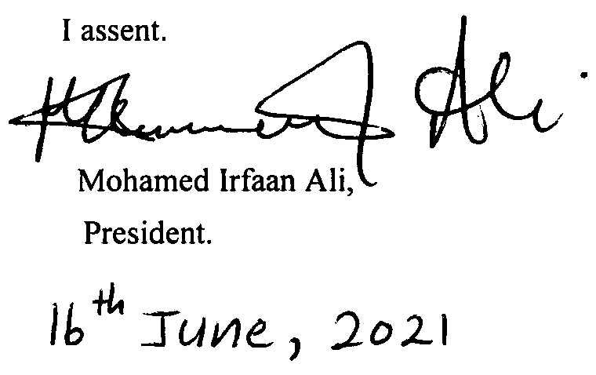

ARRANGEMENT OF SECTIONS

SECTION

1. Short title.
2. Issue from the Consolidated Fund authorised.
3. Appropriation

Schedule.
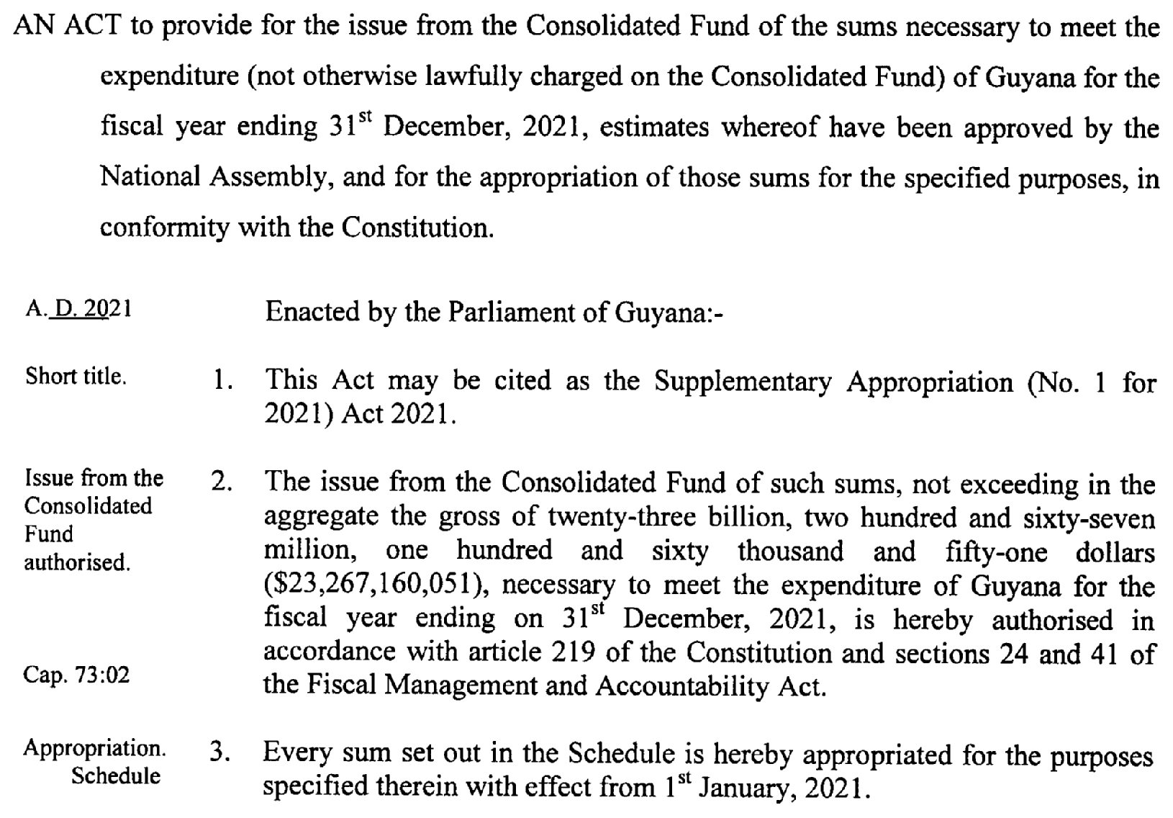

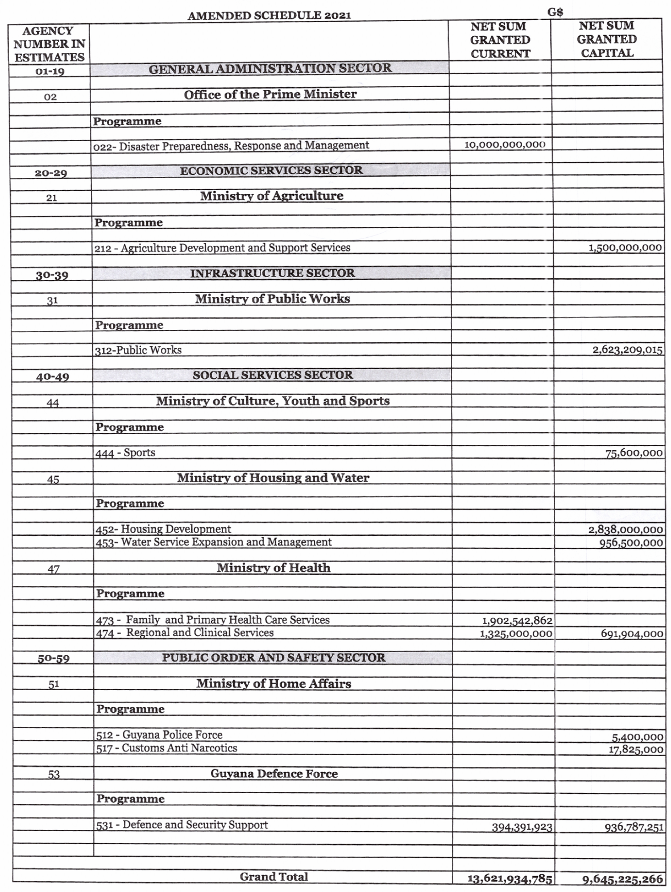

2

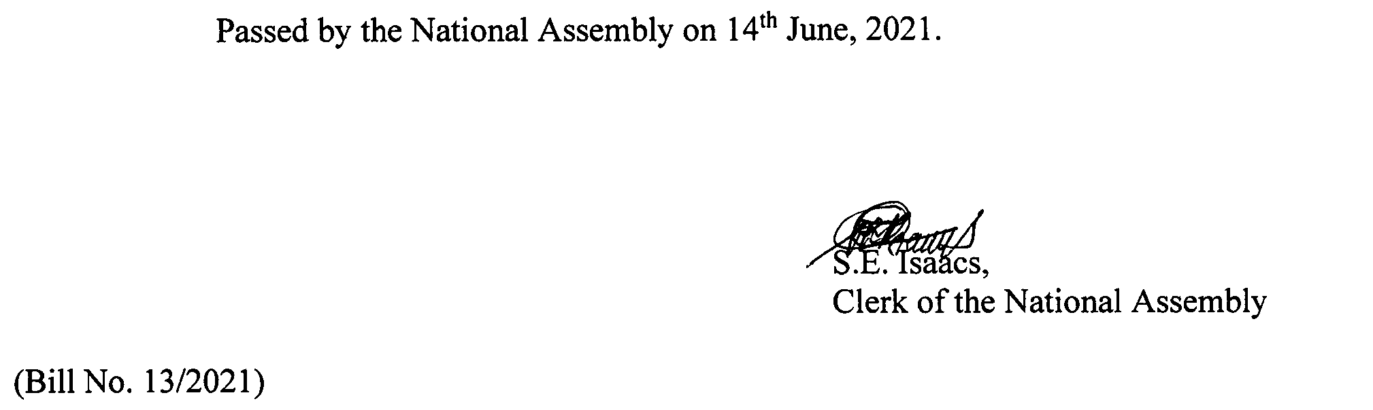

3

