THE OFFICIAL GAZETTE 7TH APRIL, 2022
LEGAL SUPPLEMENT — C

BILL No. 5 of 2022 Thursday 7th April, 2022

PARLIAMENT OFFICE
Public Buildings,
Georgetown,
Guyana.

7th April, 2022.

The following Bill which will be introduced in the National Assembly is published for general information.

S.E. Isaacs,
Clerk of the National Assembly.

GUYANA

BILL No. 5 of 2022

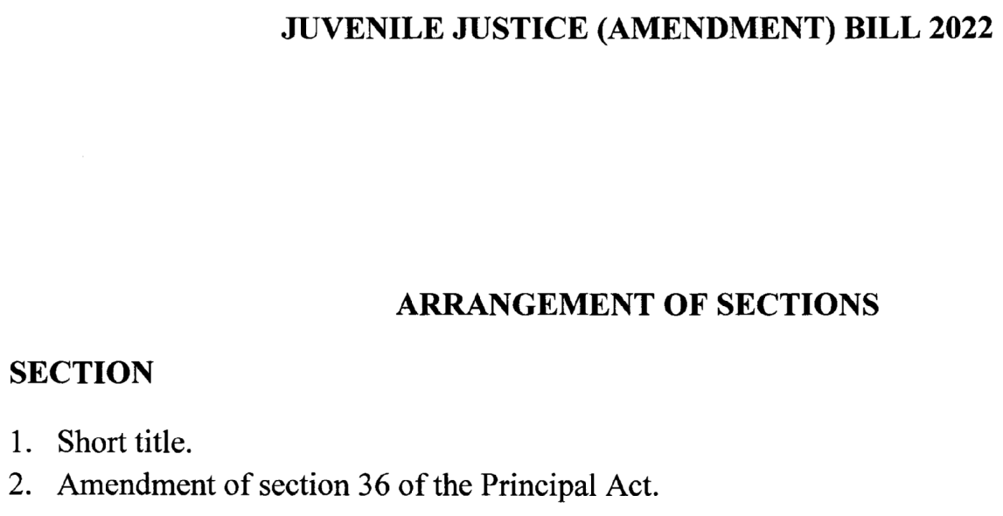

1
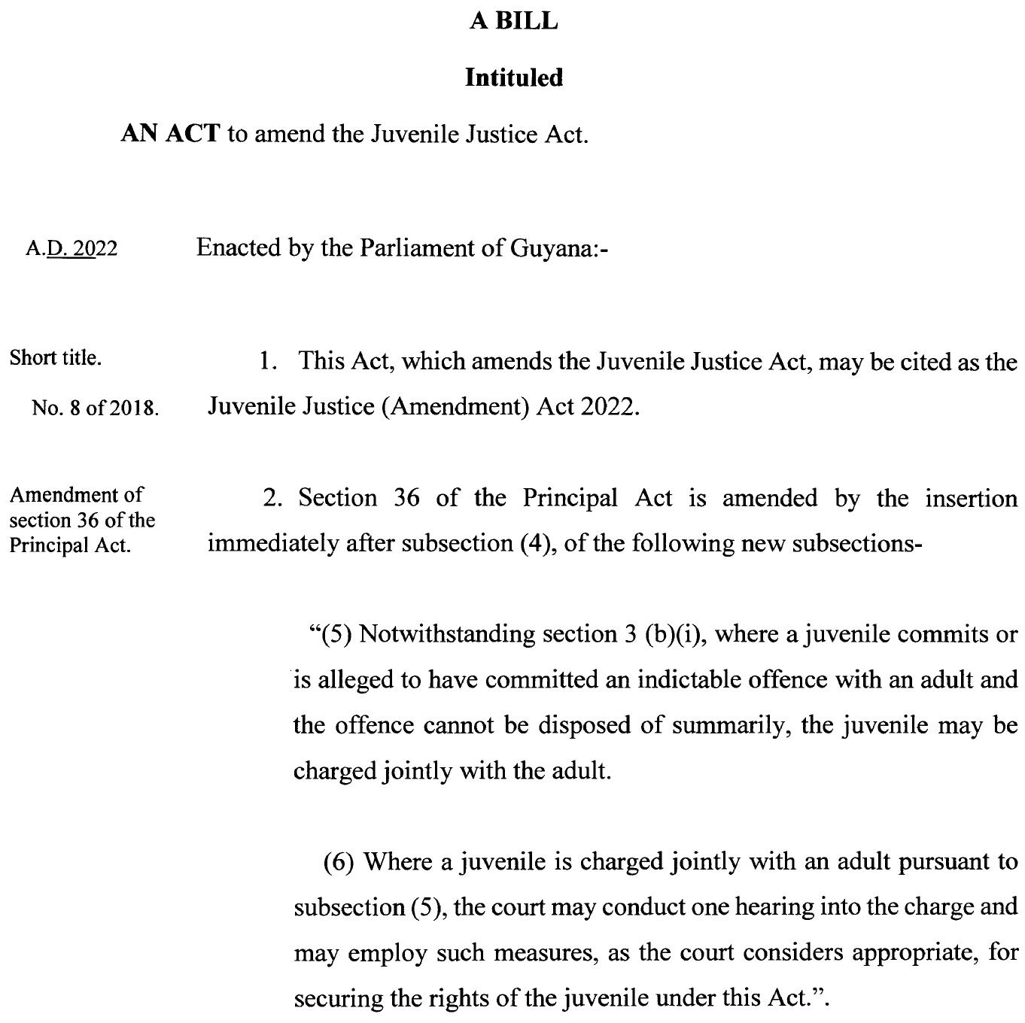

2
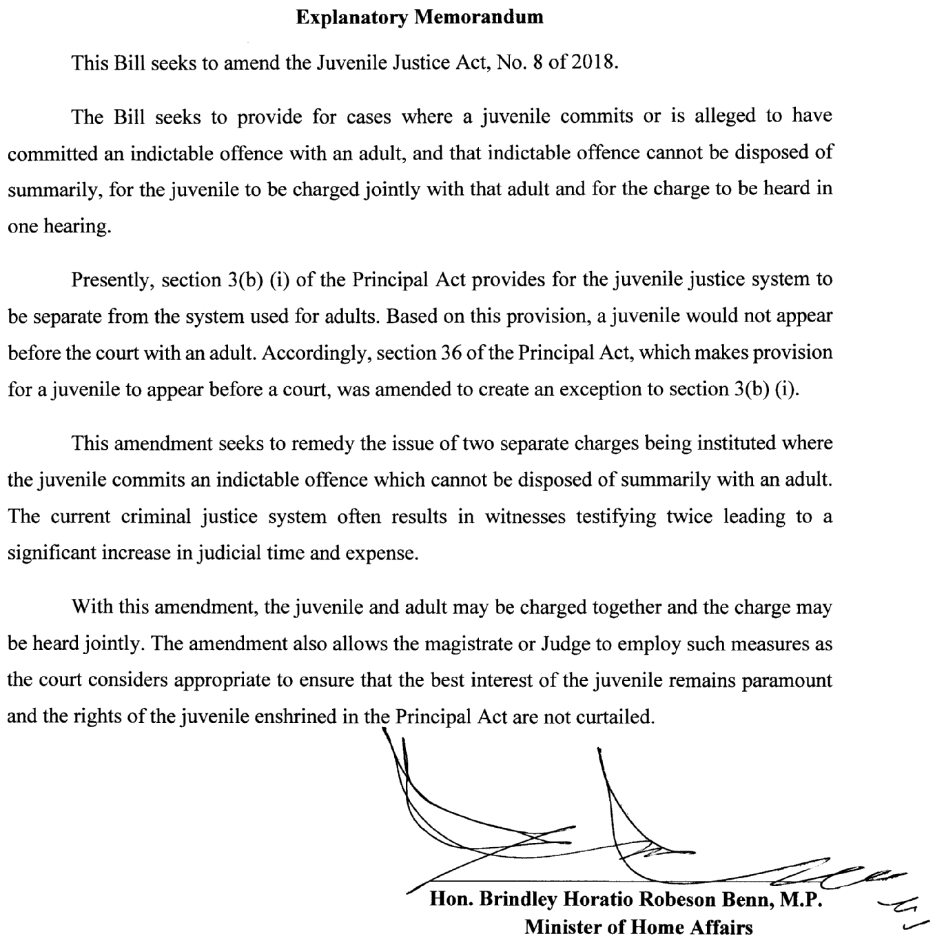

3

